The Business of Architecture and Development
  - With Reference to the USA and the UK
Robert Borg
Table of Contents

Title, Dedication, and Copyright
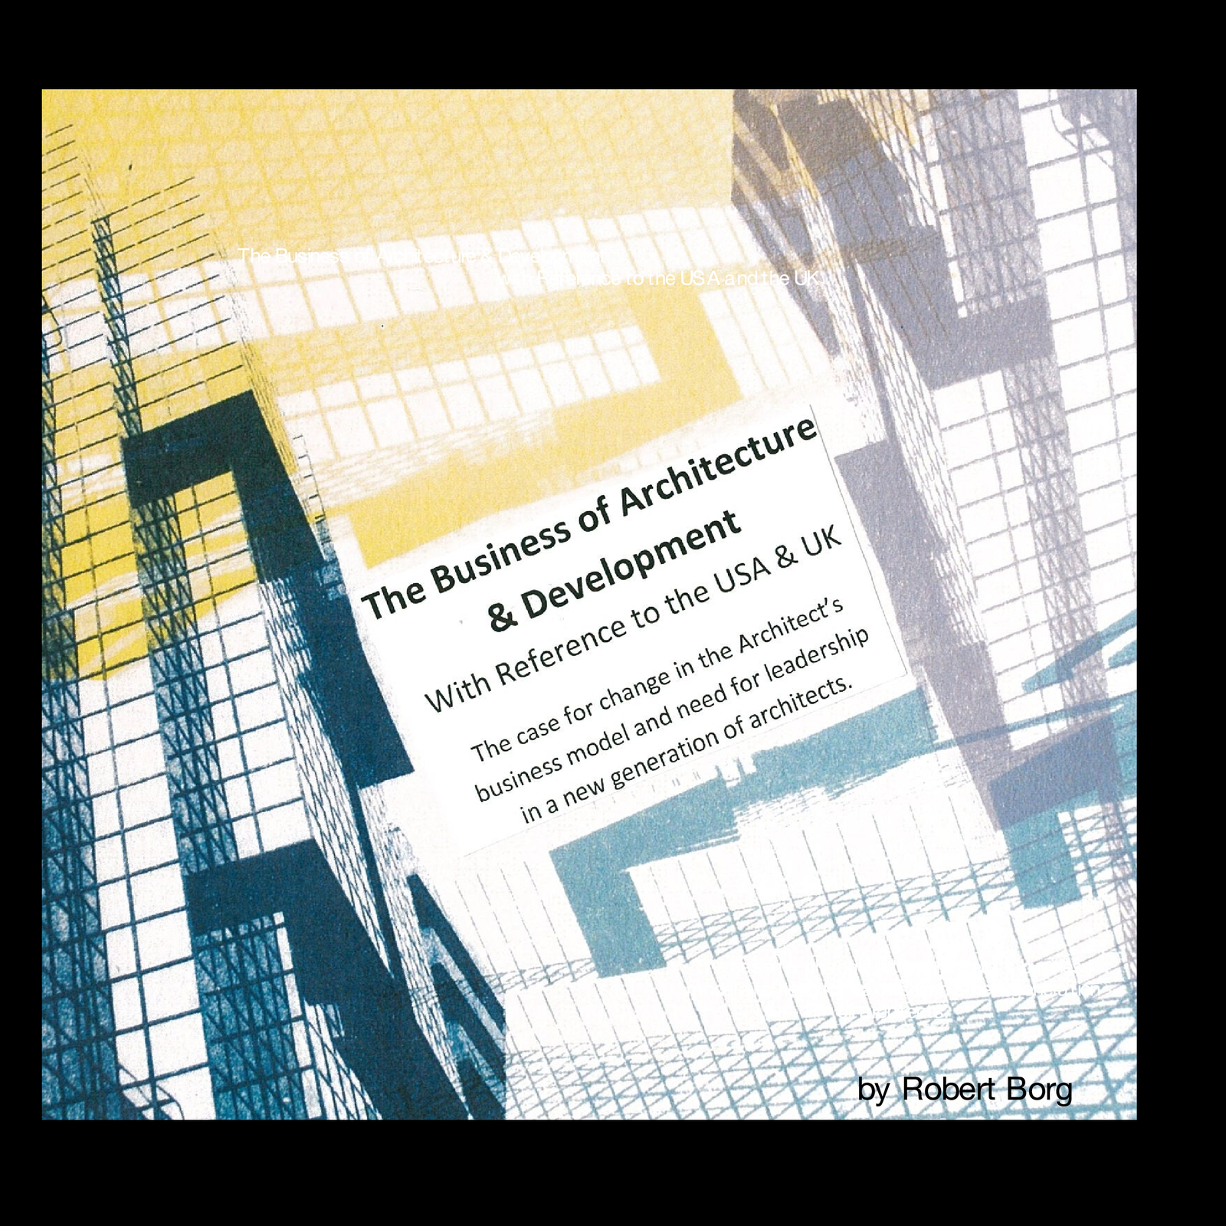

The Business of Architecture
and Development
with Reference to the USA and the UK
The case for change in the Architect’s business model and need
for leadership in a new generation of architects.
In memory of my dear friend and secondary school
art teacher June Simm and my college tutor James Hall.
Also my profound gratitude to my friend and mentor
John Page, Professor of Building Science.
Prepared for and dedicated to the student community at the
Department of Architecture, Sheffield University.
by Robert Borg

© 2012 by the author of this book. The book author retains sole copyright to his or her contributions to this book.
The Blurb-provided layout designs and graphic elements are copyright Blurb Inc., 2012. This book was created using the Blurb creative publishing service. The book author retains sole copyright to his or her contributions to this book.
To my wife Theresa and family,
who enrich my life beyond measure.

ABOUT THE AUTHOR
Born in Malta in 1945, Borg grew up in East London in the aftermath of WW!!, graduating from Sheffield in 1968 with a B. Arch (1st Cl Hons). A determined pragmatist by nature, his personal and professional commitment stems largely from working closely with his clients in the achievement of their individual investment goals. In the cost effective delivery of building projects, their construction and economic performance, his consistent design approach applies established principals of ‘design with climate’, firmly grounded in a knowledge of Building Science as a primary determinant of form and function.
He is personally committed to the need for strong and consistent management of building projects from inception to completion and places great emphasis on time and budget control. It is his acquired belief over 40 years of practice, that the key to his personal success in expediting the quality, cost control and timely delivery of his building projects and their performance, was through the inclusion of construction management as an integral and natural extension of the architect’s professional service.
Prior to establishing Robert Borg Associates in 1971, he gained his professional practice experience as project architect for prominent design and development companies such as Building Design Partnership in the UK and the Rouse Company in the USA. In addition to Planning and Design, RBA offered Construction Management services on a diverse range of public, private, residential, commercial, interior and land development projects, many incorporating the use of active and passive solar energy including the first solar heated restaurant in 1972 and earth sheltered public library in 1981 in Denver, Colorado, USA. In 1996 Borg developed his own ski lodge in the Vail Valley, Colorado, which now provides a comfortable retirement income and long term financial security for his family. In addition to architecture, he now pursues his other life long interests in art, history, cosmology, travel, music, global politics and all matters affecting the human condition.

PREFACE
Access to the major pockets of commerce is pursued by a diverse range of players in every industry. Those willing to make the investment enter the demanding professional fields of medicine, law, engineering and architecture through years of study and qualification. In the field of architecture, however, control of the industry has been taken over by players outside of the profession. Architects are now so many and competition so great that they are easily exploited by the industry they serve. How did we allow this to happen and what is the remedy going forward?
To answer those questions, this review of the Business of Architecture and Development draws on many years of working experience in the delivery of professional design and construction management services on a large variety of projects. The unusual perspective this experience, and the development of my own projects has given me on the scope of professional practice as applied to past, present and promising future business models, is the subject matter of this book. My hope is that its message will resonate with a confident new generation, fully capable of a new brand of leadership for the profession.
Where appropriate, I have used factual information and definitive notes taken from reliable sources acknowledged at the back of the book. I have also incorporated numerous personal notes taken over the years from professional development seminars, luncheons hosted by various business associations and professional magazines, together with current information available from ‘Wickipedia’ and other free access internet sources. To emphasize construction and conservation themes, select projects by RBA using earth-sheltering, active and passive solar designs have also been highlighted with photos, plans and other illustrations.
My thanks and appreciation to my dear friend and tutor James Hall who first proposed that I should transform my presentation notes to hard copy. Also to Prof. Page for being so outstanding a communicator in his field of Building Science. In keeping with the intent and spirit of these efforts I invite any and all to keep the dialogue going however passing or critical via e-mail to: robertborgassociates@comcast.net

Part One - The Business of Architecture

Opening Illustration
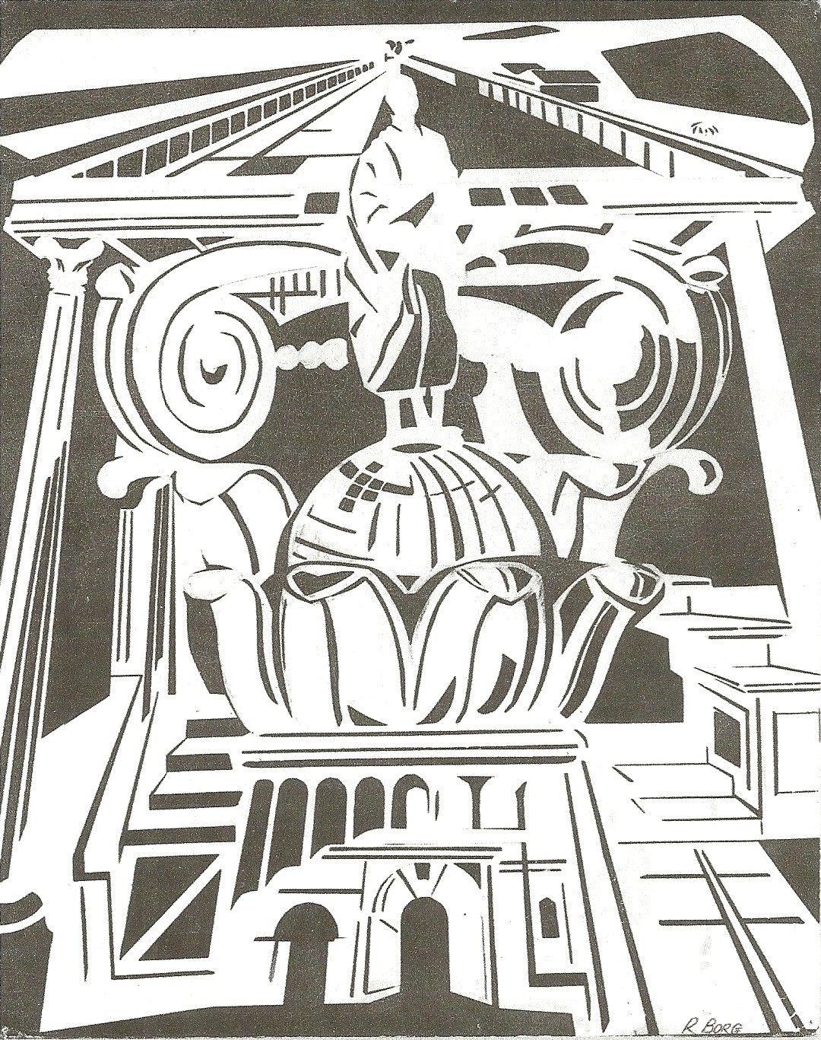

BACKGROUND AND INTRODUCTION
A few years ago I came by the department to check on my old friend and retired tutor Jim Hall. I knew he was around but was never able to catch him at home on the phone. Within minutes I was handed the phone by your amazing school secretary. Within a few more minutes we were having a great reunion at Jim’s favorite watering hole, right in the center of the college campus. I was in the meantime given a quick tour of the department by one of the students, Ioannis, who asked if I could return to talk about, “The Business of Architecture”, a much neglected, if not avoided subject, with denial at its core. This is, even among practicing architects, the elephant in the room. As such, it was for me as much a challenge, as a call to duty. So here it is.
It truly seems like only yesterday that I was in your place at this very same college, keenly looking for the kind of insights which I am now in a position to pass on to you. Looking back, if I could have started off with what I know now, I can only wonder how much easier my path would have been. But my unusual road to discovery while less travelled, has been to say the least, most fulfilling.
At this point I have to say I have asked myself why we do not prepare the student population for the realities of practice. Is it because it is deemed unnecessary at this stage in an architects’ development? Or are educators so divorced from the business of architecture and immune from its effects that they are persuaded that this can wait. The bottom line is that on this matter, budding architects are left to fend for themselves as indeed we all are.
Truth is, few are equipped with the knowledge and experience to address the challenge adequately on its own terms. All I can do is give you the benefit of my experience and get you introduced to the many challenges the business of architecture poses to the profession at this time. This is not a familiar role, so please bear with me if
what I have to say lacks the editorial benefit for a more efficient and polished delivery.
As a Sheffield University alumni, I feel especially motivated to give you the best feedback that I can after more than 40 years of experience, mostly in the USA. In that time-frame which spanned seven recessions, the scope of my business quickly evolved from that of a conventional architectural and interior design practice, to one which included construction management as a standard service and on a diverse range of projects, some of them my own. Academic study has its rightful place, but in the challenging business of architecture there is no substitute for working experience to understand the driving forces behind it.
In deciding the specific scope of the subject matter for this discussion, it was originally suggested by Jim that given my transatlantic background, perhaps a comparison of the two systems of practice might be of interest to you. After some consideration, however, I concluded that aside from differences in terminology, context and business culture, the traditional and prevailing systems of practice have substantially more in common than apart for this to be a mutually worthwhile exercise.
Instead, given the struggling economic state of the profession on both sides of the Atlantic, what is much more worthy and to the point, is a critical understanding of the serious and persistent problems they both share as business models, and how we can fix them, taking care of course not to misstate or confuse the underlying problem with mere symptoms of the same.
More than a critique of the prevailing condition, the following is a positive message calling for a rebirth of the architects’ profession in its more original and authentic tradition, now made increasingly more possible through the application of high tech resources. The underlying theme deals with its radical transformation from master builder to modern architect. How in that process the profession lost that vital
The Business of Architecture
connection with the trades, and with it, effective control of some of the key issues now critical to the successful delivery of our projects.
To begin with, it would be helpful for the purpose of this discussion, to try to assume the mind-set of businessmen rather than designers. An Architectural practice must first succeed as a business like any other, or it will not survive. So let’s pretend we are not architects, but rather salesmen charged with the task of selling the products and services of architects. Only then can we assume the right frame of mind necessary to be receptive to what I have to pass on to you.
To help you with that, I first want you to focus for a while on the pie chart on page 115, which breaks down the total retail cost of a typical project into its primary constituent parts based on the prevailing “design-bid-build”, project delivery system. This is where we must start in terms of analysis and context. To simply focus on the architects limited share of the pie as reflected in his design fees, and how we can be more efficient as a design business, would miss the bigger picture and more substantial message.
A few years ago, as an owner and operator of a ski lodge, I attended a luncheon for ski related businesses in the Vail Valley, Colorado, where I now live. The guest speaker was a nationally celebrated superstar on the all important subject of advertising who had just finished hosting a three day seminar in neighboring Aspen. After a hurried lunch and a few humorous anecdotes, he condensed his essential message by summarily stating; “Basically, it comes down to conveying three things to your clientele;
Who you are. What you do. And what you will promise them.”
This proved to be a very helpful format for a new ski lodge brochure I was contemplating and it does indeed work very well for most products and services. But for the complex business of architecture, is this not overly simplistic, I first thought to myself?
Well, perhaps not, as you will see. So let me get you further into the right business- frame of mind for this session by posing that same question to anyone of you who cares to take a shot. What would you like to be able to say you can offer your prospective clients that will make you stand out from your competition? Incidentally, you would be mistaken if you thought you were just competing against your fellow architects. Understand that before you can have a business, you must have clients who are persuaded that you are the best pick.
A good clue as to the best way to answer that question is to place yourself in the owners’ position. First and foremost he is usually a businessman. Even if he isn’t, any building project represents a business proposition involving the expenditure of considerable sums of money in your charge. So what do you think he most wants to hear? By the time you leave this setting today you will have the complete answer to that question, together with a clear understanding of the driving issues we need to address as a profession to be successful in the business of architecture.
In short, you will have a game plan for your own success. What I can’t give you of course, is the grit and determination to make it happen. In the end, for the next generation of 21st century architects, how to best answer those same three questions, goes to the object of this enquiry, which should perhaps be better restated as follows;
To be more successful, what could the business of architects be?
I could likewise give you the short take on the bottom line message which will meet that challenge, but understanding the rationale behind the message will, I believe, empower you with much more conviction of purpose, than just simply following my directions. As students of architecture you are probably at least as concerned right now about your future career prospects as I am, given where I believe the business of architecture is grounded at this point in time. The lack of stability, commensurate
compensation and the intensity of competition, can all create a high degree of anxiety and disillusionment among young architects. Clearly, you have made a serious commitment of your personal resources of time, energy and work ethic, as I did to the study of architecture, and that should not be taken lightly.
We only get to pass this way once, and so life and time are both precious and irrevocable. Twenty years from now, I don’t want you to feel that you made the wrong choices because no one clued you in. We each come into this profession with different strengths and weaknesses. But as a business which fuses art with science, one of the unique properties of this enticing profession is that it has an unlimited capacity to fulfill the personal aspirations of each and every one of you, whatever that particular definition of success may mean to you individually.
My goal here is to get you thinking about the business of the profession you are getting into, so that by the time you graduate you can hit the road running, and with a clear sense of direction. Knowing the current business context of your chosen profession and more importantly how you may best relate to it personally, is key to making the right choices or setting the right goals at this formative time in your development. Of course, if you elect not to make any choices and just go along with the crowd, that’s also a choice, and your prerogative.
As we all know, the profession is undergoing significant changes in many different directions both in the UK and in the USA, driven largely by competitive market forces and high technology. It is of necessity becoming fragmented and more diverse in much the same way as the legal or medical professions have also evolved in response to demand. Certainly, the ability to assimilate large amounts of disparate information acquired in our training has many useful applications. Perhaps many of you will by chance or design, find yourselves in twenty years time, specialists in one of the many expert services architects now perform, as opposed to those in the strict tradition of designing buildings.
My primary focus here however, relates to the Architect’s more essential role in that more classic tradition, with the unusual emphasis on the combination of design and construction management services as the most effective prescription for restoring and elevating the architects true capability, his image and financial standing, while at the same time achieving better value for money for the buyer or client.
To be clear, CM when provided in-house by the architects team is by no means simply General Contracting under a different name, nor just a higher level of conventional ‘contract administration’. The difference and major advantage of CM in this context is that from inception to completion of a project, it allows for the timely application of a wide collection of existing in-house capabilities that draws from the resources of the whole industry,- not just design and construction, but critically, manufacturing, engineering and management science. It will produce more cost and schedule design options and inevitably draw the owner into the decision making team process,- another major benefit to the ultimate success of any project as discussed in more detail later.
One of the outstanding features of the US construction industry is that it has always been most enterprising in its approach to producing and marketing its product. This has more recently lead to some remarkable diversification in the delivery of building projects, together with new options for architects in the way they relate to clients and contractors. While the UK has probably been socially more progressive, the sheer size and innovative nature of the US economy means that new ideas flourish or fail more readily. As I have personally witnessed over the last forty years, ideas that take off in the US therefore tend to be rapidly emulated by other western economies.
For US. architects, the introduction of Design/Build and Construction Management and their delayed endorsement by the AIA represent a radical departure from the traditional standard “design and oversight” role. The most notable of these
trends has been the rapid rise of the Design/Build Company, where architects team up with contractors to offer design and construction in one contract. However, although this has now gained approx 35% (based on dollar volume), of the US market and with good reason, it can present some potential conflict of interest issues for the architect who finds himself part of a company effectively selling a building as opposed to professional services. We will briefly review those ramifications of this business model shortly.
Professional Construction Management as an extension of the Architect’s design service is my preferred option to project delivery because above all, it preserves the architects’ independence and ethical relationship with his client. In addition, when the architect provides professional management to replace the general contractors’ role in the traditional project delivery model, he regains and enhances direct and critical control of his projects from start to finish.
So it would be a mistake to view construction management as performed by the architect as just a mere substitution for the traditional general contractor’s role or simply a higher level of construction oversight. To fully implement its benefits, it requires no less than a radical change in the approach and methodology involved in the design and delivery of a project, if it is to be effective in achieving its primary goals.
The benefits to both architect and client of this paradigm shift cannot be overstated. Most of all, and in practical terms, construction costs and schedules are substantially reduced while at the same time actually resolving more issues than it creates for both the owner and architect as we shall see. The Construction Management approach now accounts for approx 10% of the U.S. market, based again on dollar volume.
This is of course as demanding a solution as it is elegant, reinstating as it does the necessary performance and leadership position required of an architect for the comprehensive professional role he is called upon to serve. Figuratively speaking, it also
frees the architects’ other hand which in more recent history has been firmly tied behind his back as I will also explain shortly. As Churchill so succinctly stated, all be it in a totally different context, “Give us the tools and we will finish the job.”
Indeed, in this one bold move, by extending the scope of his service from “construction oversight” to “construction management”, the architect regains all the business tools he needs for the complete control of his projects, and never looks back. A pre-requisite for success is having the right business model, and this for me proved to be transformative in comprehensively addressing the driving issues at hand. What you may choose to do with it, is down to you. Look at this proposal as a superior vehicle - not as a
destination. Suffice it to say that separate and conflicting agendas inherent in the traditional model have never been a formula for success. They are, for owner and architect, as we have seen, a recipe for inevitable stress and failure in comfortably achieving their desirable goals.
At this time not enough significance has been credited this topic. Then again most architects are regrettably too complacent and have shied away from adding the construction management dimension to their scope of service. So this should not be too surprising. On the other hand others who have embraced the concept in adopting the alternative Design / Build model are currently thriving.
You should also know that this radical change in scope to the architect’s standard business model is not promoted by an elitist and comfortable establishment. The guys at the top will always thrive even when the essential business model is inherently weak. My concern is for how we can improve the status of the profession as a whole within the construction industry by regaining that essential control.
In the UK. we are still burdened by a lingering Victorian legacy of any connection with the so called ‘hands on trades’ being somehow beneath the standing of a
professional station. Not so in the U.S. where the pioneer spirit still prevails, and to the benefit of all who can not only get things done, but on target. Simply put, the efficient and timely execution of a plan is in today’s economy highly prized, especially in a society where time is not only money but indeed critical to the very viability of the project. And this will always take a united team effort.
There is also this inherited puritanical, if not naive notion that an architects’ involvement with anything outside of a strictly defined and purely professional consulting service participation can have only a corrupting influence, and will ultimately accrue to the detriment of its ethical values. In terms of commitment and quality of service nothing could be further from the truth, as evidenced in the birth of Design/ Build companies in the US. and we shall briefly address this issue too, shortly.
Generally speaking I have found that most architects are too apprehensive about the very prospect of delivering their own projects. This is because this serious endeavor falls outside of their normal comfort range in terms of training, knowledge and experience, and most often they have quite simply never tried it. This is why even a rudimentary knowledge of C.M. is so important and so necessary. Yet, I have no doubt that your thinking on the matter provoked by this discussion will henceforth, profoundly affect the business outlook and consequently the future livelihood of each and every one of you, whether you are personally persuaded by its arguments for change or not.
Its’ primary message is simple and stems from my own personal experience gained over forty years in the delivery of integrated professional design and construction management services on a diverse range of building development projects including my own. It is also equally relevant to the business prospects of the large and small practice both in the U.S.A and U.K. Acting on it will require your commitment. But if you do, I can promise that you will be more successful both professionally and business-wise, and on a number of levels, be it applied to marketing your professional services, establishing your
own business model, or ultimately the integration of all your resources into a financially secure and life fulfilling plan. Incidentally, you will by any measure become a better architect.
Above all I can assure you that you will never be bored or disillusioned, symptoms most prevalent among your common garden variety of architects, especially in to-days economy. As my contemporary Bob Dylan so aptly put it speaking of his own life, “If you can fill your days creatively doing what you enjoy doing the most, you are one lucky SOB” As yet another popular pronouncement goes, - “Nothing is as powerful as an idea whose time has come”, and you certainly can’t argue with the prospect of success. Essentially, it has mostly to do with leadership and breaking with the status quo.
So, in keeping with that spirit and objective, I want to talk to you now about the critical, if less glamorous matter of the business of architecture rather than what you commonly hear visiting architects and educators talk about - its design. What I will briefly say in passing on that demanding note, and certainly not to diminish its importance, is that architecture has provided me the privilege of living my life at the intersection of art and science, or more specifically, building science. As we enter into a newer and more demanding age of energy conservation, never have we been more challenged in the required melding of the two. For myself this was a particular challenge which began in my student days in Sheffield in the sixties and continues still today.
Indeed, no other matter can claim to be more critical to the architect and his profession than the success of his business. If we are where we are, it is regrettably because we have paid due regard to all considerations other than the business side of Architecture. Problems related to the sustainability of the Architect’s profession all have in my opinion a common cause and as proposed, a comprehensive remedy: the adoption of professional Construction Management into the Architect’s Business Model.
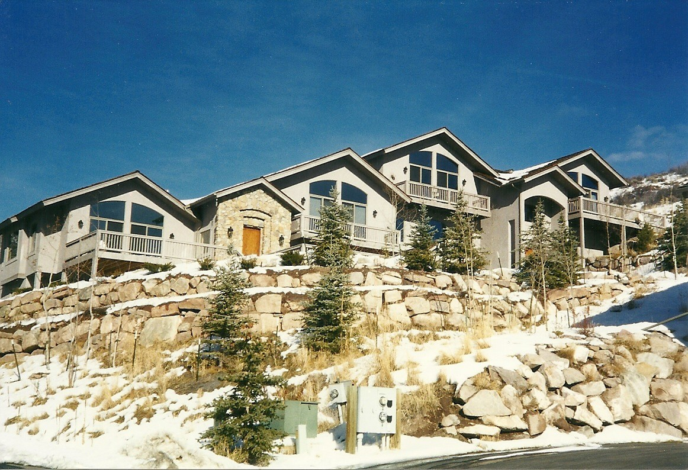
Passive Solar Duplex on West Facing Slope by RBA, 121 Palomino Rd., Singletree, Colorado
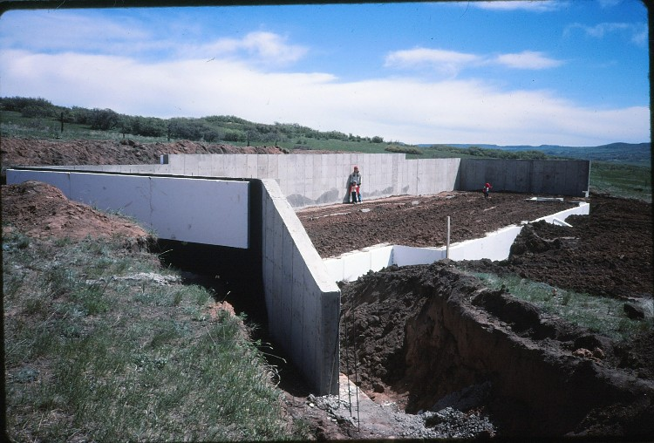
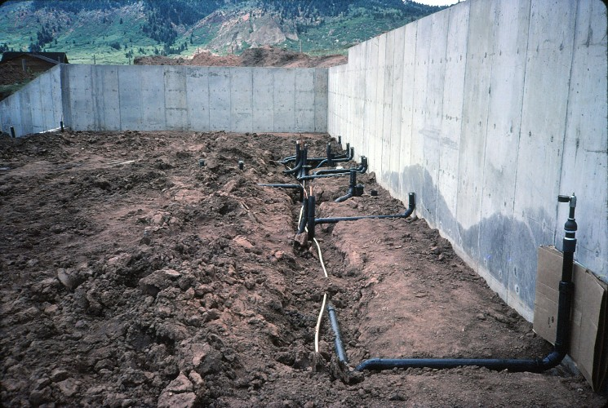
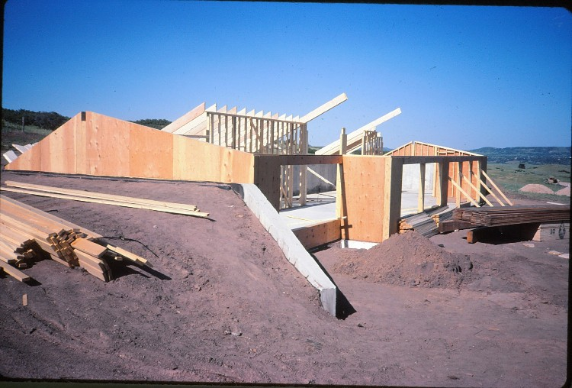
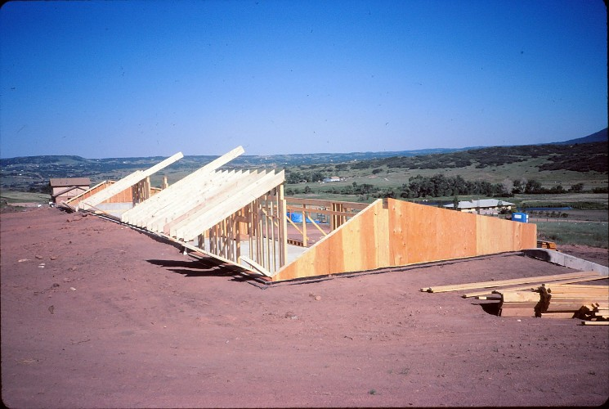
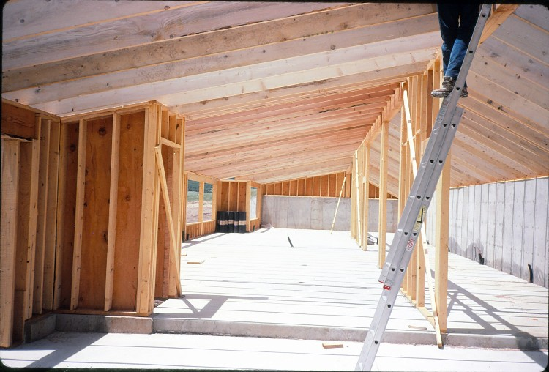
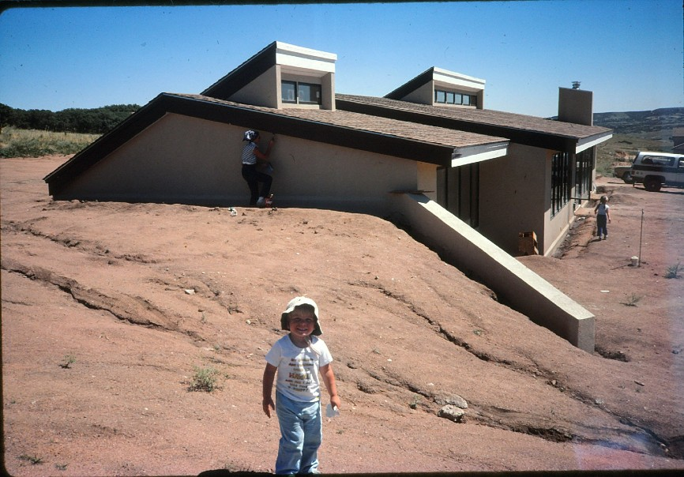
Beasant Residence (2500 sq.ft.) Construction progress photos: semi earth-sheltered, passive solar home in Sedalia, Colorado. Design and CM services by RBA, 1985.

THE CASE FOR CHANGE IN THE ARCHITECTS BUSINESS MODEL
We all understand that Architects have in one form or another always existed. In today’s complex development environment, they are by definition the indispensable players in a huge and profitable building industry. But outside of a small establishment, this is not reflected in their collective level of remuneration, financial stability or diminishing professional standing. Indeed, Architects are now, in the mainstream, deemed by the banking community to be the poorest risk of all the professionals. By the end of this presentation you will come to understand why. Coming to terms with this reality is, however, a rude awakening for young architects with typically high aspirations and limited financial resources.
As you will discover, it is one thing to know how to design a building, quite another to know how to use this talent in today’s competitive market to make a secure living. Confronting this challenge presents certain options, but working within the accepted parameters of the prevailing business model, none address the real problem which is structural or systemic, as I will explain shortly. What is interesting is that in many ways the primary issues posed are a microcosm of the recurring breakdown in the national economy i.e., an inequitable distribution of money flow. (ref: pie chart, pg. 115).
Then again, one is a substantial component of the other, so it should not be too surprising that they have symptoms in common. In periods of dynamic economic and technological change such as we have passed through in the last three decades, it is inevitable that old formats no longer work effectively. So we must at some point question the premise on which those models are based and that is the primary objective of this enquiry.
As architects we have always been capable of thinking outside the box and asking those critical questions. To quote: “When you change the way you look at things, the
things you look at change”. Looking back, the radical determinations I made for the direction to take my practice broke with conventional norms and was born of a combination of both reason and intuition. Now backed by many years of successful practice it can be supported from both a theoretical and practical knowledge base.
At the time (1974), that is about forty years ago, there were no architects known to me who had adopted the combined professional design/construction management business model, but for myself it felt like a perfectly natural and rational move, grounded largely in a feeling of dissatisfaction with the poor status quo and a desire for more direct and comprehensive control over the marketing and delivery of my projects.
Back then it was in fact misguidedly considered a breach of ethical standards for members of either institute to be involved with the actual construction. Ethical standards also prohibited advertising and any kind of fee competition. But this was to change as a result of professional societies coming under fire by government anti-trust forces, who basically charged that this virtually amounted to price fixing which was not in the consumers’ interest. It was thus determined that professional societies could not regulate fees and professional conduct in the guise of enforcing ethical standards.
In the late seventies (1979) the AIA consequently introduced new user friendly ethics standards, and today architects are found in every role and function of the construction industry much to the arguable total benefit of both the architect and consumer. As a nation driven by the power of ideas, it should not be surprising that good ideas flourish.
Certainly, my early experience with the typical outcomes for all players in the architects’ conventional business model, was persuasive enough to suggest there had to be a more objective and cost effective way to deliver a building project which better served the client’s interests and did not leave the architect at the short end of the deal.
Indeed, it became quite apparent that there was a serious imbalance in the distribution of the costs related to building development (as illustrated in the pie chart on page 115 ), which in the prevailing business model is outside of the architect’s control and which has lead in the mainstream to the economic crisis we continue to experience in the profession.
Clearly, as I’m sure you will agree, none of all the candidates is ’potentially’ better qualified than the architect to resume that control. But in practice it’s not for the asking, rather for the taking and only by those willing to rise to the challenge. So in the proposed model the new and improved 21st century architect regains that prerogative and thereby addresses this main problem which is, to repeat, fundamentally structural.
Moreover, this new model has subsequently been validated by many years of successful practice and progressive developments in the industry at large. The conclusions drawn from comparing the two models and the recommendations which follow are perhaps, as much revealing as they are confronting and challenging to a profession which as a whole and relative to other professions, has in the mainstream lost much of its original formidable identity and all the valuable benefits associated with it.
At this formative learning stage in your development, thinking on a strategic level about the past and present role of the architect, and more importantly the real prospects for positive change in a high-tech future, will be far more enlightening, helpful and advantageous to you than getting hung up on the tactical details of conventional practice. These you can effectively teach yourself as I did.
As you will see, the Architects’ essential leadership role has the potential to go full circle and to reassert itself once more, but only if we have the collective willingness to rise to the challenge. This involves adding a new dimension, or rather an old dimension to a new and more authentic job description. For architects this is a natural and rational
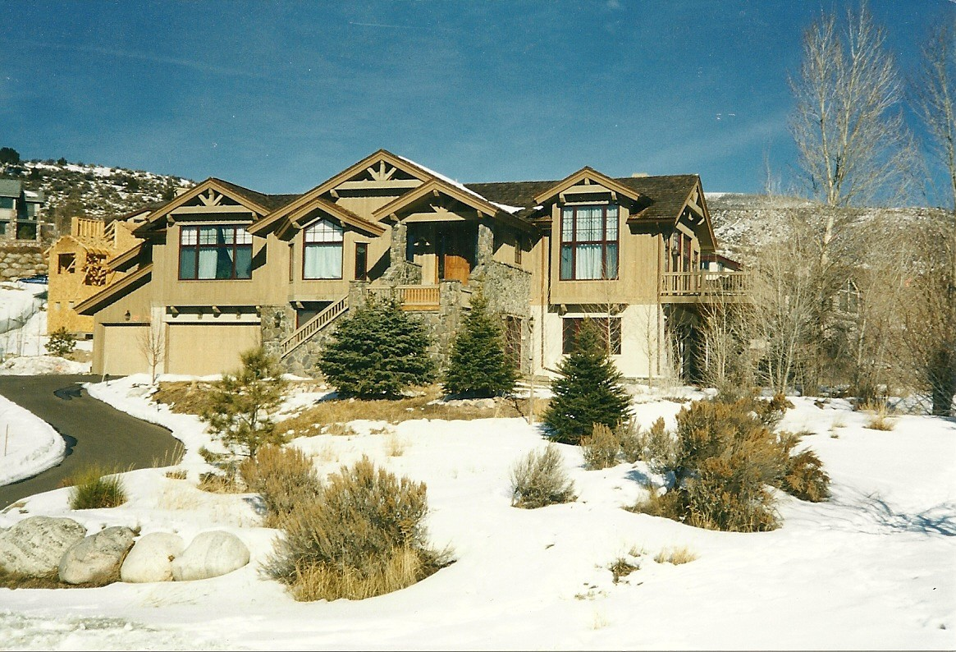
development, made even more so now with the advent of high technology. The advent of structural steel and the integration of engineering services certainly redefined the architects design role as did the arrival on the scene of the business minded General Contractor who has progressively gained control of the industry as we shall discuss below.Times changed but they have changed again and this time to the architects advantage.
To repeat for the sake of emphasis, this leadership will not be forthcoming from the deeply entrenched and comfortable establishment, but from a enlightened and confident new generation, armed with the powerful and transformative capabilities of high-tech resources. This baton, is thus handed to you.
Passive Solar Residence in Singletree, Eagle County, Colorado by RBA, 1997

(1) WHAT IS THE ARGUMENT FOR CHANGE?
The best and over-riding motivation for change always stems from an increasing dissatisfaction with the status quo. As instruments of the elite establishment, the AIA and RIBA are not always in tune with the real economy and have historically proved to be more reactionary than truly progressive. But before we set about making changes, we need to understand the underlying cause of our problems, so that we address the right issues - not just their symptoms. Simply stated, in order to fix what needs fixing, we need to be clear about what broke.
Global growth in population has continued to create an unprecedented demand for the architectural and engineering professions. But while the critical need for comprehensive planning and regulation by government agencies is self-evident, how to best achieve the common cost objectives of construction projects - and those of the related professions, has been resigned mostly to a failing status quo.
Consequently, as it continues to evolve sideways, the future viability of the profession is presently the cause of much concern and speculation, - if only by the architectural community at large. It is after all our business and livelihood which is at stake here. With the changing profiles and demanding business objectives of the new client, old ways no longer work, while market forces and the impact of high technology on the complex design and construction process only serve to underscore the nature of the whole issue. The time to examine the effectiveness of our inherited training and methodology in the context of the new business environment, and the common high-tech resources at our disposal, is now long overdue.
At its best, Architecture, mother of all the arts, continues to be the ultimate expression of the cultural aspirations of any noteworthy society. On a more commercial level, demand for development and those who produce it, is very much assured. When
we look at the business of architecture we find that throughout history so many cultural, social, economic and political forces have influenced its operation, that specific context can be seen to be the biggest determinant in setting the stage for expectations.
Without a doubt, this is more true today than ever before - except that we can now increasingly add more and more high technology to the mix and this potentially has the power to change everything from start to finish. Simply put, high tech is a profound game changer. Not just in its application to conventional practice, but in its potential to more radically and readily expand and improve the scope of a new and more viable business model. When we don’t get the results we need, we must seek to make the necessary changes to get the results we want.
Clearly, 19th and 20th century technology created many far reaching problems for the profession, but 21st century high technology has now given us the means to solve them,- provided of course that we have the willingness to take full advantage of these new resources, to re-evaluate our condition, to adapt, and to change. As a profession we must either be in control of events, or be controlled by them. Presently this is a battle we appear to be losing for reasons which will become apparent.
Perhaps we can take a lesson from the forces of natural evolution, and through the scientific method of observation, experimentation and verification come to some definite conclusions. Though on a limited scale, this is what I have been able to do with my practice and what I can pass on to you.
Architects by the very nature of their job description, understand that until one defines the problem - that is the whole problem from both a strategic and tactical viewpoint, the true solution will remain unmasked. In dealing with the present condition, the profession therefore needs to take a long hard look at the developments which have led to the circumstances we now find ourselves in. There was a simpler time
when the Architects’ condition was alive and well. So let us briefly review the broad chain of events since then, which have delivered the patient to the emergency ward.

(2) SOME HISTORICAL PERSPECTIVE
The earliest use of the label “architect” in England, is said to be in the year 1563, but those who occupied the same position prior to this time have always performed the same roles, i.e., ‘designing’ and ‘managing’ the erection of buildings. The Greek for architect, ” Architekton”, combined these two roles in the personage of a single player and certainly contemplated no divorce between architectural design and building construction, as these roles are and will always be mutually enhancing, inter-dependent and intrinsically connected.
Theoretically at least, this much remains as true today as it was in the past. In practice however, this is no longer true as the two roles have, in my opinion, been needlessly separated, much to the detriment of the efficiency and objectivity of the process, its players and not least of all, the quality and cost of the end product.
Egyptian, Greek, and Roman architecture all fared very well with the concept of the Master Builder when unlike today, design and construction was relatively simple in scope. More recently, the make-up and mind-set of those attracted to the occupation also transitioned from a practical hands-on apprentice approach, to an elite society of talented social climbers, drawn more to the aesthetic appeal and stylistic challenge which the aspirations of the new profession represented. Remnants of these elitist traits persist even today and explain why the culture promoted by the present model and the long standing establishment is so incompatible with the true nature of the economic and other practical challenges we face. Above all, it is first about the Client and his business goals in which quality, cost and time are the primary drivers.
Historically, the year 1875 is significant because it hailed the invention of safety brakes for elevators making high rise buildings possible and with it, explosive growth in the cities. From this point on traditional building construction changed dramatically due to complexities in the variety of new building systems and construction methods. Starting slowly after WWI, architectural design, now largely driven by higher engineering capabilities and expectations, also became much more complicated, thus giving birth to the new engineering sub-disciplines and revisions to old methodology.
Prior to this time the pace of delivery of building projects was also slower, less competitive and far less complex. But propelled and compounded first by industrialization and then by new engineering and information technologies, the role of the architect today is very different. And it starts with acknowledging yet another critical key consideration - the financial and other time related challenges faced by new owners and commissioners of building projects. This all on its own has changed the whole nature and character of the practice of architecture and its profession, and needs to be thoroughly understood if we are to be successful.
In addition, in contrast to the time tested traditional design expertise we used to offer our clients, the relatively cheap energy environment of the recent past, has resulted in the short term salability of building design trumping the economics of long term usability, as building form became driven in its design by a total reliance on environmental engineering systems. This has unfortunately turned architects into stylists, abandoning the knowledge of even the most basic of sound, substantive design principles and with it their primary “raison d’être”.
Obviously this has to change. With the increasing cost of energy and the need for radical conservation and sustainability, these parameters are of necessity already being reversed. Architects therefore need once more to become much better versed in a more substantive design approach. In the coming new age of energy conservation,
usability and salability will be synonymous as the totally engineered environment gives way to the natural. In Denver, Colorado and all over the US this trend is already re-establishing itself and can be clearly seen in the tearing down and replacement of familiar shopping malls with more traditional building forms combining retail with office, together with residential uses - all back on a conventional grid street plan. It’s, “déjà-vu all over again”.
In the West until relatively more recently, we saw the role of the architect change dramatically from those of combined designer and builder embodied in his title, to a single, more complex design and administration role involving the co-ordination of a variety of engineering and other construction specialists who are now increasingly taking over the leadership role. The contract for the supervision of the buildings’ construction has since been delegated to a second player, the more business oriented General Contractor, who submits his tender in competition with like minded players, and on the basis of the construction documents, following (and this is the operative word as I will explain) their completion by the architect.
What is significant here in terms of a resulting change in common public perception, is that particularly in the U.S. it is the hands-on GC who is now identified with the business expertise of delivering the building product, while the architect is seen as the increasingly out of touch office bound designer. With a view to reducing professional fees, less sophisticated owners often believe they can limit the architects on-site observation of construction progress to minimum and mere symbolic levels, without any detriment to the quality or cost of their projects. In the U.K. these effects are even more apparent.
Over time this image has reinforced the notion particularly in the U.S., that the builder is the one to approach with the critical questions relating to cost and schedule, not the architect. Self serving builders also perpetuated the view that architects by

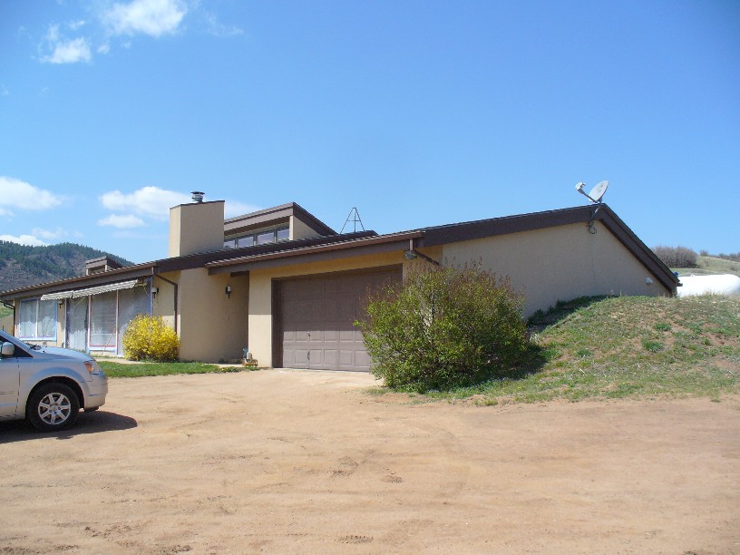
nature and inclination were prone to break the commonly accepted rules governing cost control and could not be trusted to stay within budget. In fact, contractors argued, ‘they’ were in the best position to keep the architect and the budget in check - a claim which construction project managers are now also making. (See #5, page 32)
In terms of the most critical issues we have failed as a profession to adequately address, it is primarily these pressures of time and cost control which have created openings for those now familiar players such as the QS, GC, CPM and Design / Build companies to seize the opportunity, and successfully position themselves at the architect’s expense, in the newly defined design - construct process. Without question, Architects invited this development and with it the seeds of their own current demise.
In the UK, quantity surveyors who work for Owners, Architects and GCs and who fared no better at cost control than the competitive free market forces alone in the US, also did little to promote the architects case for leadership in this area. In this context let us review the effect this has had on the architect’s position within the prevailing format of “design - bid - build”, and its related contracts for a buildings’ design commission and construction.
Semi Earth Sheltered, Passive/Active Solar Home,
Denver, CO, Design and CM by RBA 1980
Semi Earth Sheltered Passive Solar Home,
Sedalia, CO, Design and CM by RBA 1985

(3) DESIGN - BID - BUILD
By those who don’t know better, this is still the most commonly accepted process for the delivery of building projects. Here the owner has separate contracts with the architect and the GC. Given the demanding pressures of quality cost and time, this must have been a contrivance inspired by lawyers because it has served them well as an inexhaustible source of work. It is sometimes referred to within the business as the classic three legged stool, critically vulnerable to short comings, real or imagined, stemming from any one leg, be it the owner, architect or builder.
With respect to either the prevailing design-bid-build contract, or alternative types of negotiated price contracts for construction, the resulting split liability shared by the architect and contractor has formed the basis on which these two related sets of contractual obligations with the owner are defined and delegated.
From a legal standpoint, an indirect third party relationship exists between the designer and the contractor emanating from these two contracts, and this inevitably adds an unavoidable and strenuous legal dimension to the mix, particularly given that a difference in aspiration often exists between that of the professional architect and the more business/profit minded contractor. Based on my personal experience with general contractors, this is now quite simply a fact of life.
There was a time, prior to the 1960’s as my more seasoned colleagues would tell us, that a common spirit of cooperation could be counted on in the delivery of a building project. Today as we commonly hear, its all about the bottom line and this goodwill on the contractors part has increasingly all but disappeared into the voids left behind, as architects relinquish their roles as deliverers, as opposed to only designers of their projects. If not a byproduct of the split in liability between the architect and general contractor inherent in the Design-Bid-Build Model, it is now very much a given condition.
To the GC, for the most part, with typically little or no intellectual capital vested in the design, it is a business proposition, the success of which is very objective and all about maximizing his bottom line on the satisfactory performance of a fully defined scope of work by the architect. In the standard format it is not unusual depending on market conditions for general contractors to add 7% to 10% for overhead and another 7% to 10% for profit to their declared construction costs and for a role which is today essentially one of management. More aggressive players shoot for a total of 30% and more.
In reality of course the real cost of the construction is the contractors business and if having secured the contract, he can improve on his bid numbers, well that’s only fitting - right!! He is certainly not obliged to pass on any savings. In practice so much of his declared overhead can be absorbed in the general requirements of a construction contract and other costs which he directly controls, that his effective profit is far more than usually meets the eye. (See pie chart, page 115)
For the architect on the other hand, his professional commitment to the owner’s interest is open ended and duty bound. For his role, success is much more challenging, more subjectively defined, and the amount of his fee is a matter of official record. In addition to the ever increasing cost of professional liability exposure, it has to cover all his office and salaried overheads together with those of his engineering consultants, and there is certainly no separate and additional mark up for profit, based on a percentage of the projects cost.
In this traditional design-bid-build scenario, duties relating to design and construction are separate legal responsibilities. As we know, the architect is not a party to the contract for construction, but has certain duties derived from it. He is both agent to the owner and arbiter to the building contract. As such he cannot and does not guarantee the contractors’ performance. The GC on the other hand assumes the risk for
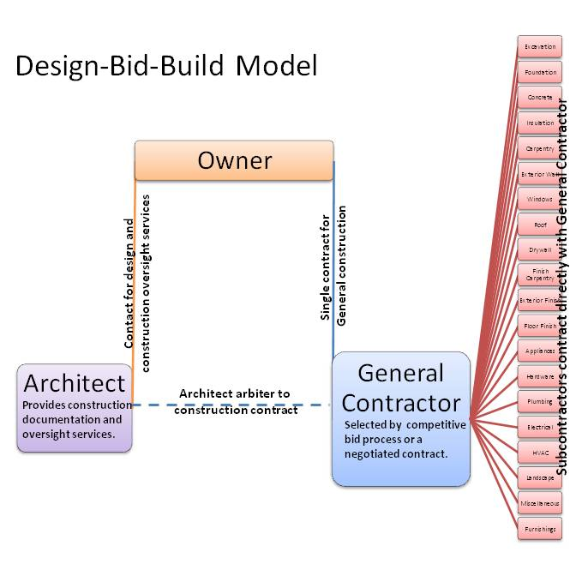
the project being constructed on time and within the bid or negotiated price and is therefore deemed to be entitled to, though not guaranteed a profit from his commitment. This used to be the prevailing and accepted model, but it is now far from being responsive enough or even best suited to the practical realities involved in dealing with the driving issues of quality, cost and time. The obvious and underlying flaw in this arrangement is that it normally allows no timely opportunity for key subcontractors to make experienced contributions to the design effort.
This is because using this model, until the design is complete, prospective bidders cannot be given a detailed set of plans and specs to bid on. With no position on the team until the GC or prime contractor is appointed and the contract price set, subcontractors and suppliers have no incentive to approach the owner or architect to suggest possible cost savings. Quite the contrary.
Consequently, more often than not, bids come in over the Owners’ budget, subsequently requiring a reduction in the projects scope, quality or both. Either way, substantial revisions to the documents are therefore required of the Architect, often at his expense and time. After construction starts, there is then the matter of the inevitable change orders and their schedule and cost impacts on the budget. Cost overruns resulting from contractor claims on construction projects have thus become a matter of folk lore.
In today’s competitive environment it can certainly be demonstrated that the need to control the cost of construction and its completion schedule, together with advancements in scheduling, organization and management philosophy, are ill served in the prevailing Design-Bid-Build model, where design and construction are handled as two separate and independent activities - and by different companies on sequential time lines. In response, this began to change with the concept of the Design-Build model introduced by more ambitious, progressive and service oriented construction companies.

(4) DESIGN - BUILD COMPANIES
In the US the introduction of Design - Build Companies more than fifty years ago can be regarded as a free market response to these problems and a turning point in the emerging power struggle between Architects and GCs for the Owners’ perception of authority and leadership in the construction industry. Architects could not answer the Owners’ critical questions on cost and schedule effectively, so they naturally turned to the GCs who had better positioned themselves to not only address, but often guarantee price and timely delivery of their projects.
This they were able to do by virtue of their superior financial clout, acquired relationship and experience with the trades, and by objectively controlling the design. These design - build companies were usually construction companies which seized the initiative and elevated their service to include design. As such they have been able to succeed at the expense of Architects who they typically now employed.
More recently design professionals and engineers have teamed up or partnered with contractors to form Design - Build companies which in addition to better addressing quality, cost and time issues, also represented to the owner an appealing one stop shop with single point contact and centralized responsibility.
The advantages of design - build are an easy sell and rhetoric is of course, very cheap. Backing it up is a whole different matter, calling into question the true level of commitment on the part of most builders given their typically limited capabilities and investment in study of the issues involved. There are of course exceptions to this general rule and as things stand, by no means do architects have the reputation or as yet even the aspiration to be contenders for first place.
In this Design - Build model, if control in this business is the operative issue then
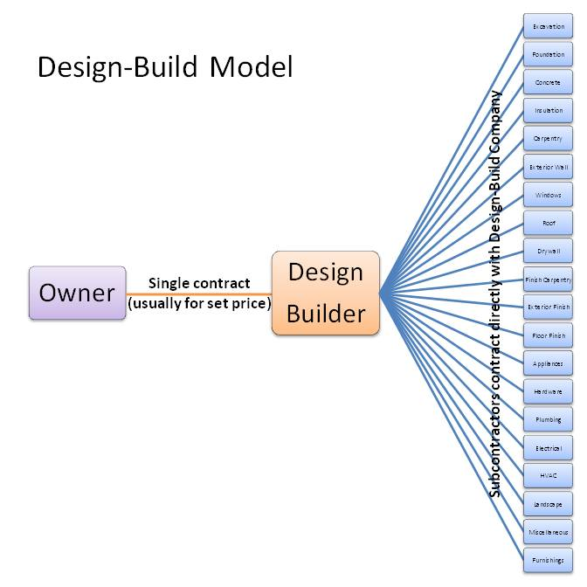
that is still firmly in the hands of the Builder. Remember he who has the gold calls the shots and if a builder takes on a partner in the form of an architect it is because he is astute enough to realize that this will enhance his marketability and appeal by doing so. He typically makes much more in mere profit than architects normally make in fees, aside from the earnings he makes on those items of the project he directly performs. So architects can rarely expect to be anything more than” junior,” in all aspects of the partnership and its share holding. This is definitely not where we want to be.
Until 1979 the AIA prohibited members from providing construction related services, but as previously noted, owing to overwhelming market demand and anti- trust legislation, Design-Build services were effectively endorsed with its new user friendly “Guide to Design-Build Services”, on the part of design professionals. The practical distinction between these offerings and those of the integrated Professional Design/CM approach endorsed by the AIA is referenced below and has to do mostly with client expectations and the level of client involvement and control in deciding on issues of design, costs, schedule - and even company profits. In legal terms, conflict of interest issues avoided in the professional CM model for consultant architects, continue to make this the more preferred and personally endorsed option. Much more on this later.
Design - Build Contracts are particularly popular with government agencies and other corporate type entities with large multiple repeat project requirements. These save costs by feeding the buying power of vertical and horizontal contract negotiations. In selling their turn-key services Design-Build companies have been most successful in the US on a diverse range of building types ranging from simple warehousing projects, to other highly complex and technologically demanding building types like hospitals.
Here the construction team is responsible for taking a broad concept, together with fully developed performance specs produced by the owner, and completing the detailed design in house, often using a known, programmable and efficient, time tested
building program in an effort to save time and cost.
When these companies also serve as an outlet for proprietary pre-engineered type building systems, they are best suited to the merits of this option because of the historical cost data immediately available for closely similar projects nationwide. Otherwise they simply establish their own reliable cost guidelines staying within the owners declared budget.
Some design/ build companies specialize exclusively in particular building types such as hospitals, and draw directly on their resident in house professionals who have all the relevant expert design and engineering experience. They are most effective and very profitable by knowing exactly how to contain costs using proven design and construction yardsticks, together with their own construction management history. When up against this kind of experienced competition, architects working within a conventional design, bid, build model are absolutely no match and can be made to look way off track.
As part of their marketing strategy these specialists will seek out and monitor projects in the charge of architects which have stalled at the bidding stage owing to inevitable overruns on time and budget. They are then in a strong opportunistic and commanding position to quickly rescue and take over the project by knowing exactly what their costs are, and by offering the owners guarantees on cost and schedule, in-spite of building huge profits into their fixed price contracts.
To meet these commitments they will also take full advantage of phased construction on a’ fast track’ schedule. Here, the project is divided up into separate construction contracts. Working drawings and specifications are completed in house for each contract as it appears on the critical path, and construction begins as soon as contracts on that portion of the work are bid. Construction can therefore begin well in advance of a completed design (fast track). This accelerates schedules and reduces the
potential impact of inflation. Of course, the multiple contract nature of fast track requires a greater level of coordination, but this is inherently more feasible since continuous management is an important part of the design-build philosophy and is applied from the start of the project.
The level of sophistication of the fast track schedules adopted, will vary with the level of commitment on the part of the design-builder and the scale, cost and degree of complexity of the project. A disadvantage of the design-build model when applied to an unfamiliar building type is the lack of a fixed price, though it is fair to say that the shorter schedule and other enhanced design benefits of this more flexible model are superior in potential cost savings to that of the design-bid-build approach. When critical to the owner, and it always is, the design-builder will set a comfortable “not to exceed price” which is written into his contract.
Knowing the margin he wants to make, he will steer the owner towards material and other options within preset budget parameters which are incorporated into the terms of his bid. In this context contractors therefore often bid by square footage costs, plus a percentage profit margin, and contract by cost-plus agreements tied to whatever actual costs are incurred, regardless of projected costs. Here the main advantage to the owner is speed of construction which begins almost immediately with site preparation or demolition at the signing of the contract and continues with the ability to overlap design and construction functions.
Another significant advantage over the design-bid - build model with its separate and sequential roles for architect and builder, is the reduced potential for conflict resulting from the integration of these two efforts into a common purpose projected by the single contract of the design-builder. This much it has in common with the professional CM services by Architects with one most significant difference. More on this later.
Incidentally, and as an aside, it is important to understand that an early construction start date, a significant benefit of the design-build and Professional CM models, is especially welcome and most important to the owner because it also represents the point at which he can start to draw bank funds from the construction loan proceeds. Up to this point, the Owner has been using his own or corporate funds assigned to the project, and these have typically all but run out by now. Of course, as also in the traditional model, this can in turn positively affect the timing of payments to the Architect and his engineering specialists, whose extended goodwill is also wearing thin at this totally engaged point in time.
An early construction start date also means the project will be placed into service and will be able to generate sales, rental or retail income sooner rather than later. From the Owner’s standpoint, given that the construction loan interest begins to accrue upon the withdrawal of the first construction draw, the sooner the project begins to pay for itself, the better.

(5) CURRENT PERSPECTIVE-ADVENT OF THE CONSTRUCTION PROJECT MANAGER
In both the US and the UK, to fill these voids identified in the conventional process by more objective and astute owners, another alternate model which is rapidly gaining ground on large or complex projects, replaces the two traditional contracts with three, adding the construction project manager (CPM) as agent to the owner. He is typically more of a strategic thinker and by virtue of his broad knowledge and experience in the development industry, well versed in the merits, application and relative costs of alternative building systems and technologies.
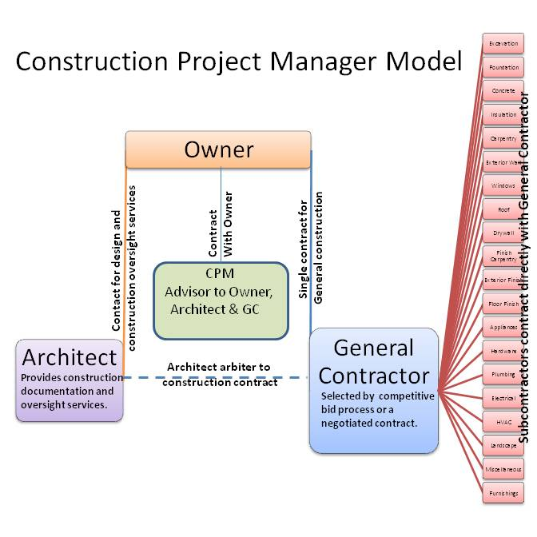
So compromised has the image and role of the architect become, that some owners now feel they need to appoint a CPM to basically protect themselves from the excesses of both the architect and the GC. Obviously they have this backwards and this is another measure of how far off-track the role of the architect has been derailed. Here the CPM is paid a professional fee for his service and acts primarily as the owners’ agent, and adviser to owner, architect and contractor. As in the two previous models, it is important to note that the builder typically continues to assume the liability for the construction, - not the owner.
With regard to the ‘professional liability’ assumed by the Construction Manager, this depends on the defined role he plays and the nature of the relationship and responsibility he has with the owner at both the preconstruction and construction phases of the project. When the construction management is fee based and the responsibility is exclusively to the owner and acts only in the owners interest through all stages of the project’s design and construction, it is termed ‘Agency CM’ Here as implied, the CM is the owners exclusive agent.
When the service requires a commitment by the CM to deliver the project within a Guaranteed Maximum Price (GMP) it becomes ‘CM At Risk,’ which as again implied, considerably increases his exposure. Here in the preconstruction phase, the CM is a consultant to the owner and all players involved in the evolution of the design and its proposed budget. But upon completing this phase and establishing the GMP that relationship understandably changes in the construction phase, as his obligations now dictate, and in effect become more like that of a GC.
To satisfy the specific terms of his Professional Liability insurance agreement, when the architect performs the CM role as an extension of his design service it must be within the strict definition of ‘Agency’ CM so that this will not increase the cost of his
premium. In expediting construction progress he must specifically never be seen to be directing field activities, site safety or ways and means of sub-contractors. These are the direct responsibilities of the subcontractors and the project superintendent who have contracts with the owner. As Owner’s representatives, they are contracted to and paid for directly by the Owner.
In another context the CPM, who can also be an in-house employee of the corporation proposing the development, is responsible for taking a concept developed by the owner and expediting its completion in detail through all the many players involved in its delivery, including the architect and approving authorities. He will often determine and recommend to the owner the appropriate awarding method, contract system and type of contracts for each player,- an exercise in common with the role traditionally performed by the architect.
What is most relevant to our inquiry here is that upon review of the role of the construction project manager often associated with these typically substantial contracts, one finds almost a complete overlap with the secondary, non design roles originally performed by the architect. Understandably, the ensuing competition between these two parties has resulted in a serious loss of professional turf for the architect, as his compromised leadership role has been delegated to the CPM and other specialists in the team.
The unavoidable question again is; Has this development resulted from the architects inability or unwillingness to take more positive control of the relevant issues, or has the growing complexity and demands of the industry made this inevitable? Let us for the sake of the argument developed so far, give the architect the benefit of the doubt, and allow this to remain an open question.
Undeniable is that cost and schedule control, both in the UK and USA, has not
been a priority by architects in terms of their commitment and resources willingly applied. Indeed, cost over-runs in state sponsored projects everywhere, have assumed scandalous proportions, which raises the unavoidable and serious question of the collective professional competence of the industry as a whole.
In the UK, the related tasks have clearly far outgrown the normal scope of capabilities expected of the QS, upon whom architects have traditionally relied for “cost planning and accounting.” These fall far short of the broader and more fundamental role and goals of “cost control” and must include much more emphasis on value engineering and procurement negotiation to be more effective.
In the USA where there is no QS, cost control has relied mostly on the not to be underestimated competitive forces of the free market place at the bidding stage, and on the introduction of design-build companies, together with other rhetorically similar if not opportunistic models which quickly filled the voids neglected by a complacent professional establishment. Ultimately there truly is no substitute for the competitive bidding process as we shall further discuss under (7) Practical Cost Saving Advantages of CM.
There are also reputable construction companies which have capitalized on these
weaknesses in the prevailing design-bid-build model by adopting the standard policy of bidding most competitively to win the job, and who then set about exploiting every revision, omission, ambiguity or deviation of any kind from the construction bid documents, to insure a very tidy profit through claims resulting from unavoidable change orders.
Needless to say this does not bode well for the owner, his budget, or indeed the architect who becomes the usual target of blame. Generally speaking, it would not be unfair to repeat that the architectural community has not yet fully embraced the challenge posed by these issues to the full satisfaction of the owner. Obviously the prevailing system is ill-suited to the task. Hence the arrival on the scene of the CPM and
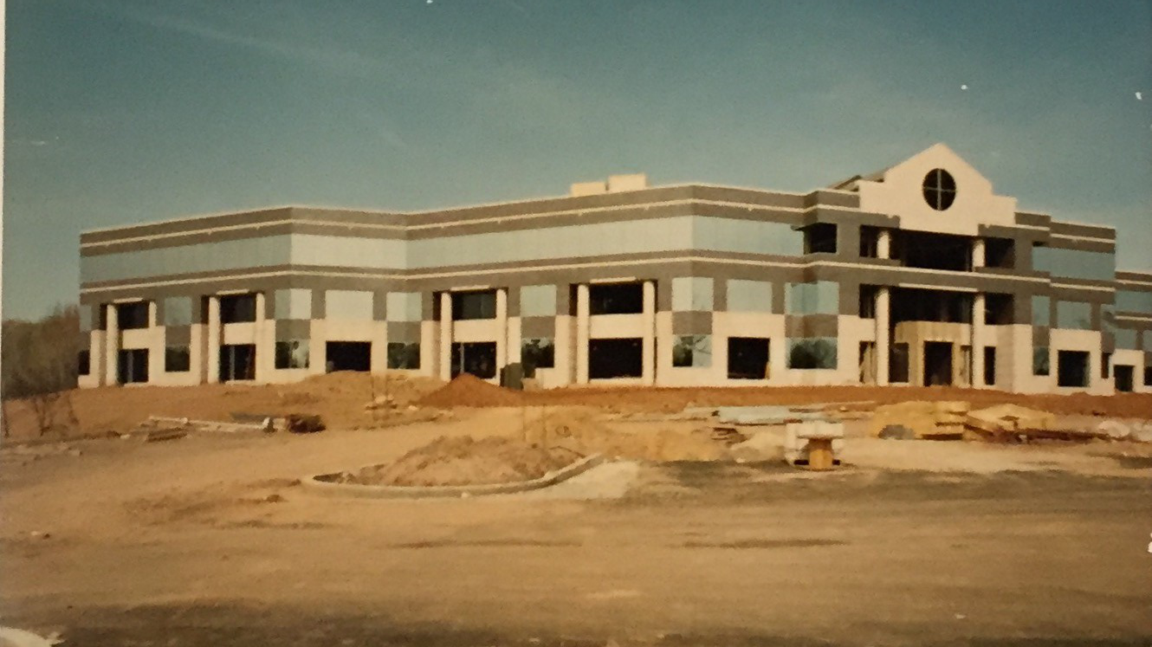
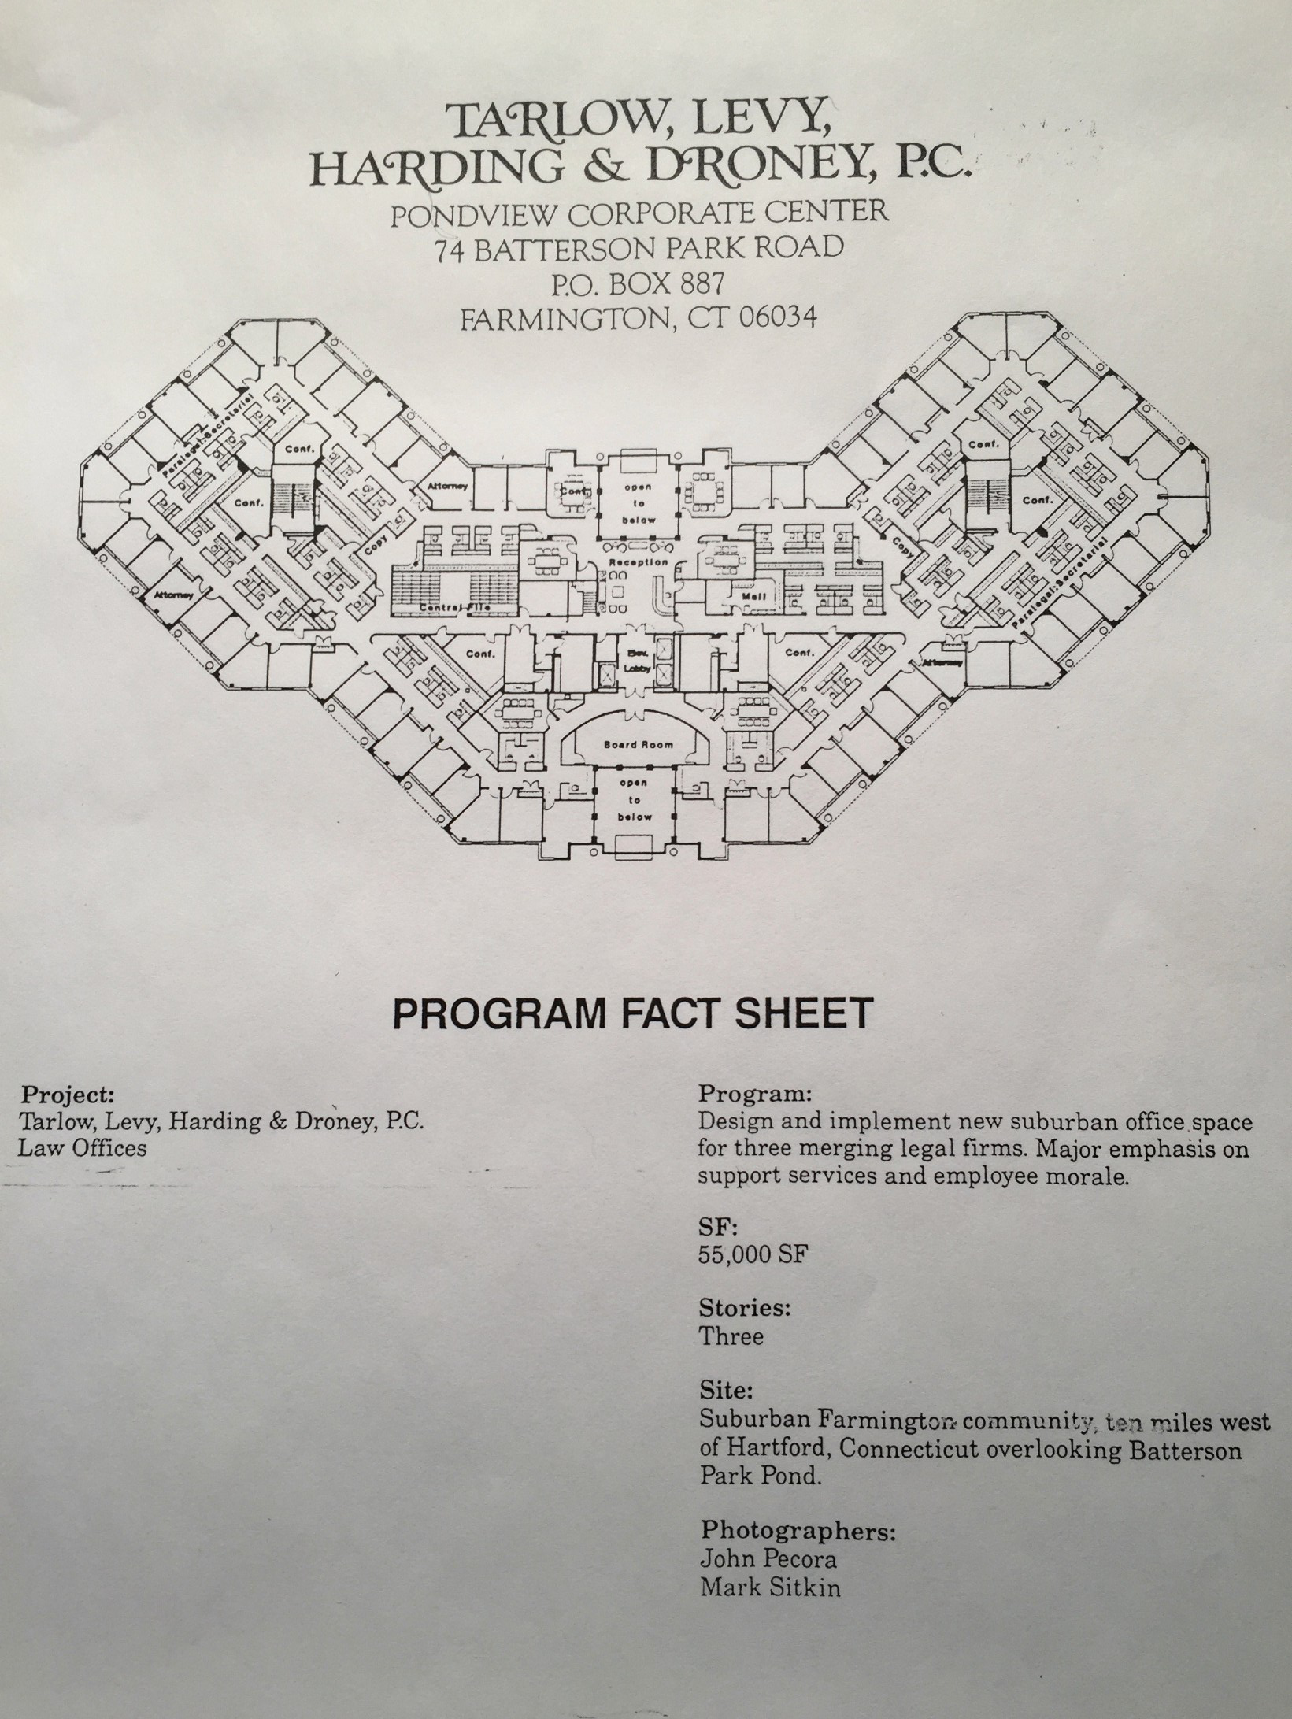
LAW OFFICES. TARLOW, LEVY, HARDING & DRONEY, P.C. FARMINGTON, CONNECTICUT
The Design/ CM model - a perfect application for a new 55,000 sq. ft. 3 story suburban office space for three merging law firms with major emphasis on support services and employee morale.
other alternative models such as design-build, both of which by-pass and usurp the architect’s leadership.
For the Architect, if he is to regain his leadership and authority, the radical solution surely lies in his taking back control by combining the lead roles of design and construction management. And why not. Surely we are at least the equal to these imitators with little skin in the game who apparently feel so entitled. At the very least they should be working for architects, not the other way around.
A case in point is the project illustrated prior page where we were architects/interior designers , construction managers and project managers to boot. The owners looked to us for guidance from inception to completion on a 55,000 sq ft, 3 storey, interior tenant finish project which was to accommodate the consolidation of three separate law firms.
Most critical was the limit placed on the budget together with the need to have all systems up and running on the very first day of move-in. The combined billables for the three law firms amounted to tens of thousands per day and so there was no tolerance for failure to meet this objective. On the friday all employees were to leave their office and by the monday resume work at the new office with all voice and data systems up and running. Only with the authority, flexibility and above all the control which comes from wearing all three hats could this be achieved. Incidentally our professional fees for these comprehensive services were 21 per-cent of construction costs.
Restaurants are another building type which are served exceedingly well by a one stop shop for comprehensive services because they can be customised to fit a variety of business models where quality, cost and time are determinants in their success. It used to be said that when you design a hotel you are really designing a business. On a broader note this can be said of any building type, given that the vast majority carry considerable loans which come with monthly debt service agreements.

(6) INTEGRATED PROFESSIONAL DESIGN & C M.MODEL
Apart from this question of the architect’s leadership, whatever the evolution of the circumstances and rationale for the status quo, another unintended consequence of this role separation is to have critically undermined the use and development of ‘all’ the architects’ potential resources and capabilities, let alone the integrity of the essential design-construct process. It is as though we handicap ourselves by choosing to utilize only half the potential management and service tools at our disposal. As the saying goes, when all you have in your tool box is a hammer, everything looks like a nail. So instead of a horse we potentially, and usually end up getting the proverbial camel,- whether we know it or not!!
So aside from dramatically improving his business model, the major benefits to the architect of assuming the construction management role have to do much more with the flexibility and agility which this overall level of direct control provides him throughout the whole process. With respect to the interaction of the three constant variables of design, cost and schedule, when the architect has the freedom to juggle each, any or all of these, he can usually, if not always meet the challenge presented by any issue, whether proposed by the owner, a subcontractor, or the evolving needs of the project.
By virtue of his hard earned qualification no other player can claim access to all the combined forces of imagination, talent, training and knowledge to fully serve this critical catalytic and creative role. By no means does this mean to suggest that the architect will always be the best problem solver. But as a worthy leader, his team united under one professional, collaborative agenda will always meet the challenge.
This is by far the overriding positive feature of the proposed new business model which trumps all others. This vital ability to facilitate a change of course in
solving a problem without having to deal with all the usual time consuming and counter-productive procedures and costs normally associated with the conventional triangular format is what makes this linear model so superior and so compatible with the needs of our time.
It is important to note that this is not a problem unique to the construction industry. It is in fact one which has, in this space age era, presented itself in many old and new industries involving a custom design and production effort, and particularly those in the dynamic and diverse high tech industries from whom we should certainly take some helpful leads.
The most significant point here is that almost without exception there is no separation in responsibility between the design and production teams. The same company is, without any reservation, contracted for both. How else can you possibly retain the flexibility required to respond to changes in priority which are often revealed, only as a result of pursuing the evolution of a design as it progresses down the time-line?
In addition, clearly the conventional model with its role separation, is by its very nature and in practical terms, divisive and predisposed to abuse, inefficiency, confrontation, and ultimately much of the potential for litigation we see emanating from the construction industry. Indeed, when the stakes are high enough, yet another player, a Mediator/Arbiter is now pre-assigned to a project to head off and resolve conflicts in a non adversarial process, before they result in costly and debilitating litigation. It should be very obvious that we have clearly arrived at the point where the tail is now wagging the dog.
What is most revealing in this context is that in my experience, many of these potential conflict issues effectively diminish when the architect undertakes the
construction management service. First and foremost he and his team works in the owners exclusive interest, not just on design issues but also those relating to construction, its cost and schedule. Within this paradigm the dynamics change dramatically, as there is only one common team agenda, under one professional leadership, instead of the traditional model of the two headed monster embodied in separate design and construction agendas.
The practical and other cost benefits of this linear versus triangular chain of command on a projects outcome is obvious and refreshingly eye opening on many levels. In retrospect we appear to have indulged in the ultimate folly of having traded the time tested, straight forward and direct model, for one more complicated, problematic and arguably far less successful. Bravo!
In the Architects’ prevailing model, Owners are basically asked to choose any two of the three performance attributes of: GOOD, FAST and CHEAP. In adopting the Professional Design/CM model the architect can offer all of the above and in the process take back that critical control of his business while giving the owner better, more comprehensive service and value. More-over, it not only more than doubles the income stream of his business for the same marketing effort, but is the key to out-performing the new competitors in first soliciting the job.
Where as a profession we dropped the ball here, is in having allowed the general contractor to be the first to seize the initiative and advantage of combining the two services. Ironically the people we mistakenly delegated the construction management to, now want to take over control of the design too. In retrospect our cause would have been better served and more timely, if this move was collectively embraced, instead of rejected by architects. Better still we should never have given up this natural role extension in the first place.
The classic, intellectually appealing arguments you typically hear from a self serving establishment in defense of upholding the conventional relationships can, far more convincingly, be turned on their heads. The road to hell would indeed seem to be paved with good intentions.
Here the unfortunate consequences of separating the two services, all be it driven by presumably positive motives, must be called into question. Given the profound changes in the industry which have resulted from the transition from a craft or trade based industry to an industrial/ factory based mode of production, there surely was less and not more reason to delegate such a critical and demanding role to a third party. But as the expression goes: “Better late than never”!! What’s more, we now have the high-tech tools to take us to this higher level of performance and comprehensive service.
Traditional specification narratives such as ‘in a workmanlike manner’ have long since been replaced with equally generic directives now typically expressed directly on the drawing requiring that products and equipment, ‘shall comply with all relevant building codes and standards’ and that installation shall be, ‘in ’accordance with manufacturers instructions’. Together with an increasing use of performance, as opposed to proprietary specifications, this places the burden of performance squarely and rightly on the shoulders of the specialist suppliers of materials and labor. Traditional craftsmanship in the field has thus been largely replaced with quality control in the factory, and product warranty guarantees performance.
Here, it should be noted that as it relates to the integration of CM. with building design services, “performance” is, on a more primary level, also key in transforming design methodology. In adopting CM as an extension of the Architect’s conventional role, clearly defining ‘a project’s performance’, both functional and economic, is a necessary starting point driving his approach to both a project’s design and its delivery. Architectural style as it evolves should be first a derivative of performance, not its straight
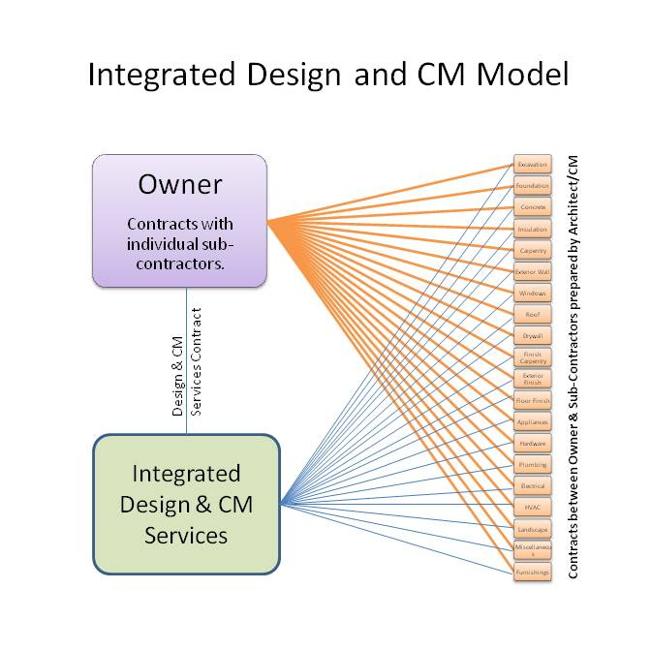
jacket. Castlewood library (page 81) with its semi-circular and semi-earth sheltered design is a case in point where a low building and operating budget inspired a radical departure from the conventional. Who, more than it’s designer, will ever be more motivated and committed to all aspects of the practical realization of an inovative work product? It is certainly not a third party.
On both sides of the Atlantic, there is now no product, material or item of equipment which does not have state approved codes, standards or regulations governing its acceptance. Whether a material item or its’ installation is defective, is an easier determination to resolve and correct by the responsible party than the more subjective assessments required in the past. These developments are also positive in creating a clear line of responsibility for all building components and their installation. In reducing the potential for serious dispute or arbitration, for the architect they further validate combining the roles of design with CM.
In the end the best interest of the client is the only interest to be considered in the delivery of the architects’ service. Is that not the essential role of a true professional? Who the effective winners and losers of these past misguided actions really are, can only be assessed on the basis of their outcomes and effective results which, for the current condition of the profession as a whole, leaves so much to be desired.
The exact distinction between the architects professional design and construction management model, and that of a design / build company is one which needs clarification to clients who will pose that question. First and foremost one is providing ‘consulting services’ on a fee basis, all of which are offered in the owners exclusive interest. In contrast, design / build companies are essentially selling the owner a building, the production of which is geared to the builders in house business agenda and which ultimately includes a healthy profit margin. So for the architect, here the
builder is as much the client as the owner.
In contrast, as a consultant architect providing CM services and working on a professional fee basis, there is no incentive to make a profit on the building. He places his knowledge and experience solely in the owners financial interest and that of the project. To repeat; the best interest of the client is the only interest to be considered. There is no other agenda. In contrast the builder in partnership with his architect uses the same to benefit his own bottom line by improving the quality of his product. For the builder, in keeping with normal business conforms and aspirations, the lower the cost, the higher the price, the bigger the profit, and therefore the healthier his business.
This does not mean to cast the business minded design/ build companies in a negative light. On the contrary, they should be commended for their initiative in responding to the same challenge from within a different context. They have succeeded with the architects help in elevating standards in a way which we failed as a profession to accomplish on our own initiative.
There is however a very real and defining difference in declared context and motivation between the two models. From the buyers’ point of view, for a given application, if there is a choice, it basically comes down to which model for a given objective commands the most trust. Some owners will invariably opt for the design/build model if only because the alternative requires a certain leap of faith which our current reputation fails to merit.
It should also be asserted that usually, none of the critical C M advantages of value engineering, flexibility and agility come with the design/ build model where these attributes are from the builders more limited perspective inherently incompatible with his bottom line. But ultimately, for the architect it comes down to how he represents himself. If he is part owner of a D/B business which like any other will only survive if it’s
products make a profit, then the buyer has only to decide if for him, that product is worth the firm asking price.
If on the other hand the architect is contracted to act as the buyers’ agent in a professional consulting capacity, then he owes him his direct and uncompromising honesty, loyalty and integrity in carrying out those contractual duties. This will sometimes require that at the outset, a prospective client be referred to an architect who is better equipped to provide the kind of cost and schedule guaranties often required by his lender. Clearly we know what we need to do to avoid being in this position.
Notwithstanding all the above benefits and explanations, by far the most rewarding to the Architect in living up to his true potential, CM will improve not only his control of the process but also the performance of the product of his services. When architects develop the confidence in their own ability to control and deliver their projects on time and on budget, the courage to inovate and break with inherited, tired and out-moded building stereotypes will fuel a greater commitment to performance driven design.
The Architect will thereby place himself in the unusual position to hire the expertise required to address the performance he wants - just as in any other product delivery program. And here, we are not confining ourselves to simply the nuts and bolts aspects of design, but more critically, to the more subjective aspects of its conceptual planning. Research by our universities in every conceivable related aspect of architectural related study is now available which never sees the light of day because architects who value its importance and implementation the most, are not always “in control” of the decision making and value judgments.
Thanks to a new generation of architects/social scientists, even the limited application of this research, mostly in Europe, has successfully demonstrated that new
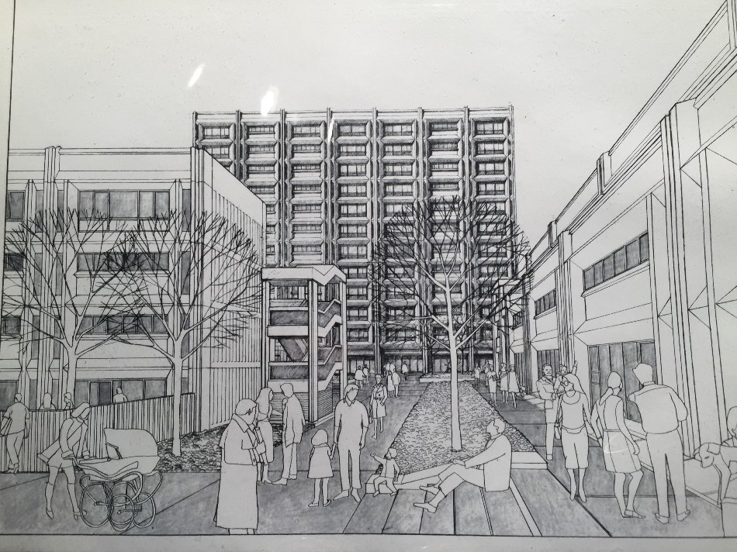
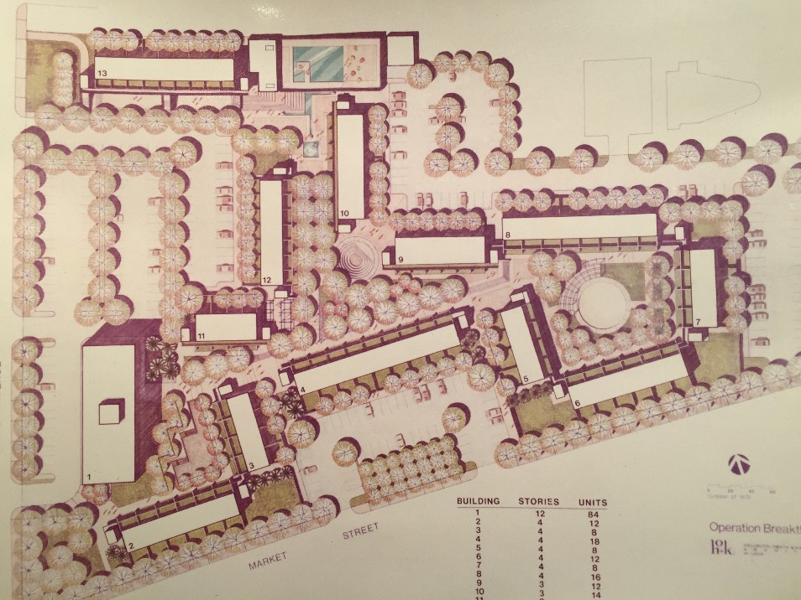
approaches to the planing and design of primary building types such as housing, offices, schools and hospitals, can be fundamental in resolving not only the practical, but also the psychological, comfort and mental well-being of the community they serve.
‘OPERATION BREAKTHROUGH.’ LOW INCOME HOUSING PROJECT. ST. LOUIS MISSOURI. Special design criteria for this Federally subsidized low/medium rise project as established by H.U.D. and N.B.S. were further developed by the design team and applied to space standards, fire rating, sound control and critical economic yardsticks. Architectural problems related mostly to meeting the particular requirements of the “WATES”precast concrete housing system for efficient production, while site planning problems derived largely from the high density nature of the need for large areas of parking within direct access to the 250 units served.
In this 1972 low income housing project the development of packaged kitchen and bathroom modules applicable to crane lifted construction was also a major design exercise where critical involvement of manufacturers and their installers was vital to the cost effectiveness of the end product. In terms of the business model the in-house architects worked directly for the Wates Construction Company in what would today be classified as a Design / Build organization. This model has proved itself successful in controlling quality, cost and scheduling issues. It does however place the architect in more of a subservient rather than leadership role .

(7) PRACTICAL COST SAVING ADVANTAGES OF THE PROFESSIONAL CM MODEL
In the traditional design-bid-build approach each general contractor bidding on the project has a set of subcontractors who will assist him in his bid effort by giving him their lowest price. On bid day one would typically expect to find that each GC had some low and some high prices. None has the low subset. Alternatively, when construction management is an integral part of the “architects” comprehensive service, , as opposed to the general contracting approach, design and construction become a single process under a common leadership.
In this format, at the outset of the project, key contributors to the design effort, be they engineering specialists or trade contractors, are invited to participate collectively at the beginning of the design process and only after a preliminary exploratory screening of individual players in each trade best suited to the specific scope of the project.
At the point of bidding, each trade contract is bid or negotiated individually, allowing the owner to pick the lowest qualified bidder and get the lowest subset of contracts. When each price is broken out trade contract by trade contract and compared against an estimate in the construction budget, any unreasonable price clearly shows up and can be re-bid competitively without any detriment to time and progress. In addition, experience has shown that when a subcontractor is bidding against his competition and bidding directly to the owner, bids will be lower than they would be to a general contractor.
The Owner thereby pays the actual cost of the project not the price of the winning bid, and the potential savings here are extraordinary. In return for this over- riding benefit, as there is no general contractor, the Owner is required to insure for the project’s construction liability, working through his professional design and construction
management team who already carry professional liability insurance for the performance
of those services.
With regard to the impact of C M on the architect’s liability, it is important to note that in the U.S. almost 50% of all claims of all types result from last minute changes and substitutions. Approximately 50% of claims regarding construction failures pertain to roofing, about 30% to exterior walls and fenestration, including below grade waterproofing and 10% to site work and drainage. I am convinced that more attention to installation compliance with manufacturers details and relevant codes in the field through the practice of professional construction management services provided by the Architect’s team, is a key to reducing these statistics.
One reason for this is that insurance companies have long since been aware that any time you can consolidate rather than fragment control and responsibility for design and construction management, the lower the risk. A case in point is the recent BP disaster in the Gulf of Mexico where no one seemed to accept ultimate responsibility for anything, which is why there was a problem in the first place. It makes perfect sense that when architects are more involved and get to spend more meaningful time on their projects both in the field and at the planning stage, the risks of ‘mistakes’ going unnoticed and transforming themselves into serious ‘errors’ are considerably diminished. In my practice I saw no increase in professional liability premiums upon combining CM (that is Agency CM) with design services.
With regard to the total cost of liability coverage for construction, in the conventional process the general contractor is usually asked to provide a performance and payment bond, the cost of which is passed on to the owner. By the same token the subs are also bonded, so that there is effectively a duplication of related insurance cost to the project. When the combined design and construction management service approach is taken, there is only one layer of bonding. Contracts are between the owner and trade contractors. Since there is no general contractor, there is no double
bonding and no cost redundancy. With the additional advantages of fast track and continuous management applied from the start of the project, the key issues are therefore addressed directly by the architect’s team. Treated this way, and with everyone on board with the goals of the project, cost and schedule implications can be evaluated by the architects’ team before the design is set, thereby preventing the usual costly budget overruns and schedule delays. “Value engineering,” the exercise of determining the comparative cost/schedule benefits of alternative systems of construction (or as I prefer to call it cost/benefit analysis) thereby becomes a true design function instead of remedial work.
In addition should design priorities, the construction environment or client goals change, new forces can be implemented with little disruption to the flow of the project. With a view of all the pieces that make up the project, the application of all the resources derived from construction management, particularly with its inherent potential for flexibility, allows a project to be put together in a variety of ways and overcomes the rigidity and above referenced pitfalls of the general contracting approach.
In keeping with these aspirations, for the architect and his CM team the use of Cad and other high tech programs now facilitates the inevitable changes at both conceptual and detail stages throughout a project’s development. Adopting this proposed model thereby expedites maximum early communication, and with it, the best prospects for increased design quality, reduced costs and faster schedules.
Moreover, as previously stated, when there is one clear lineal chain of command and a common team agenda, the potential for conflict is considerably diminished. In deed this benefit all on its own is again sufficient justification for architects to adopt the construction management model, aside from all its other profound and positive impacts on the business dynamics of their own practice.

(8) THE CRITICAL ROLE OF THE OWNER
As an aside, with regard to the all important mind-set of the “owners,” who must in the first place be persuaded to above all, invest their trust, they come in a variety of temperaments and personalities, some more confident than others. They also know how to assert themselves with self serving pronouncements like the ‘Golden Rule’. Golden rule! you may well ask. What is that? He who has the gold makes the rules, comes the smug reply. Indeed at their worst, some have the power to destroy small offices if the proper precautions and safeguards are not taken. On the other hand the more successful tend to be very impressive, personable and accomplished business men with less fragile egos and good leadership qualities.
In any event, the need for credit reports and references are essential of both clients and indeed contractors. Be aware of sharks and sharp practices. These include minimum fees, no up-front fee, little or no timely payments and often, no final payment. In this regard a firm policy of ‘No Pay, No Drawings’, is a safe bet against this most common abuse of the architect’s goodwill. That should be the architects’ golden rule.
The worst and most common errors by architects with respect to owners are inadequate fees, slow payments and carrying the owner’s debt. Architects are also by nature, prone to pay minimal attention to book keeping and tax planning. Early success and over-expansion is another tendency which fails to recognize the cyclical nature of the business and which can effectively compromises the architects negotiating and survival abilities.
It is also important to realize that be they corporate or individual, owners are not always looking for a monument. Generally speaking, they fit predominantly into the
personality type of the “driver”,(as opposed to the amiable, analytic or expressive). They are typically very objective, goal oriented, bottom line based decision makers, responsive to facts and figures, which when adequately presented, facilitates their quick and decisive action. As such, striking the right notes with owners on how you propose to accomplish THEIR goals is what they most want to hear.
So, while design aspirations are of definite interest and might well have been the owners’ initial source of attraction to the architectural firm, they are not necessarily a preoccupation at the outset of the project. At this preliminary stage, owners are usually looking more for assurance that the whole team is totally on board with the business objectives of his project, and these have much more to do with cost and schedule. The Architect’s ability to identity with and commit to these objectives is therefore paramount and critical to his success in first securing the contract for professional services. Combining design with CM services is therefore a huge advantage.
Remember also that beauty and function mean little to lenders, the other important players in the development program. They look strictly at numbers relating to hard and soft costs, and returns on investment, all of which need to be tied down. (See Part 2, page 109.) A lender will typically lend 70%-80% of the appraised value of a project including land and building. His confidence in the owner’s team to deliver the project within the stated goals is paramount.
In the project feasibility equation therefore, realization that the cost benefits of early scheduling are as great a determinant of ultimate bottom line savings as those derived from simple unit cost impacts, is a driving force on the Owners’ time-line and is further fueling the perceived need for involvement of the construction project manager as the key player acting on the Owner’s behalf. The larger question posed again by these developments is; Where does this place the architect in terms of his traditional leadership role, if the CPM effectively assumes that critical overview position?
On an equally important matter, nothing will affect the morale and positive outcome of any project, as the integrity and goodwill, or lack thereof, projected by the owner. This is particularly true when the time-line aspirations of a project are especially high and team motivation is critical. For positive results, here, more than anything else, prompt payment for services rendered becomes an important consideration and this must be made clear to the owner at the outset. We live in a mundane world of obligations to payments on debts, and nothing says thank-you better for an on-going job well done than a prompt check.
However, because the amount of money involved in any project is considerable, every day an owner can hang on to it, means interest earned versus interest paid. He will therefore often be motivated to drag out the time-line for payment. But this tactic cuts both ways, and contractors will simply add this interest to their cost of doing business at a higher interest rate than the usually lower rate of the Owner’s construction loan. The net effect is that the cost of the project to the Owner will go up not down. Not surprisingly, to some self absorbed owners who see themselves at the center of the universe, (another common trait in the mind-set of some Owners,) this is apparently a revelation.
The role and involvement of the Owner does of course change when the nature and scope of the Owner’s relationship with the key players change, but especially when the architect becomes the owners ally on all matters of quality, cost and schedule. Owner participation in the evolution of the design, at all stages of its production is essential and very desirable if he is to be in tune and satisfied with all the workings of its end product.
Equally important is the avoidance of a feeling on the owner’s part that critical decisions affecting quality, cost and schedule are being made without his involvement and approval. One of the primary benefits therefore, of the combined design/cm services model is that it will generate many choices at every level which only a well informed
owner can make. He inevitably gets to be a vital component of the decision making team, thus facilitating the efficient progress of the project’s development and timely communication.
Given that good communication is key to avoiding misunderstanding, this has to be a primary reason why the combined design/cm model with its linear relationship between owner and architect is much less problematic, more efficient and far less vulnerable to the usual source of claims arising out of the tri-party design-bid-build model.

(9) THE TIMELY IMPACT OF COMPUTERIZATION.
To quote: “From inception to completion of building projects, computerization has afforded us the means with which to meet the information management challenge presented by even the smallest project. It has assisted in the creative process by facilitating the trial and error of numerous ideas, their interaction, storage, modification, 3-D modeling, visualization and networking. It facilitates the rapid testing against basic design criteria for cost yardsticks, energy efficiency, aspect and prospect etc., It has also made it possible for small firms to compete with large firms pitting talent against talent .”
It has also transformed the delivery process and the relationships involved in the architects services and all players in the development business. In particular the timely evaluation of design alternatives is invaluable with regard to value engineering and the construction decision making process.
Sophisticated, goal oriented project and construction management programs now abound which together with the time-saving practical advantages of cad and the use of the personal computer, have set the stage for architects to more readily reclaim the
role of construction management and as we have seen, thereby regain the timely control required of all three determinants of a project’s success i.e., quality, cost and schedule.
High technology has of course transformed the practice and integration of construction management. Even pick-up trucks have a factory installed module for PC, fax, modem and cell phone. All players are continuously connected at all times so that construction details can be field modified and instantly updated and recorded . Computerized cost control and critical path systems are also key to keeping project teams and their cost /schedule targets on track. So, to be successful these new technologies and programs need to be mastered.
The use of Building Information Modeling (BIM) and 3-D Visualization with its benefits over 2-dimensional CAD drawings, are now well established as design, engineering and construction management tools. Increasingly these are expediting project delivery by shortening construction schedules and reducing the need for change orders. By simulating designs before their construction, whether applied to contractibility, energy use, cost, maintenance or even comfort, it is enhancing communication between all players which is key to the success of any project.
Once again a greater commitment to CM on the part of architects will be an important key to facilitating the design/construct process. The difference in design approach and methodology as previously referenced also results in more options at every turn in the project’s design and equally important its procurement. This inevitably requires greater participation on the part of the Owner as team player in the decision making process, thereby reducing the prospect for miscommunication and dispute which the conventional tri-party model is more prone to.
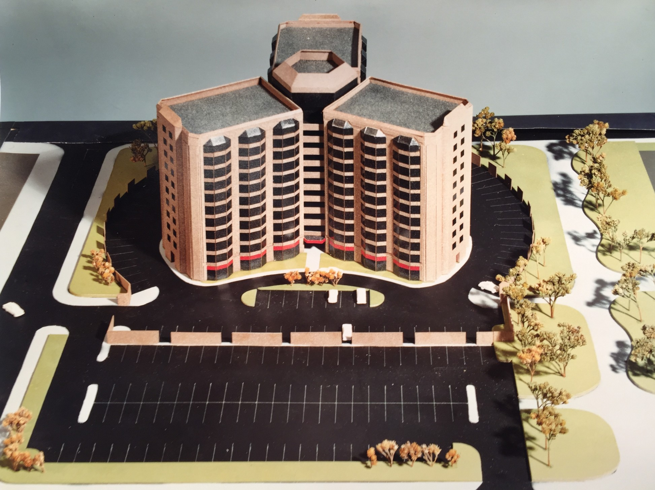
SLOANS LAKE PARK RESIDENCE RETIREMENT COMMUNITY By RBA Building form and orientation was critical in maximizing units per floor while minimizing the travel distance for occupants, thereby avoiding the institutional effect of long corridors normally associated with slab blocks. The number of floors and northern exposure is reduced and all units enjoy views and sunshine year round..

(10) THE ARCHITECTS CONDITION
In the conventional design role of the present job description, today’s Architect has, thanks to the separation of the design and construction effort, become a sedentary worker tied to his work station and phone, and spends less and less time on his buildings in the field in the construction phase. A consequence of this development is that compared to the original role contemplated in his title, architects are often hired more for their drafting skills than knowledge and ability to implement the practical construction of their designs. In Australia there is a trend toward minimum documentation and minimum fees with only those details called for by the Builder, once construction has begun.
Regrettably, divorcing ourselves from the original construction management role, direct involvement with the trades and construction in the field, has fed directly into this notion. A vital connection for evolving architects has thus been lost and at great expense.
The architects’ title is of course attached to all official documents even when the common aspirations for the project are more ordinary and economic rather than inspired and prestigious. Here the architect is often hired more as a means to obtaining a building permit, the process for which is loaded with ever increasing, bureaucratic paper-work only the architect and his team can expedite. In any context, these and other related design responsibilities are time consuming, and no less diminished by the quality of the project afforded by its budget. Compared with time spent on construction related services provided by the builder, they are however, deemed to be intrinsically less valuable by the owner, as reflected in the relative disparity seen in the remuneration paid to each party for their respective roles.
From the standpoint of monetary, technical and ethical responsibilities, the architect must also by definition, always stand behind the product of his practice. Now
more than ever, due diligence is the over-riding standard applied to the performance of his duties with respect to all related aspects of liability exposure, be they budgetary, construction integrity, scheduling or even ongoing maintenance. In an increasingly litigious society with high expectations of its professionals, Architects are being held to higher standards of accountability for the working product of their designs, even when they don’t have control of the construction of their projects in the field.
The common mind-set, sometimes a ploy, on the part of the owner is to seek compensation for dissatisfaction with any aspect of the project’s performance or the services rendered in its production, regardless of who may be at fault or the inadequacy of his wishful budget in the first place. On this note, guess who is most vulnerable and therefore least likely to get fully compensated, especially if the project is over budget. Consequently, Professional Liability insurance premiums continue to skyrocket, while fee competition has perpetuated a race to the bottom among architects determined, particularly in bad economic times, to stay in business at any cost.
Most architects enter practice ill-equipped to cope with the myriad of business requirements, and licensing agencies do not test for proficiency in day to day business procedures. Hence it is not surprising to discover that a lack of knowledge in basic business procedures has had a marked negative effect on the architect’s business success. The essential need to reduce client agreements to writing, or question a client’s capacity to finance a project adequately, are a prerequisite to avoiding common pitfalls and vital to the architects self-preservation. Yet these are not unusual lapses in due diligence to be encountered among practicing architects.
Projects with inadequate funding frequently lead to claims against the architect. We should always recognize that selection of project, client and contractor are just as important as any associated with materials incorporated in the buildings’ design. To survive, architects must therefore exercise at least the same degree of care in their
business procedures as in the technical aspects of practice. It is estimated that half of all projects in the architects’ office either lose money or barely break even. During recessions the percentages are even worse, as projects are stopped in mid-stream. These losses start with inadequate fee negotiation and continue with poor billing practices.
The Architects’ essential contribution in the early stages of speculative development projects also makes him a target of developers, particularly in bad economic times. Risk capital for such ventures is typically in short supply on the part of persuasive development speculators, so that the choice for architects is often between risking the investment of time, effort and expense in the hopeful expectation that a live commission will result in the future, or staying idle. Here again an architects’ youthful optimism and entrepreneurial spirit can usually be counted on.
Of course, once developers get a taste for free preliminary design services complete with renderings, it becomes almost an expectation even in good times. Unlike other contributors to risk capital, few architects will share in the rewards entitled by their speculative work investment, because they don’t yet think like businessmen about the business they are in. To do that one must first understand the business of development.
Clearly this is also fundamental to an architects’ understanding of the nature and financial underpinnings of the projects he is called upon to design. If you also want to better relate to and identify with your clients goals, this is essential. See Part 2, The Development Business - Key Notes.
Premised as they are on the conventional business model, the above outlined conditions apply less critically to architects who embrace the proposed new CM business model where a higher level of performance and participation is naturally promoted on the part of all players, but especially the owner. We must never forget that a well nurtured and informed owner can often hold the key to a creative solution.
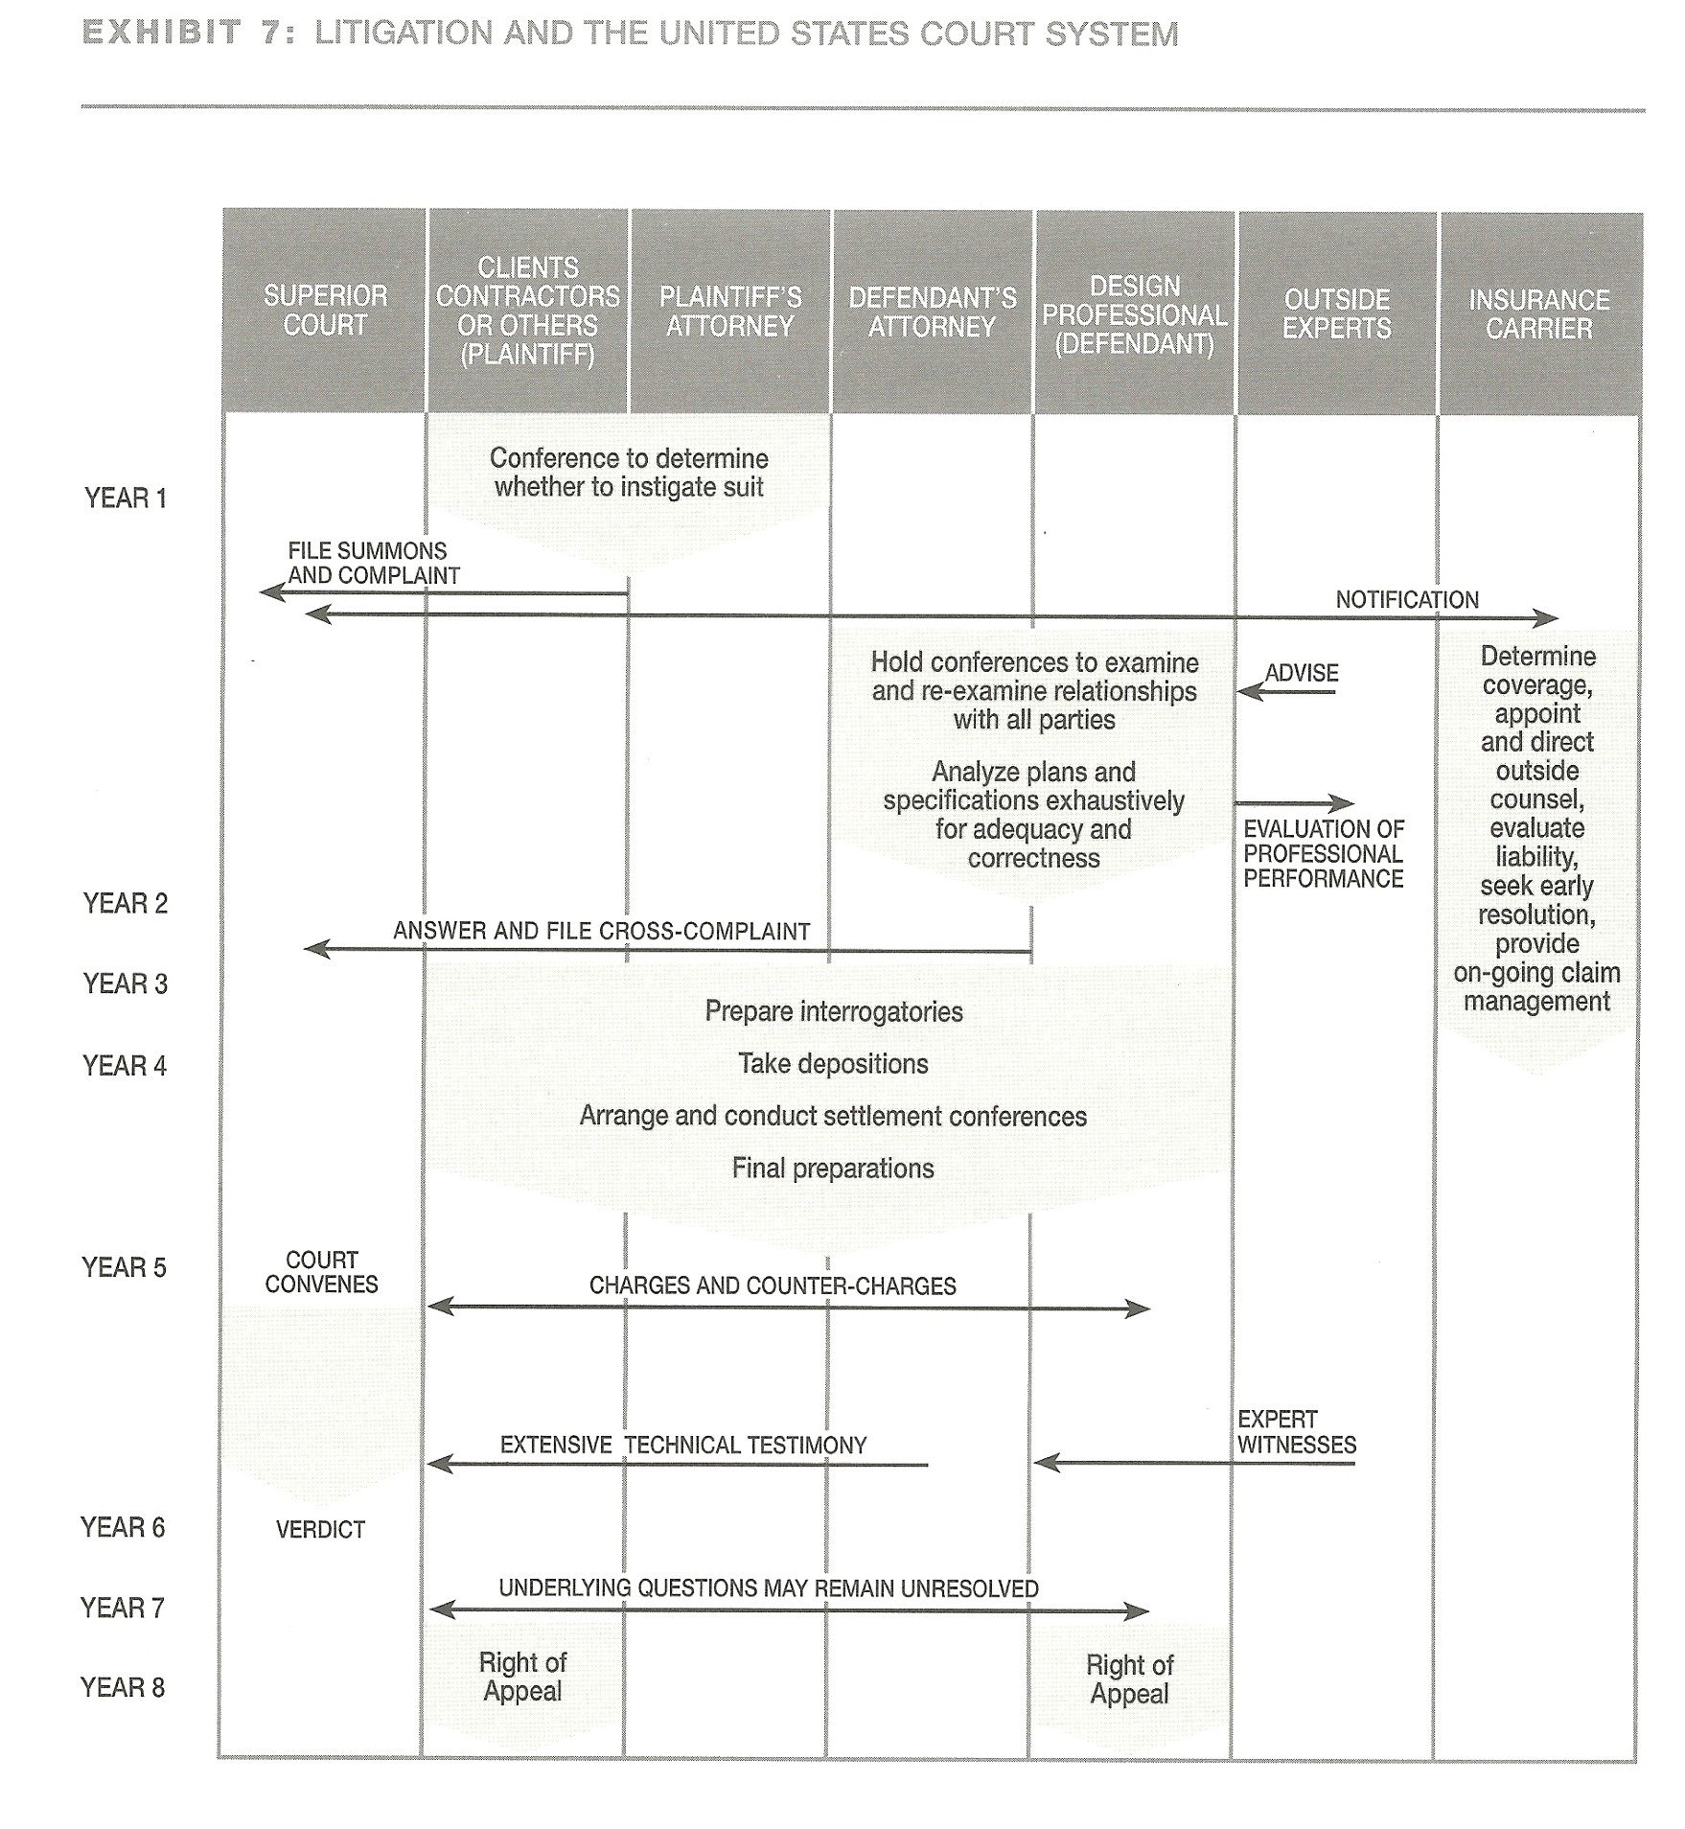
Used with permission from Lessons in Professional Liability
Litigation and the United States Court System

(11) THE NEED FOR A NEW 21st CENTURY HIGH TECH BUSINESS MODEL INCORPORATING CM
Given the scope of the challenge, is it any wonder therefore, that in the mainstream, we have become a conflicted profession at odds with the competitive times we live in, and in an unsustainable fight to remain economically viable. But, of course, we cannot change how the game is scored, until we change how the game is played.
In recognition of the wide liability exposure already assumed by their position, architects would be better served by adopting a Business Model with the built in control needed for the comprehensive role they play in pursuing the efficient delivery of their projects and the necessary compensation required to fulfill its’ growing obligations. In philosophical terms, if we want to improve the outcome, we need a new paradigm, one which is in harmony with both its goals and the means to achieve them. How this new business model can also be successfully integrated with the growing prospects and opportunities for the architect as developer and the long term goals of a secure life plan is another topic as illustrated in Part II.
To repeat, the common objective is to deliver the best building in the shortest time for the lowest price. These are the natural goals which will resonate with any client we wish to attract,- and have no doubt, they are more achievable when construction management is incorporated into the architects business model. Having personally tested the proposition of a ‘professional’ one stop shop’, this for myself, is not a matter of conjecture but a proven fact. What is more to the point, is that adopting this superior model dramatically changes the methodology in the approach to designing, managing and controlling the delivery of a project and affords the architect all the time and opportunity to achieve his objectives through the careful and considered timely selection of contractors best suited to the common goals of all his project.
Why then, have architects not taken advantage of, indeed resisted the opportunity of formally combining design and construction management services? There is a number of possible answers to this question which come to mind beyond the architects apparent aversion to perceived risk. But as the popular expression goes: “No strain, no gain”.
First, because the business of architecture is the product of architects, it is appropriate to understand the creative nature of architects; how we typically think, what about our work turns us on, and what we don’t particularly enjoy doing. These attributes tend to conform well with what we know as left and right brain characteristics, and by that definition we are notoriously bad business men.
So incidentally, and for other reasons, are doctors and lawyers, though they make relatively higher and more stable incomes. Whereas these fellow professionals have however, retained a certain self-serving awe and mystique about the esoteric nature of their work, everyone naturally feels that on some recognizable level, he can design a building especially given the easy access to cad programs.
It is also a fact that earnings of the profession are not commensurate with the length of training, especially when compared to other professional players in the same or other industries. In the US, and I believe also in the UK, adding to the problem, deregulation of architecture has meant that even his title is no longer protected. (Warne Report recommendations to Parliament, circa 1994). While CAD enhances productivity and helps with the resolution of complex problems, it has by the same token, reduced the need for an already overpopulated profession.
The business of architecture therefore poses special problems relating to its condition and marketing which are unique and challenging. Compounding the problem are a diminishing client base ( in the US an 8 fold increase in architects versus 2 fold
increase in population) and fewer corporate clients. Consequently, we thrive as a whole when the economy is in overdrive, only to have all our gains wiped out when it stalls. One message is: If a ‘designer’ wants to have a successful design business, he should hook-up with a marketing specialist and business minded partner to manage the ‘business side’ of the practice. For medium and large sized architectural firms this is a must. This may also explain the appeal to some architects for partnering with a Design/Build company.
We have also seen a lack of public trust, and a waning of professionalism. An educated class now aided by electronic data bases and expert systems are more prone to challenge a professionals’ judgment. Indeed this has become commonplace in all fields including medicine and makes it difficult for the professional to control information and protect “knowledge” through licensing.
Architects are also conditioned by their education and training to settle themselves comfortably into the conventional establishment mind-set. After all, the current business model has considerable time and tradition behind it and we have apparently learned to accept its earnings limitations without much of a struggle. The trouble is, it is a model which works more favorably for the general contractor and other related profit minded players. It does not work so well for the owner or indeed the architect who has allowed the role he plays to be progressively marginalized and devalued into the bargain, as most reflected in the owners’ elevated expectations and the architects diminishing fee levels.
All this, together with a general lack of appreciation for esthetic knowledge by the population at large, has effectively diminished the perceived value of the Architects’ contribution. The need for architects to rise above their new competition is therefore paramount for success. This brings us back to the questions I posed at the beginning of this presentation with regard to,” who you are, what you do, and what you can promise to your clients.” In this context the conventional practice is clearly no match for the
new business model which can boast delivery of the best building, in the shortest time, at the lowest cost. “And here, Mr. Client is how WE are going to accomplish YOUR goals.” is the lead into the architects narrative for the case for combining professional CM services, which you now fully understand.
To architects part of the establishment and content with the status quo, and there are many on both sides of the Atlantic, adding another dimension to the scope of business currently performed, i.e., CM, can appear at face value to be an additional burden, layered over an already high level of responsibility. Of course, design competence is not tantamount to management competence, and here, architects need to improve their current reputation.
In practice however, CM is not rocket science and relatively speaking far less demanding an expertise in terms of talent and training than that of design. Because of the huge overlap in the architects training with that of a construction manager, Architects typically make great construction managers, but the converse is rarely true. For the architect, as I have argued, they are in fact complimentary tasks and mutually improve each others’ performance level. As previously referenced, I have also found that the enhanced level of control afforded by combining these roles and responsibilities has the redeeming effect of actually alleviating those very same pressures associated with split liability, i.e. when two separate players are contracted for inter-dependent responsibilities, instead of an equivalent, one.
The genius of the conventional program we have embraced so willingly, is in its deceptive ability to persuade its key players, the architects, that they are the beneficiaries of their net loss of power, control and financial standing, in an industry only too happy to have also allowed them as part of the bargain, to retain the lion’s share of the responsibility. What a deal!!

(12) CHANGES REQUIRED IN THE ARCHITECTS TRAINING
In practical terms the production of any building has invariably required the involvement of three basic and indispensable collaborations: First and foremost, an entity to pay for the project, whether public or private; Second, a skilled workforce ready, willing and able to execute it; And most of all, an intermediary with the required artistic, technical and management ability to expedite its production.
Traditionally this was the Master Mason, who combined the triple function of architect, builder and clerk of works, learned his craft in the field and was elevated to that esteemed position only after many years of hands-on practical experience in all related construction trades. This model was natural and worked effectively in the context of its time and more limited scope.
More recently, in contrast, it is the college educated graduate of architecture, typically characterized by his graphic design ability and proficiency in the use of ‘cad’, but understandably, also his lack of hands-on field experience with the trades. A lack of enthusiasm for purely construction problems is also excusable to a certain extent on the part of young students, because the demanding task of building only becomes really interesting when translating a design into a live, functional and above all weather-proof solution.
If you will excuse a blunt analogy to make the point; As students of architecture we start as skate-boarders being trained to think like astronauts, in a world which is looking for pilots. So, do we want to be pilots or flight assistants? We therefore absolutely need to learn what it takes to bring our projects in on time and on budget, or as we have seen someone else gets to fly the plane - it’s that simple.
In my experience, there are however, students of architecture who will honestly
acknowledge that their primary strengths or interests are not ‘Design’, but in the technical, construction management, business management and other complimentary roles. Within the broad range of related talents enjoyed by aspiring architects you will certainly find all the necessary team ingredients, fully capable of delivering turn-key building projects from start to finish. So let’s keep it in the family. Even if you are not completely cut out for the complimentary business or construction management roles required, hook up with someone who is. It’s your collective strengths as a collaborative team which will make you and the profession successful.
Anecdotally, I must commend the department of architecture for acknowledging this reality more than forty years ago, by being one of the first to break from the standard mould and offer post graduate students of a three year degree program, the opportunity to pursue their strengths in special areas of related study in a masters’ program.
In keeping with this policy and for reasons which should be apparent, I would personally go one significant and progressive step further by including Construction Management as mandatory in the undergraduate course work, and an option in the postgraduate program. It should be regarded as no less a fundamental skill as the study of any of the engineering disciplines to the architects comprehensive understanding of essential design criteria, their critical interaction and control.
The role of the architect today is by any definition a versatile one involving design, planning, management, cost, and schedule control. The commitment to the learning process has therefore, to be enduring and vocational in nature as with any other profession. But because architectural “design” is so demanding a skill, this will always be the primary focus of college education - and rightly so. This however, is only the primary skill of many required in the complex demands of the profession, and its practice draws on all the others.
Planning, designing and managing construction projects of any size also requires considerable skills in the communication with, and co-ordination of consultants, specialists and contractors, all within stringent time and cost parameters. The application of more sophisticated organizational skills is therefore essential and should be part of the curriculum.
The theoretical and practical process involved in a buildings’ construction certainly warrants as much attention as the design process itself, but most architects become accomplished in these and other vital aspects of practice out of necessity and from experience. However, because the process of construction is and always has been such an important determinant in design, it should receive greater priority in an architects’ training and the creative thought process of problem solving, - as opposed to being an inconsequential afterthought. This takes on more direct significance when an architect assumes the additional role of construction management, but no more than it should in his prevailing role if he is to be a truly effective designer.
If you want to learn to swim, you must first get into the water. Just putting on a swim suit may look good but doesn’t begin to get it. As students we are not expected to know very much, but when qualified we will be the object of ridicule if we are not knowledgeable, and as much about basic practical hands-on field matters as those more academic in nature. So where ever you are, have the fortitude to ask lots of questions. You will be amazed at what you can learn from experienced hands-on craftsmen and their willingness to pass it on. Being prepared is the name of the game. All the opportunity in the world will not matter if you are not prepared.
My advice to students of architecture therefore, is to get all the exposure you can to construction on building sites in your vacation time and year out of college. This is also a good time to establish some useful contacts and to showcase your smarts.
Employers are always on the lookout for motivated talent, if not for themselves, then for their business associates. Timing-wise this is far more practical and relevant to your training than anything else you can do as students to equip yourselves for the design and management roles you will need to fill. You will have plenty of time in the future to gain office bound experience.
With regard to the nurturing of professionalism, traditionally a man who was considered to be a member of a profession was either, a lawyer, a physician, or a clergyman. Over time other disciplines have joined the ranks of the professionals by way of legal statutes, establishing minimum standards and public acceptance over a period of years. The design professionals are included in this latter group.
It was in the early 21st century that complex engineering technology made the requirement of specialized knowledge the mark of the new design professional. Then as now, great emphasis was placed upon a high sense of commitment to duty, public service, ethics and civic responsibility above those normally attached to the members of the crafts, trades or other forms of regular employment.
This image of commitment to duty is what affirms the Architect’s honorable motives, establishes his authority and bonds him on a higher plane with his Client’s goals. This is what sets him apart from the fray and why re-assuming his role of Construction Manager is so appropriate and critical to the future welfare and integrity of the profession and the industry at large. We have already touched on the distinctions between combined professional Design/CM and Design-Build motivations. True professionals may have always existed but have been recognized as such for only a few centuries at most. This is why the label is so coveted, often misrepresented and so frequently and superficially attached to misguided, self serving imitators.
For me personally, the true hallmark of a professional is his willingness to place all
his hard earned knowledge and experience to the benefit of his client, as opposed to any singular self serving material motives. To repeat once again, “The best interest of the client and his project is the only interest to be considered”. In this respect an architect is no different from a doctor, except that on a lighter note, one gets to bury his mistakes while those of the other live on.
Only two percent of college age kids worldwide get the privilege of a college level education. The roulette wheel of life has been most kind to you. But remember that to whom much is given much should be expected. It is life transforming and on many levels. Above all you are being trained to think. So question everything. The truth is usually straight forward. If it isn’t then something is wrong.
Ultimately, the purely practical goal of education is to develop in architectural students the ability to prioritize and reconcile the many and often conflicting requirements of a projects brief, and to render these into a worthy, inspired and functional design solution. In practice the key to accomplishing this endeavor is in the assimilation of all the comprehensive design data relating to all aspects of a projects’ requirements, including and especially its’ budget and schedule for completion. As stated earlier the challenge this represents in the real world is best served by creating a flexible, interactive business model which provides for timely input by all the key players before, not after the design is set and contract documents completed.
Knowledge of CM theory and practice will therefore equip the young architect with the confidence to deliver his own cost effective turnkey projects on time and on budget. By doing so he will become a better strategic thinker and more objective in the way he views the integrated efforts of planning, design and construction of building projects as befits his leadership role. Understanding the benefits of its application, he will, when necessary hire a CM as a member of his design team, rather than be hired by a CPM on behalf of the owner as typified by current trends.
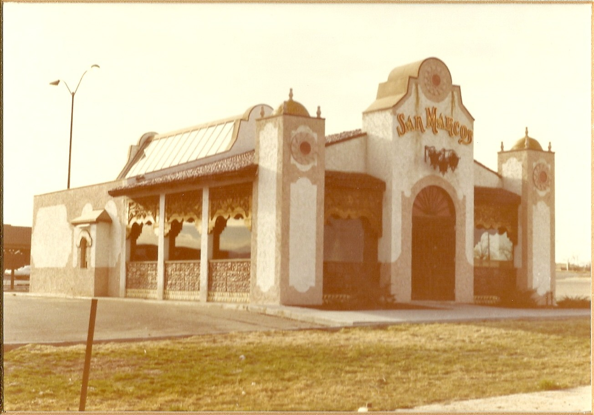
Including construction management as part of his skill set will as I have thus argued enable the architect to revive and consolidate his leadership standing. Ultimately it represents a credible and practical path to improving his sustainability and that of the profession at large. With global competition in mind, remember that today, architectural design can be performed anywhere in the world away from the job site while construction management must always be applied locally.
Most of all, architects will in the process, also position themselves to deliver to a fully informed and on board client a ‘finished product’, as opposed to just the ‘bid documents’. The cost benefits of this strategic change in the business model to both the owner and architect need no amplification except to say that this is a win-win proposition for both parties. Its inherent efficiency will also afford the architect the new found freedom, time and opportunity to further enhance the artistic value of his work and reaffirm the unique quality of his design contribution to its end product.
San Marcos Mexican Fast Food, 1st Solar Heated Restaurant in Denver by RBA 1976

(13) TO SUM UP
Critical problems of performance confront the business of architecture, the scope of which cannot be addressed without a fundamental change in the architect’s business model. Primarily these include; over supply of architects, financial instability, lack of control of the critical issues of quality, cost and schedule, vulnerability to litigation and lost leadership. It is my personal opinion that all have a cause in common and arguably a common remedy, i.e., the inclusion of CM into the scope of professional services.
In surrendering the construction management role embodied in his title, the architect has compromised not only the integrity of the design-construct process and fiscal control of his projects, but also his own financial standing and sustainability. Together these losses account for a diminished leadership position in the industry, much of which has now been assumed by other players more willing and by experience, better qualified to address the critical issues of schedule and cost control.
In the U.S., to underscore their control, more progressive contractors have either hired or teamed up with architects to form Design/ Build companies, with positive results for all, but especially the contractor. Design / Build companies now account for more than 35% of the output. This is a condition which can be reversed in both the Client’s interest and the Architect’s favor by a concerted commitment to fully embrace the construction management role as an authentic and essential part of his professional service in a newly defined high-tech era. What is remarkable is that rather than reinventing itself, this solution simply requires the reinstatement of the Architect’s original model.
Given the considerable high-tech resources now at our disposal, architects should re-evaluate their enhanced capabilities with regard to expanding the scope of their service to include both design and construction management in the delivery of
development projects. Consolidation and integration of Design and CM services provides the Architect with complete control of his projects thereby improving design quality, shortening construction schedules and reducing costs.
By eliminating the GC and consolidating responsibility for design and construction it will also promote a timely, direct and professional approach to expediting building problems, thereby eliminating unnecessary and costly disputes. Having comprehensive point control of all design and construction elements which make up the project allows new forces and techniques at the architect’s disposal to be brought into play and with a minimum of disruption.
It will also improve design by providing for more opportunity and timely inputs from all engineering specialists, experienced subcontractors and other critical contributors to value engineering efforts, cost control and resolution of schedule constraints. In addition it facilitates the inevitable changes in design, should client goals or the construction environment change. Here too, the demanding role of construction management also plays to the architects acquired strength and versatility as a creative problem solver.
In the proposed new model there is only one combined contract for comprehensive services, and one common team agenda. This is notably shared by the owner and architect, his sole representative, who unlike the GC, works not for a profit on the building, but on the basis of a professional fee. Free from any profit motive and the potential tensions commonly associated with the Architect /GC relationship, all the architects energy and productive resources, together with the cost benefits of consolidation and centralized control can be focused on the quality of the design /construct process.
Add to this the construction cost benefits of CM, together with shorter schedules
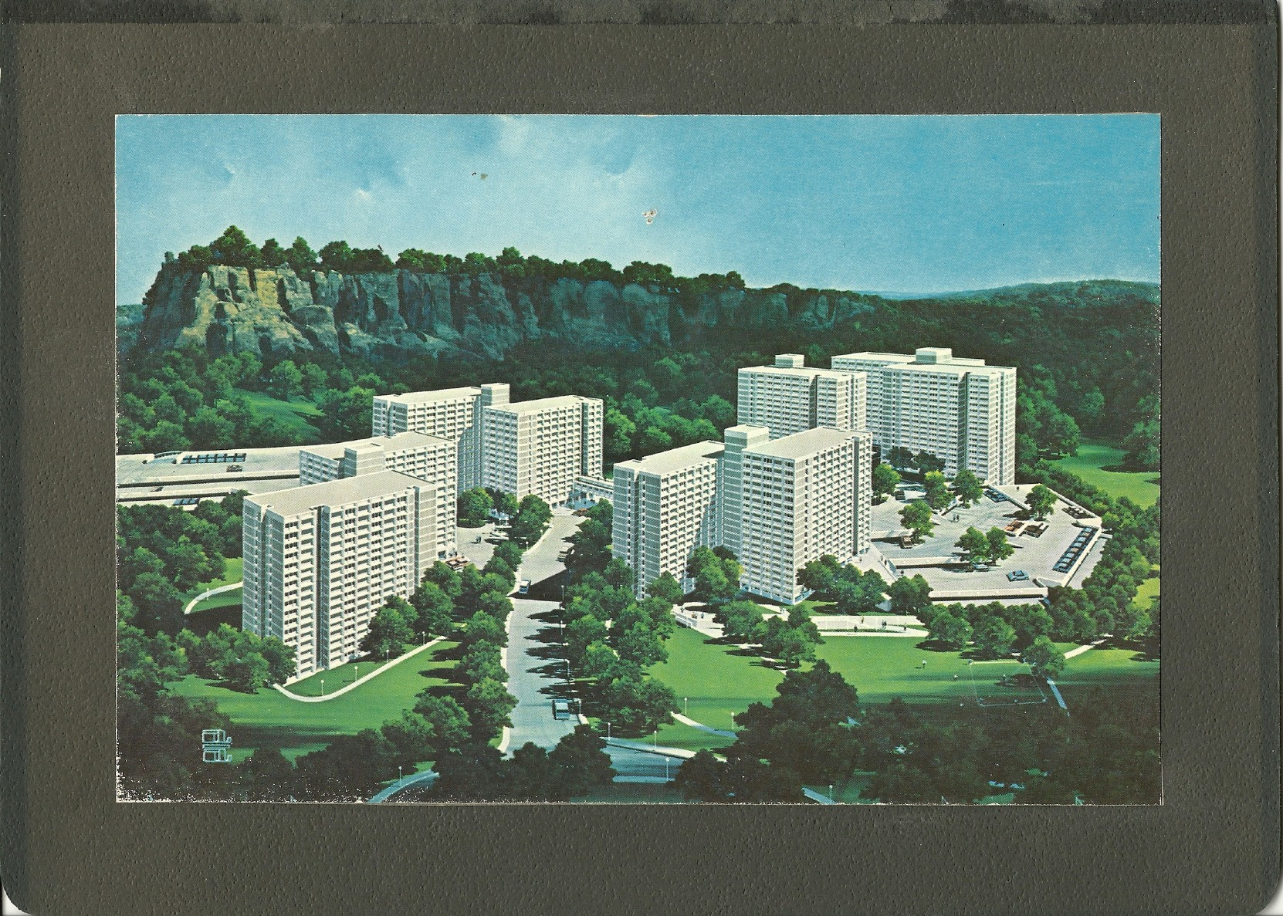
for completion of both large and small projects made possible through fast track, and the competitive edge this offers architects marketing comprehensive, turn-key services, and the architects’ practice becomes less subservient and substantially more viable. Most importantly, with the economies of scale and consolidation, a more productive, cost effective and profitable business model, more capable of sustaining normal cycles in the economy. In a nutshell, Architects need CM skills to better compete for the comprehensive demands of a competitive building industry.
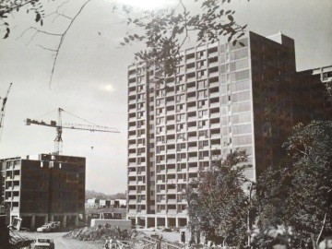
BELLA VISTA - LOW COST ELDERLY HOUSING PROJECT. NEW HAVEN, CONNECTICUT.
Using the “WATES” precast concrete housing system this high rise application comprised five tower blocks and 1800 units and was completed in 1973. Crane lifted precast concrete wall and floor panels tied together using a poured concrete joint constitute the structural system . Electric baseboard heating and through the wall individual unit type air conditioners were used throughout The rugged nature of the site and its severity of slope also called for a multistory parking facility. The experienced gained on the low/medium rise Missouri project was readily applied here but this time we were working for our client the developer / general contractor, not Wates the precast concrete system sub-contractor.
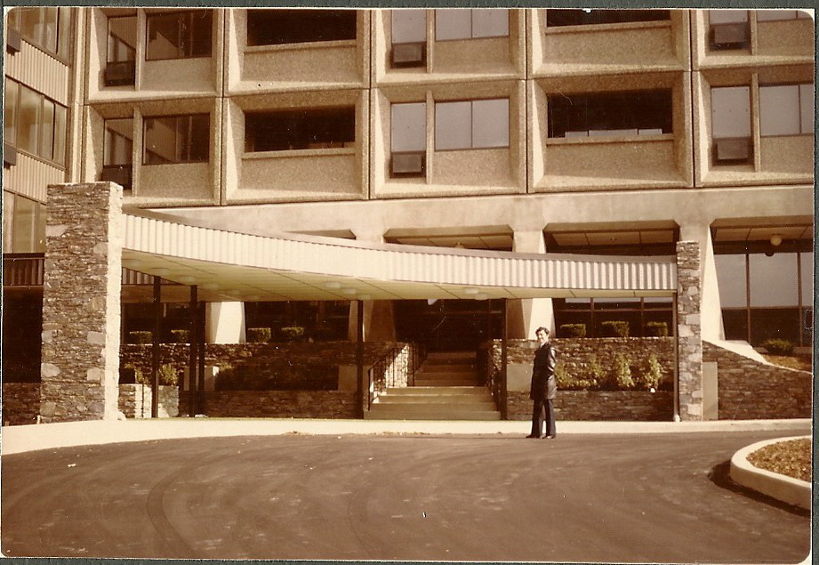
As an owner and developer with his own construction company he exercised total control of the project, its conceptual design and related budget. Given the federal subsidies which supported the project, strict economic criteria relating to all aspects of the projects delivery and performance were strictly applied to space standards, fire rating, and sound control all of which required much inter-action with N.B.S. While the cost benefits of high density, high rise construction are undeniable as applied to elderly housing it does leave much to be desired on sociological grounds. The lessons learned here were applied ten years later to a private retirement community project sponsored by a hospital group where the design was market driven and units were for sale not rent. This particular project represents the early stages in the development of what has become a far more complex and comprehensive team approach to elderly housing in America and other western economies.

(14) A QUESTION OF LEADERSHIP.
Of “leadership,” someone once said that: “It is getting other people to do what you want them to do because they want to do it”. I find that to be particularly relevant to the architects’ special brand of leadership and the directives inherent in this message. Connecting everyone on the team with a common sense of conviction about the goal and purpose behind one’s own brand will make all the difference to the ultimate success of our projects.
Now, aside from the necessary leadership qualities, Architects do have talents in common and talents apart from those of other professionals. So what particular gifts set us apart? One only has to spend some time working with engineers, quantity surveyors, GC’s or to a lesser extent, the new self styled masters of ceremony - the CPM’s, to discover that architects, if they are willing to rise to the challenge, are ‘potentially,’ the better qualified to assume the leadership role in the construction industry. This by virtue of their acquired intellect, ability, training and most significantly their broader, more comprehensive vision. Other more subjective qualities also come into play not least of which is the willingness to invest in the commitment to research and preparation.
However, over the last 150 years or so we have seen the hard earned traditional label of “Master Builder” with all its vestiges of leadership steadily surrendered, to the point where the common perception is quite different. Why is that, and how do we regain that standing? We have already touched on some of the more significant reasons. In an increasingly self serving society which has evolved so much in so short a time, it is time to reclaim the original ‘dual’ role of design and construction management as a standard for the profession, with a positive view towards improving its result oriented effectiveness and economic viability. Reaffirming the original and true nature of the Architect’s role and capability, represents an urgent and long overdue correction.
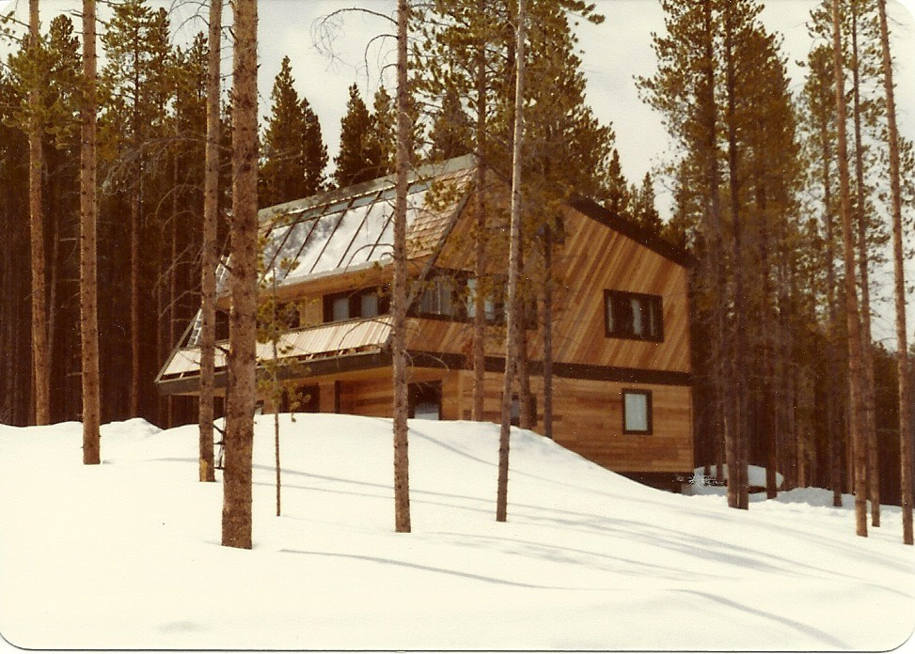
To more fully answer the questions posed by this proposition also requires an appreciation of how and why the design and construction management roles became separated in the first place. This too has as much to do with the aspirations and, more particularly, the training of the modern architect, as with changes driven first by industrialization and then by the ongoing high tech cultural revolution. In doing so it is important to first recognize that the architect in retrospect, unwittingly or otherwise, gave up a significant part of the control over his projects and with it his ability to directly affect a more positive outcome on behalf of his client. If, however, we start with the established facts, and take the simple objective view that we need to regain what we have lost in order to become more effective, we must first start with changing how architects see themselves before we can expect a different view by society. A willingness to make the necessary strategic organizational changes is necessary, but most of all we need to take full advantage of all the high tech resources we now have at our disposal to take back what is after all the architects birthright. What we need is a new generation of take charge architects. If we don’t others will, as in deed they have already.
Active Solar Residence, Breckenridge, Colorado. Integrated Design and CM Services by RBA

(15) CHANGING TIMES
With respect to the question of the timing of this proposition, current trends which define the economic /political context for architects in the future, have never been more favorable. The same over-riding consideration which will continue to drive all related economic issues is, in a single word -’ Energy,’ and it will of course impact both new and existing buildings. World oil production was projected as at many other times in the past, to have “peaked out”, this time in 2008. But newer oil extraction technology has once again defied the expert forecasters, while the advent of fracking in the US has created a false sense of temporary relief and further postponement of a fuller commitment to a more sustainable and environmentally friendly solution. It is now 2018 and what a difference 10 years has made in the establishment of renewable energy as an economically viable and environmentally friendly alternative to fossil fuels. But If there is one finite resource even more precious than energy, it is of course our fresh and potable water. Here too the use of solar energy is proving to be a viable resource in fueling the extraction of condensed water from the ever present atmosphere. In remote and undeveloped regions this is already an economically viable solution.
While world demand is increasing exponentially, as emerging economies like India, China, and Indonesia have so far emulated the unsustainable model established by the West, the fossil fuel era is coming to a close thanks to the commitment to renewables which has lowered costs of solar collectors in the west by as much as 80%. The impact of this on the reduced geopolitical/economic power of the old order as opposed to a new more equitable status quo will be felt for decades to come. Of all the many renewable options, nuclear energy still holds a great deal of promise in terms of capacity, but at a cost which is currently almost prohibitive and potentially catastrophic,-that is unless we acknowledge that there have been significant developments in the design of nuclear energy generation since the introduction of “first generation” power generators in the 1950’s and take a fresh look.
Outside the UK none of these early models are still running today. Operational US and French reactors are mostly ‘Generation II’ reactors and even these are now far inferior to so called “Generation III” reactors which of necessity have been designed to reduce capital cost, construction time and above all operational problems while also improving their efficiency. This has been accomplished through a comprehensive commitment to simpler, more durable and impact resistant designs together with a serious reduction in the possibility of core meltdown. More critically, an equal success in the more complete and efficient burn-up of fuel and effective reduction in its waste. As compared with the statistics relating to the consumption of fossil fuels and its now measurable and hopefully reversible damage to our global environment, there is no contest.
A few short years ago I would have argued that we need to see past the skillful propaganda which special interests have inflicted on our negative perception of nuclear energy as a now valid and most viable alternative to fossil fuels. But there is reason to be far more optimistic about the prospects of renewable energy based on the recent commitment to wind and solar which is now embraced by users and their Utility companies particularly in the US where the cost of solar produced power is now cheaper than that associated with environmentally unfriendly oil or coal. At the present and projected future rates of growth and consumption of energy (3 or 4 fold in population by the end of the century) we need to get to grips with this global challenge and soon.
No question therefore, energy will continue to be the driving economic force in the future as it has been in the past. As we have seen, the ensuing global competition for energy resources has driven the political and military agenda of the west for much more than a century, with the war in Iraq only a recent case in point. With regard to the use of the energy we are able produce, this is where as architects we need to be much smarter.
It would be a gross understatement to say the present use, or should one say misuse of energy is unsustainable, both in our buildings and automobiles.
By the same token, we likewise need a radical re-evaluation of our design priorities relative to construction and operating cost, with a greater emphasis on substance over a past preoccupation with style, often for its own sake. This does not mean to devalue stylistic innovation in the creative process, but this should be rooted first in performance. Indeed, performance should be the starting point in defining the design challenge.
In this respect, Architecture is akin to any industrial design endeavor. We need to thoroughly resolve functional problems related to all aspects of a design challenge before we get to aesthetic considerations. In particular the cost/benefit equation relating to energy use and conservation must be addressed at the conceptual and all subsequent stages of a project’s design. The esthetic and intellectual challenge this represents can only further fuel, revive and sustain a newly charged profession properly armed with all the old and new tools at its disposal.
In the final analysis, investment capital, or more simply put money, is the most valuable commodity we have, and energy conservation has to make economic sense in terms of both front end and operating costs. Too often we miss the point and resort inappropriately to expensive high tech solutions which never pay back, even on the basis of a very limited scope rationale. If for example, high energy cost is the issue, it can hardly be left out of the economic equation when proposing high tech, energy conservation type solutions, the high production cost in energy terms, we cannot afford.
We are going to have to get back to building science fundamentals, adopt design with climate principles and get to grips with all the ‘no cost’ design resources we have at our disposal to reduce both front end and operating costs. On a global scale the most sophisticated buildings in the future as in the distant past will be earth-sheltered or built
of mud. In China this is already happening out of necessity. Conservation coupled with the use of renewable energy such as wind and solar, both active and passive systems,are solutions which can be readily incorporated at the outset in the evolution of a projects design. Moreover these approaches are now socially and economically more viable as advanced technology continues to lower production costs.
A perfect example of this is Castlewood library illustrated in the following pages. A prominent developer who was also the landlord of my office space at the time had been approached by the director of the local library association about the need for a new library in a rapidly growing district and would he be interested in participating in a limited competition for its design and construction. The proposed budget for its development and operation was extremely tight and RBA was invited to partner as project architects. As you will see, there was a comprehensive solution to all these criteria in the form of a passive /earth shelter approach to energy conservation which was also cheap to build and efficient to operate.
The structure is comprised of a cast in place concrete perimeter wall with a 7.5 inch thick post tensioned concrete roof deck with thickened slab to form beams on interior concrete columns. The exterior finish is of brick with interior stud walls on the perimeter and interior stud partitions. A suspended drywall ceiling was overlaid with applied accoustical tile in the form of decorative panels between fluorescent lighting units all set in a radial pattern.
Partial earth sheltering is achieved on the semi- circular perimeter wall on east, west and north exposures while passive glazing with calculated overhang for sun control completes the southern exposure. Four single zone roof top HVAC units provided the heating and cooling for this low budget facility. In addition to energy conservation the earth sheltering aspect of the proposal also insured excellent cover from traffic noise due to the proximity of the major arterial road immediately off the north side.

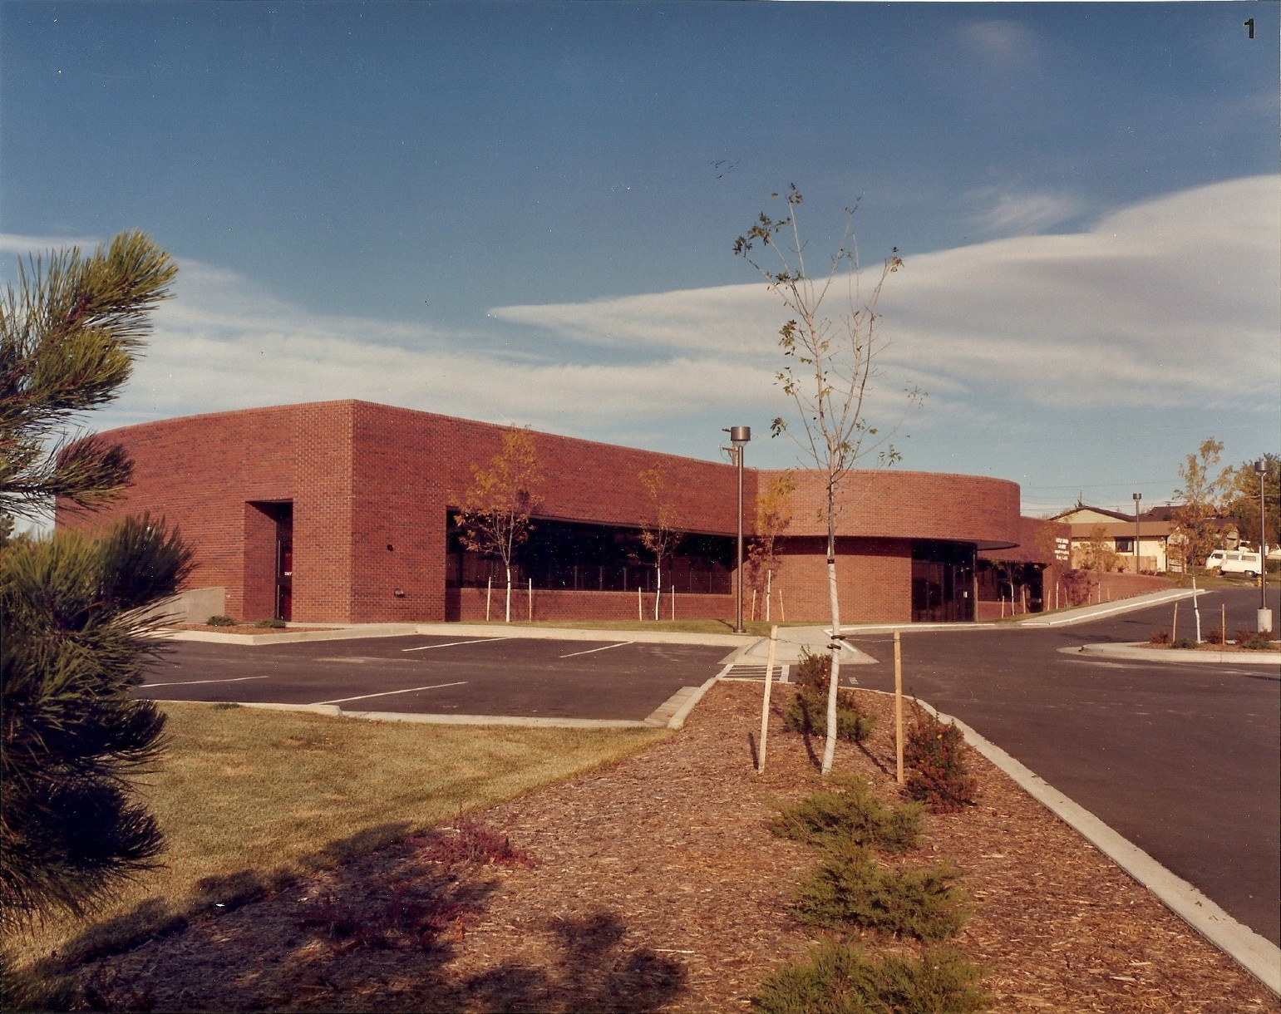
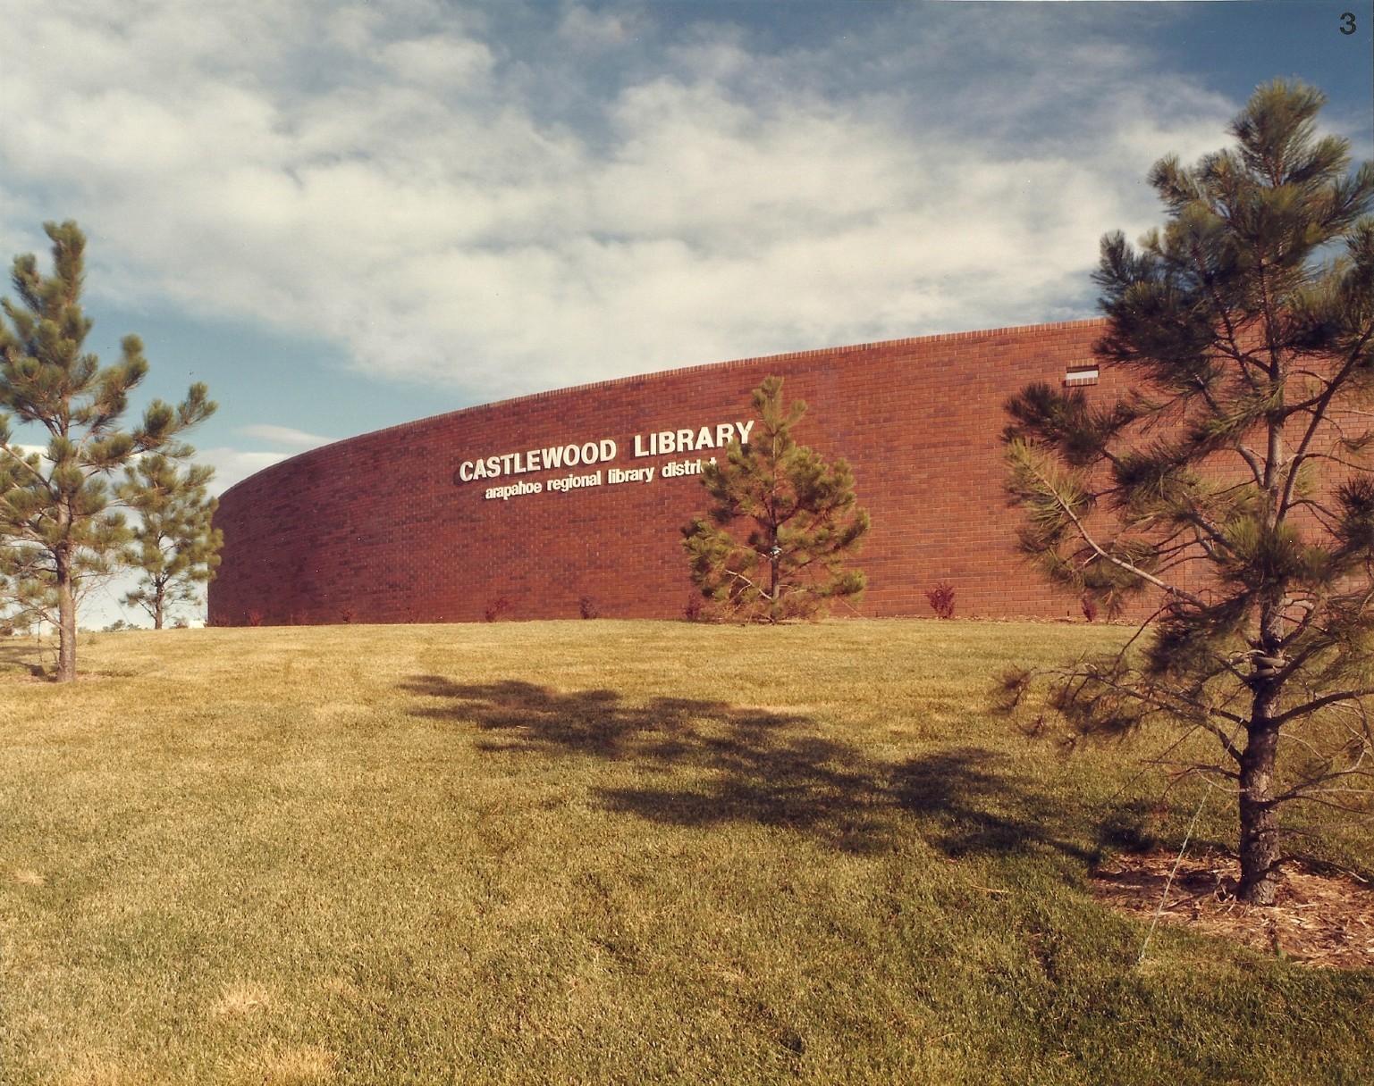
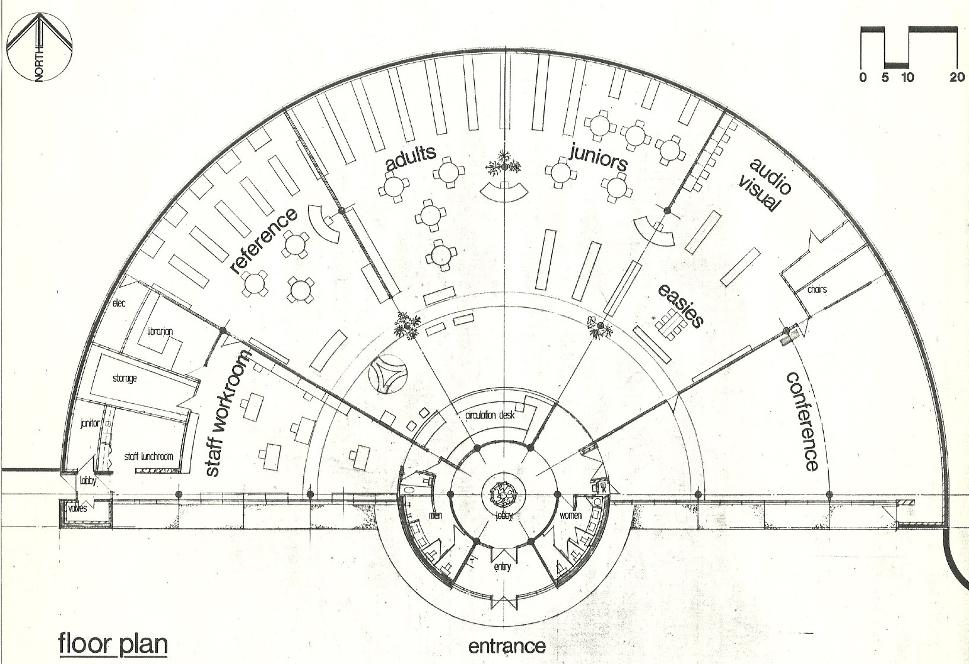
Castlewood Community Library - 1984. Was a Design/Build collaboration between RBA and Perlmac Construction. Its semi earth sheltered, passive design concept takes full advantage of a Southern Exposure while addressing energy conservation, external noise control, and reduction of construction, maintenance and operating costs, major requirements of the Building Program. On many levels particularly functional and economic, this was very much an example of a “performance” driven project.
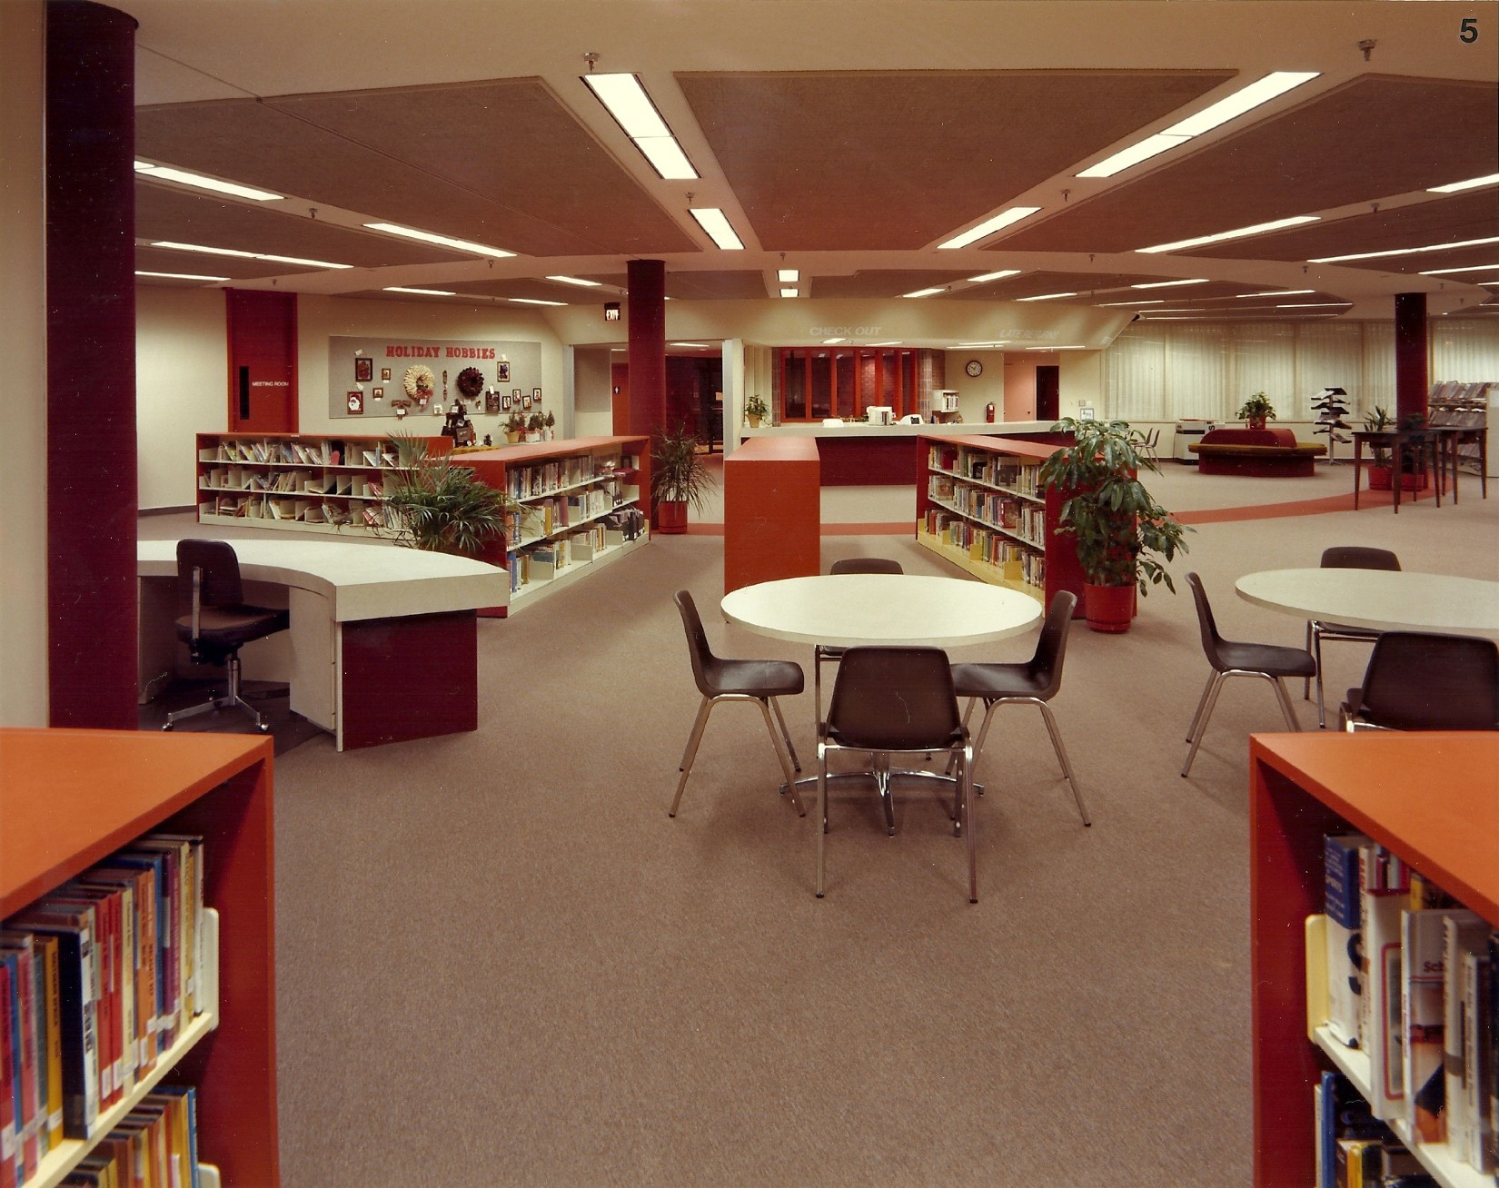
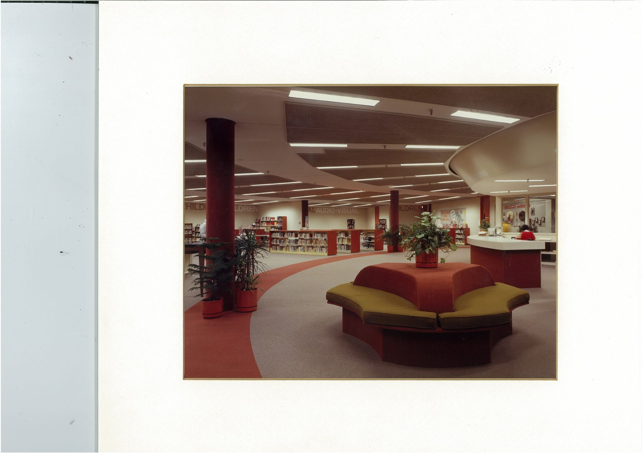
Castlewood Library: Semi Earth-sheltered, Passive Solar Design Concept and Interior Design by RBA
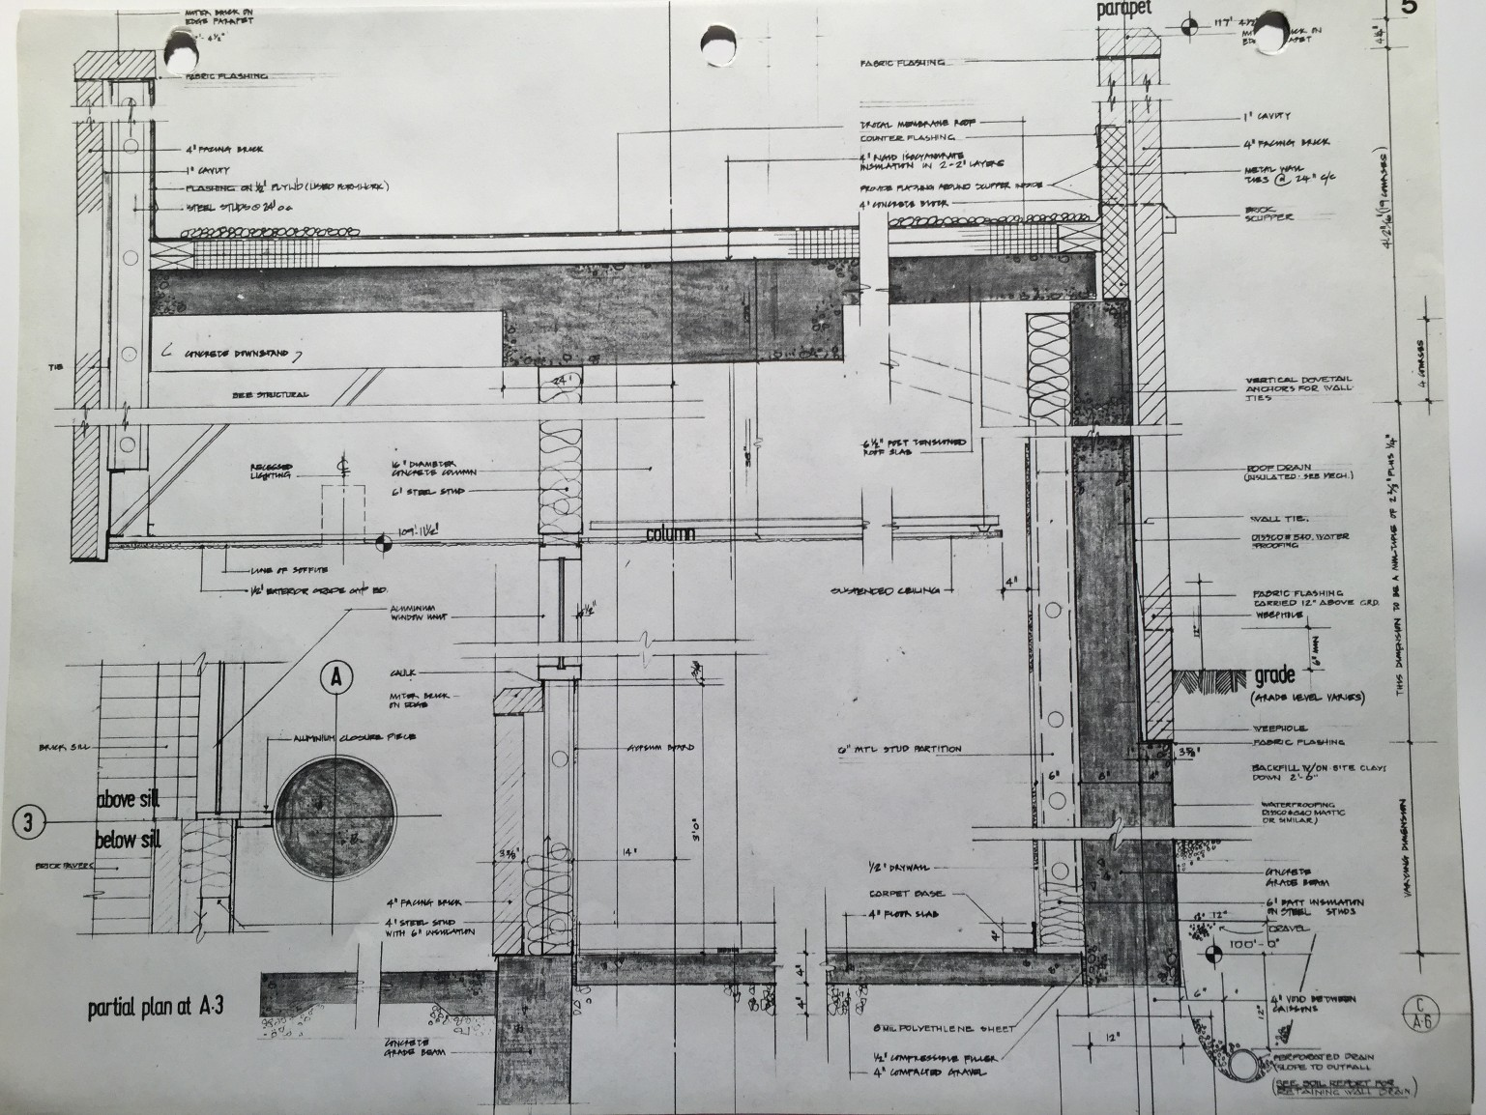
CASTLEWOOD LIBRARY. BUILDING CROSS SECTION AND PARTIAL PLAN DETAIL
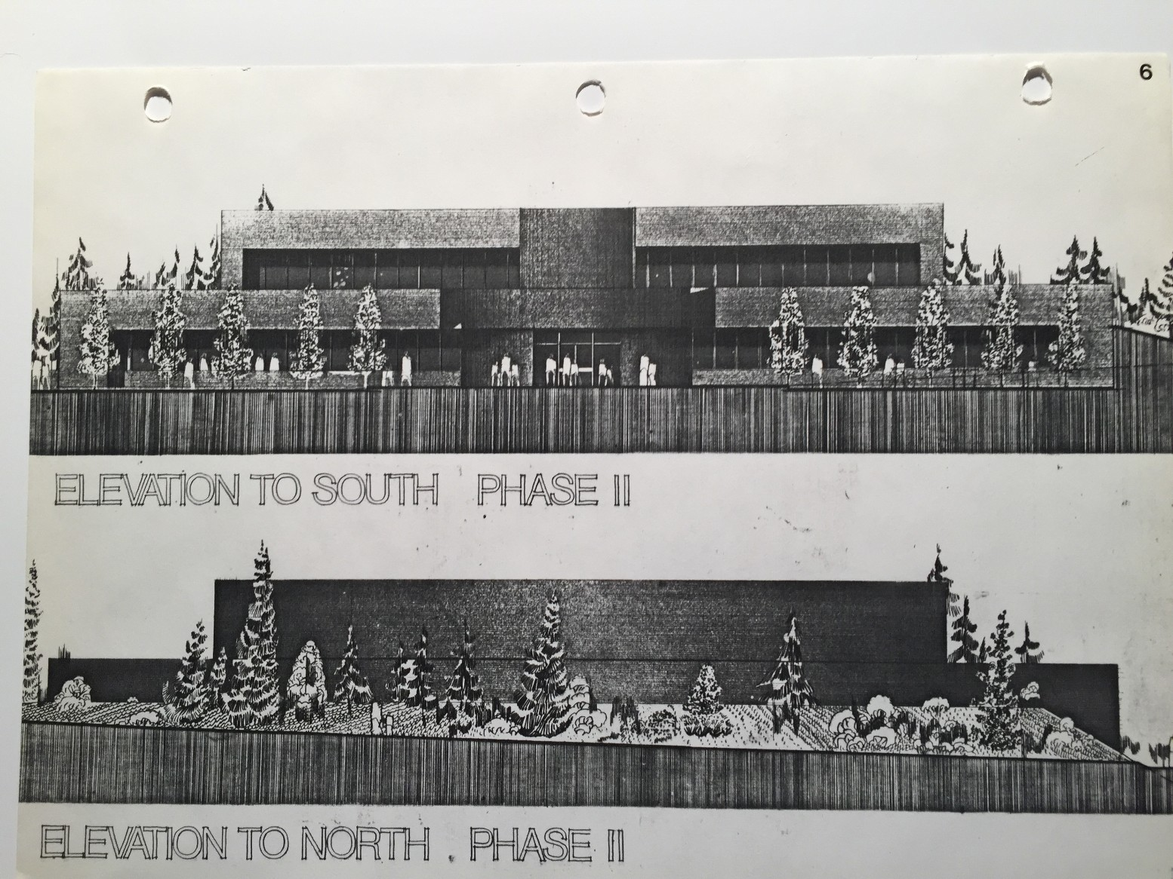
CASTLEWOOD LIBRARY. ELEVATIONS OF FUTURE SECOND FLOOR EXTENSION

(16) THE CHALLENGE AHEAD
Architects should have no doubt the application of the driving principles of conservation by design will inevitably become the order of the day as operating costs continue to escalate. These challenges, affecting both new and existing structures would already be upon us with a vengeance, if not for the recent impact of “fracking”, notably in the US and a new global commitment to renewable energy, mostly in the form of wind and solar which have together reduced the strangle hold of OPEC on the energy market. Of course in all these efforts the application of passive approaches embodied in design with climate criteria is the primary key to reducing thermal loads and minimizing the need for energy in the first place.
In the West given that 20 years from now 95 % of our urban inventory will probably be what we currently already occupy, the potential rehab work for architects to be generated by these developments is by any measure staggering. Governments will find it economically more expedient as in the US to provide building owners with financial incentives to make vital improvements, as efficiency becomes the new fuel of the future. So the need for energy in our buildings must be reduced to its essential level even if this works against special interests.
No longer can we disregard orientation and building form at the expense of a total dependence on electrical and mechanical systems for lighting, heating and cooling. The advances we have made in technology, now enable us to provide power, heating and cooling through a varied combination of renewable sources including, active and passive systems, photo voltaic, wind and geothermal, using the building itself as the point source for its generation. If the trend continues, environmentally unfriendly fossil fuels will become back up, not primary sources of energy as buildings become less dependent on mechanical systems and the use-up, throw-away culture gives way to reuse and adaptability. If however, political events world wide distract from these progressive
movements away from waste and inefficiency, (let alone the enduring damage to the global environment), then all bets are off with regard to slowing down the lasting effects of global warming which go well beyond the realm of architecture to cure. But on a more positive note, we now have every reason and confidence to place our faith in knowledge based science to resolve our problems as opposed to appealing to the empty faith based recourses of the past. Who knows what new revelations will emerge from our discovery of dark energy and dark matter which make up 95% of the unseen forces in our universe.
More than ever before we truly live in exciting times.
In terms of future lifestyle, living in the country and working in the city will be a luxury very few will afford and urban living the only viable choice for the working community and those on limited and tightening budgets. Conservation and sustainable living will be, (if it isn’t already) the order of the day. If we as a profession want to become more relevant in this context, we need to better position ourselves to respond to the call or become irrelevant as the key initiatives are assumed by those more willing, if not better qualified as we have already seen.
As a design profession, are we positioned by virtue of our expertise in the area of energy conservation in building design and remodel, to take a leadership role in providing meaningful, cost effective solutions? There is a need for us to change, but that does not mean it will happen given the usual resistance it typically promotes. Complacency, as we have already seen first-hand in our profession needs to be replaced by pro-action. Leadership by the profession is critical and a new breed of motivated, ‘take charge’ architects would be in the best position to play this vital role. However, the power of the profession to taking charge is in a word “control,” and this is accomplished more directly when architects assume the role of construction management which is the primary message of this narrative.
The economic reality of conditions facing the profession at this time, is that while
‘monumental’ architecture occupies the gainful employment of a fair number, many architects are presently struggling. This, at a time when the potential demand for design and construction management services in the area of rehab/conservation alone is unprecedented, especially when based on the proposed new turn-key business model.Obviously something has to change because the status quo is unacceptable and on many levels. We have nothing to lose and everything to gain.
As another popular saying goes, insanity is to repeat unsuccessful strategies of the past while expecting different results. As things stand, as a complacent profession we cannot even claim to have a strategy. In the years ahead, if we are to reverse current trends and become a more economically viable profession by changing our business model, success will be defined as much by overcoming the strategic business challenges we face, as what we deliver in the quality of our services. The two are of course connected unless you believe that the financial stability of the profession is irrelevant to its motivation and level of commitment.
This after all, is a central premise of our democratic free enterprise capitalist system where positive results are rewarded and failure is not really an option. Beyond our creative contributions, we therefore need to prepare ourselves to succeed by developing our business acumen and better understanding of the complex interactions of the financial, technical, management and organizational skills required to analyze and successfully complete the projects we want to attract.
We must also accept the economic realities we face in the cyclical nature of the national economy and compensate by positioning ourselves to better survive the ill effects of its “feast or famine” impacts on the business of architecture. Like other professions we basically need to be more profitable when times are good, so that bad economic times don’t cancel all our gains or bury us in debt. This is counter-productive to our cause and here, we have come to the whole point of the matter when selecting the
best vehicle for that task. In deed the cost benefits of the proposed new consolidated professional design/construction management business model are self evident and undeniable to Owner and Architect alike.
The willingness among architects to compete with each other should be properly applied to quality and scope of service, not to lowering fees. There are of course some very simple arguments to make in support of upholding standard comprehensive fee structures. But these are often poorly made, poorly understood, or worse still not really believed by a profession grounded in optimism. We absolutely do our clients a disservice when we compromise our fees (and their projects) because at the end of the day, reducing the ‘total’ cost of a project including professional fees, is the clients real goal, and this cannot be achieved by lack of due diligence for any phase of the design /construct program.
As advised by liability insurance professionals, “low fees usually mean a low level of service. So negotiate services, not fees; fees are not negotiable. Use a detailed scope of work list as your guide and in the contract agreement, so clients don’t expect more than they are paying for. Always apply the golden rule that for every concession you give in negotiation, you must receive something in return.”
Einstein is quoted to have said, “Imagination is more powerful than knowledge”, something as architects we can all personally attest to. But the perfect combination of both these attributes is what we as a profession must strive for. Style and substance must apply not just to our commonly accepted design function but to our ability and willingness to shine in complimentary areas of expertise we presently don’t embrace with much enthusiasm, such as feasibility analysis and construction management.
There is no reason the Architects’ in house team cannot deliver the final product, the building, rather than a service, i.e. the construction documents, within an
expanded scope of the business we already do and the responsibilities we already carry especially now with all the high tech resources we have at our disposal.
Design and construction management together, were historically the domain of the Architect and should become so again as changing times dictate. In doing so, we will also more importantly live up to a time honored commitment to our clients and society at large. We don’t need our leadership to be compromised by all the middle men who have effectively carved out a superior living for themselves, with our blessing and at our expense.
What it will take is a commitment to a new job definition that we already fully understand, or rather going back to the original definition, but in a new high tech setting. In the process we will not only become better, more pragmatic designers in keeping with the demands of our times, but rightly more influential in an industry which is increasingly dominated by one dimensional, less aspirational players. And here, let’s not forget the ever present, self serving lawyers who in spite of projecting a non judgmental position thrive on conflict and litigation.
The single act of separation of the design and construction roles has over time been an inexhaustible source of business for another over supplied and populated profession. In the US the legal profession is said to be an annual 10% growth business and there would seem to be every incentive on their part to perpetuate its source.
So we can either continue to play the poor, subservient hand we have been dealt and play second fiddle to our dependents or take back control and recover all that has been surrendered. Now as never before we are in a position to choose.
This is what it is going to take if the practice of the profession is to become a more economically stable, secure and viable business model. To this end there is a need
for both a strategic shift in the purpose, role and scope of our education and the acquisition of the broader and related experience needed by the student community.
Needless to say we have much to do if we want to accomplish these goals. It will take time no doubt, (hopefully not too much time), but above all, it will take individual and collective commitment. I have no doubt that with proper leadership we will rise to the challenge. After all, you are the cream of the crop studying at a world class university. So let it start here. We know what the problem is, so let’s commit to its’ solution - and to your success.
Always remember, knowledge is power. It has no substitute. That’s why you are here. But if history has taught us anything, it is that power without knowledge will result in a waste of resources at best, disaster at worst. (e.g. G W Bush and now, Trump). In deed that’s what has us where we are now. Ignorance above all has been the sad and regrettable hallmark of our human condition.
The difference is that we have at great sacrifice and expense, now acquired access to considerable knowledge and experience, and now all at our finger tips. There are no questions, only answers. This is surely the turning point. Hopefully, history will not continue to repeat itself. It is a matter of collective leadership. Clearly, time is running out and we can no longer afford to bungle along the same misguided path. The stakes are simply too high.
With reference to Churchill once again, who warned us in vain of the pending threat of war in 1939 . “It is now too late to head off the threat. All we can do now, is react to it.” Presently we are not too late. We have in the last century seen remarkable steady progress inspite of politically motivated and needless, but temporary set backs. Moral antagonists will of course continue the fight as human nature and human history has consistently demonstrated.
Even if there is no coherent ideology coming from the current administrations on both sides of the Atlantic we have come too far to believe that the West, will not always be a global force for democratic values and freedom. There is a saying, that there are those who know what’s going on and act on it; those who know what’s going on and do nothing; and those who simply don’t know what’s going on!!
So work hard, play hard, but don’t waste your time. Time is irreversible. There is much to learn and this is the time and the place. So go for it. If you have grasped the power of this message, you have a powerful head start on the competition together with hopefully, a clear sense of mission. As another saying goes, “Some people dream of success. Others stay awake and make it happen.”

(17) THE US VERSUS UK BRAND OF CAPITALISM AS APPLIED TO BUILDING PROJECTS
At face value the contrasting approaches to the business of implementing the design and construction of building projects in the US. and UK. would seem to stem more from the growing excess burden of bureaucracy accumulated in the UK. over hundreds of years of cultural evolution, than from fundamental systemic differences between the two allies. Indeed as one would expect, the original US model was largely inherited.
In the UK. the 19th and 20th century boom in development at home, together with unprecedented global expansion of its global empire was sustained in large measure by the implementation of diverse rules and regulations, the lasting effect of which served the homeland well into its future. On the other hand, the inertia over time created by the same bureaucratic tendency to increasingly over regulate, has inevitably slowed innovation and acceptance of valid alternative and progressive models. For this reason I am more optimistic for the prospects of progressive change in the architects favor in the US, than my familiarity with conditions in the UK or for that matter the EU would otherwise allow.
So far, and politically speaking, persistent threats to the independent free thinking heritage of the American culture have not succeeded, though it currently struggles, as in the UK, with the growth of corporate power and that of the social media in distorting the free will of the populace. The overwhelming force of misleading information and blatently fake news with its self serving agenda, has already carried many election outcomes and there is indeed, much evidence to support those claims on both sides of the Atlantic. The Brexit and Trump phenomena are arguably a case in point.
The lack of fair representation by a disconnected, out of touch and elitist political establishment certainly carries much of the blame for these developments. Fair to say that constant vigilance must be the watch-dog of freedom as much in our institutions as in our politics or it will slowly but surely evaporate and without barely a notice. Over time this is exactly what has happened to our profession.
Presently it would seem more so in the US, that there is a limit to the tolerance for counter productive redundancy and duplication and this, as it applies to the practice of architecture, is relevant in the search for clarity, efficiency and objectivity in the manner in which we choose to deliver our projects. At this time there is no question that our present business models leave much to be desired in terms of effective control and it is my opinion, backed by years of proven results that the incorporation of CM. is a game changing step in the right direction and will dramatically advance these goals. Hence the growing acceptance of CM by the architectural profession.
The duplication of manpower and its related cost are a feature of the UK establishment practice which certainly stands out more prominently when basic comparisons are made. Why for example, is it necessary for an owner to pay the state to validate for a second time, engineering services already performed by the licensed engineers of record, effectively paying twice for the same service. Is this a government job creation program? If so we, are all paying a premium and for no additional benefit when one considers that the state engineers accept no liability for any lapses in their over-sight.
This surely calls into question the value of the licensing process in the first
place, if licensed engineers must have their work checked for its assumptions and correctness. This is of necessity always the responsibility of the hired engineering professionals. In any event this is precisely why consultants carry professional liability insurance. A similar debate on the need for a Clerk of Works also presents itself when CM. services are performed by the architect. Clearly the architect can always be trusted to faithfully execute the construction of his own project through the service of his selected subcontractors without an additional layer of policing.
There would, on the basis of results, also seem to be considerable advantage to the more open ended, competitive free market approach prevalent in the US. especially when a unified Design/CM is the adopted model. When each sub-contract is separately and competitively bid out as opposed to bidding the whole project, the owner pays the true ‘cost’ of his building and not the final inflated ‘price’ of the winning contract. Disparity in bids in the US is one of its striking characteristics and it is fair to say that open competition among sub-contractors will always encourage efficiency, lower costs. This should always be incentivized and rewarded, not discounted as is presently the case.
This applies in that same spirit to the competition which CM by architects
will inject into the building delivery services arena. There is in my opinion no contest between the proposed, versus traditional design-bid-build model with respect to elevating performance levels, and on all three considerations affecting the ultimate success of the end product. First, quality of design will be enhanced, if only because the architect will be far more involved with his project from inception to completion. Likewise the cost of the project will be reduced by the competitive consultation and bidding of each sub contract. And delivery time will also be reduced if only from the inherent efficiencies of fast tracking.
How the proposed CM model will impact the strategic role of the QS in the UK is another subject most worthy of evaluation. Business as usual will not be the order of the day. They too will need to step up their game, just as the architect will need to apply a new, more flexible on-going design approach to his projects. The QS when he is on the architects design/construct team will need to provide on going creative support from initial analysis to final certificate of occupancy.
As the changing demands of the project evolve, and always with the goal of staying within the limits of the cost plan, the process is more dynamic for all players involved. And no less for the prime sub-contractors, who throughout the evolution of the project, have an equal voice at the owners conference table. The paradigm shift of profound significance here, is that all contracted players have a linear business relationship with the owner of the project. There is no third party agenda. The interest of the owner and his project is the only interest to be served.
In the US, the absence of a learned QS. profession has not been noticeably
missed and generally speaking estimators and the application of new high tech estimating programs have certainly filled the void. That is not to say that their special skill set will not always be most welcomed in the US when available. But it can also be argued that in the preliminary search for game changing ideas, not having the standardizing effect of a heavy accounting hand in the established process, has yielded positive trade offs. So we need to promote a greater reliance and confidence in the open, independent and competitive market place, rather than the uniform standards generally promoted by the in house establishment. The business and negotiating skills of that profession will also be more emphasized in the context of the new competitive delivery model where they will play a more objective role.
On a much broader note, the prevalent attitude in the UK. appears to be that yes, we know things are not perfect, but they work well enough, and who needs the expense and the disruption which comes with change. Clearly, here lies the cultural challenge our new generation must confront in replacing an obsolete model with the promises of the new. The power of reason and knowledge in changing the mind set of the establishment cannot be over stated, but if we know the improvements we want, we must be willing to make the changes we need and this will not get the support of the current beneficiaries of the status quo.
Of course there is nothing preventing the adoption of this tried and tested model as I and others have on our own initiative. But aside from the development of design skills, only one of many which students of architecture must possess, is it not also the mission statement of our learning institutions to prepare our students for dealing with all the issues affecting their current and future viability and that of the profession at large. If we don’t, we should not expect to reverse the waste of resources currently reflected in the alarming number of unprepared and disillusioned graduates who are ultimately not committing to the profession.

(18) CODA
It was 1945, the year of my birth. The Second World War was over, but at the overwhelming price of millions in precious lives and treasure, - and for the second time in 30 years. Revenues from its global empire had barely funded WWI, but this time the country was totally broke and to the unprecedented debt of 15 Billion in American Dollars. Victory had finally come, but at the horrible price of national bankruptcy. Once again Britain would have to appeal to its closest ally to meet its obligations, or literally face starvation.
As one of the few solvent countries in the world, the United States would of course come to the rescue by extending a loan of 3.7 Billion Dollars at 2% interest over 30 years. This compromised amount was negotiated in lieu of the 5 Billion dollars to be repaid over 50 years interest free which Churchill had requested. This time however, the terms of this bail out was more politically measured and conditioned to place American interests and prestige ahead of their “Imperialist” allies across the Atlantic, who now had to play second fiddle to a new world order with US leadership front and center. Before long the entire structure of the British Empire would be dismantled, while its closed system of trade and commerce was opened up to American enterprise. It also had to abide by the Breton-Woods agreement which made the Dollar the reference point for global exchange rates rather than the English Pound Sterling. So, why is this relevant?
Growing up in East London post 1945, playing carelessly among the broken bricked ruins of scattered bomb sites was probably more excitement than mischievous kids were honestly equipped to handle. I also recall asking myself why the American lifestyle which regularly portrayed itself through Hollywood movies at the Mile End Odeon, was so enviable. This I simply surmised must be due to the abundance of native resources compared to the need we had to import so much as testified by our ration books. Of course, my brilliant street - wise friends were quick to concur, so that had to be the reason. Needless to say the real explanation was so much more illusive than that,
and would come to me only after my first visit to the US in the summer of 1966, halfway through my years at Sheffield. What resonated so strongly with this observer then, was a sense of the contagious power of real opportunity to so motivate what was essentially an inspired emigrant work force and at every visible economic level.
So all the resources in the world amount to nothing without the power of aspiration and that essential enterprising spirit it first takes to transform it. The two world wars had indeed, decimated the physical infrastructure and economy of a proud, prosperous, independent nation, and recovery would be decades in the making. Understandably, this appears to have been a turning point too, in the political mind set of a shell shocked populace who together, now turned more to a greater reliance on government backed economic initiatives for food, housing and health care .
Given the recent near collapse of the world economy, America too has now joined the global club of debtor nations, thanks in large part to a common pitfall among dominant nations, i.e.., an over-indulgence in unfunded war efforts and Wall Street excesses. It remains to be seen how much longer we can all fly-wheel on the economic momentum generated by the on-going high-tech revolution before our current good fortune runs out. Easy credit alone is obviously not the whole answer. Global Interest rates have never been lower, though in the UK. fixed rates are not as attractive, nor as available as they are in the US . Tax incentives for owners of investment properties are likewise lacking compared to those we also enjoy in the US.
What it will take, given where we are in the UK, is the kind of vision and entrepreneurial spirit demonstrated so remarkably in Communist China, where the driving forces of capitalism have been harnessed by the State for State sanctioned developments often, however, at the real expense of individual property rights and personal freedom. While this capitalist-communist duet has proved to be a highly productive and efficient formula for rapid results, these appear however, to have out paced the ability of the mainstream populace in China to afford its primary products.
The backlash has yet to play itself out, and so it will probably be a long time before China has the real wealth and confidence to truly catch up to or replace the West in any leadership role in world affairs. On the other hand, we still have in the US and UK the long acquired resources of capital and culture to re-invest in our future. We now also have the hard earned knowledge and experience to make the wise choices in the direction we choose to take. What we appear to lack is the leadership, confidence and vision to match.
The failure of the architectural profession or for that matter academia to live up to its potential in the context of today’s highly competitive free market business environment, is in large part due to the lack of appropriate regard for the driving role of vital business objectives in the implementation and achievement of successful development projects. It is also why it is loosing its relevance and ultimately its support.
Aspiring architects are apparently graduating with little understanding of the driving forces and role of the relevant players in the industry they are entering. As such they are handicapped in their aspirations and eventually disillusioned by the misguided contempt they develop toward their related counterparts. Is it any wonder then, that only 30 percent of graduate architects commit to the profession. The suspicion is unavoidable that, in spite of their considerable commitment of time and money, students are not being supplied with the necessary vision, knowledge or tools needed to first understand, access and then thrive in an industry so ripe with career opportunities.
To this end, a better understanding of the development business and the potentially diverse role of the architect within it, can only serve to motivate and sustain that commitment. It is my belief that integrating CM with the design services we currently offer is a critical first step in this regard and will give the profession the freedom and flexibility necessary to succeed.
If we don’t, other players, notably developers and GC’s, will continue to exploit our complacency and apparent willingness to assume all the responsibility (and the blame) for budget and schedule over runs, while they enjoy the lions share of the pie. As such they have no incentive to change the status quo. On the contrary, they thrive on it, and at our expense.
In any event the teaching of CM to aspiring Architects can only enhance the overall performance of a more fully engaged, less subservient profession, and open doors at the entry level for the student work force who need the special brand of learning which only comes from field experience. In practical economic terms it will of course, improve its condition and better insure survival in both good and bad economic times. By thus assuming a greater measure of control in the industry it serves, it will also position itself to command a more commensurate share of the assigned compensation this represents.
Given the economic facts of life in our major cities where property values are sky high, it would be fair to say that rehabilitation as opposed to renewal of our existing inventory, will continue to be the more affordable order of the day. This only underscores the need for better control of cost and schedule, but no more than it does for any new project. We also need to stop relying so much on government sponsorship and subsidies. This can never substitute for the personal commitment to success which only comes from private enterprise. In government, apparently no one is ever really accountable. The Chinese government knows this only too well and to their great advantage as discussed earlier.
In the West, market driven development projects are quite capable of standing alone in terms of their analysis and feasibility, and we have the private capital resources to support their financing. But the contention is that these efforts are best supported by a ‘can do’ team of seasoned professionals in which architects, if properly equipped can play that critical aspirational and leadership role. No other member of the team can lay claim to the broad knowledge and experience required. And it begins with their training.

(19) RESPONSE TO THE BOOKS PRIMARY MESSAGE
The following is a summary of some of the feedback and comments I have received, - and my response.
COMMENT
Its core message for Architects to embrace construction management as a natural extension of the standard services offered by the profession, is realistically only relevant or viable on smaller projects.
First, this is not an uncommon reaction because many architects cannot envision themselves playing this expanded role. It is after all outside of the scope of their training and experience. But what practical consideration is really provoking this comment, or is this a classic failure of imagination. Are we saying that we are not up to the demands of larger projects. Are we not qualified and on many levels equal to the task. In practical terms it is primarily a management engagement which can only deepen our commitment to our projects and their successful completion. Can we not also avail ourselves of the same management tools and resources currently employed by the GC. Or are they somehow endowed with such exclusive talents. I think not.
Times have changed since hands on Architects were both the designers and builders of their projects. But times have changed yet again and this time to the architect’s clear advantage, to the point where every item which goes into or on a building is backed by manufacturers warrantee and code protection controlling the details of its operation and installation often by company approved contractors. Drawings today are a far cry from even those required twenty years ago. So our training, methodology and job description must also change with the times.
Our role is surely what we make of it, not what it has been progressively reduced to by self serving interests. Those external forces which drove our profession into its compromised role have not only played themselves out, but have been replaced with more powerful ones which now play perfectly into the architects favor in reassuming his classical role of both designer and builder of his projects.
It is the traditional GC whose role is arguably now redundant if architects choose to perform CM services. Armed with even a modest amount of instruction at the college level, architects stand to gain so much from experiencing the construction of their projects first hand, especially on their smaller projects where this certainly amounts to a win-win for both architect and owner alike. More importantly this seamless interaction and control gives the architect a greater level of authority, flexibility and freedom in meeting all the budget and scheduling goals usually denied him within the normal scope of standard services.
COMMENT
CM by architects is more suited to residential projects.
Not so. Again if it is the application of a better business model for the delivery of a goal oriented project in terms of quality, cost and time, then there should be no distinction. The truth is, the inflexible and outdated skill-set currently being taught and applied, fails to address these driving issues and it is precisely their lack of control which is undermining the architects standing in the industry. Nor does it take advantage of a free market economy which can when allowed to function as such, achieve the desired result. The self serving general contractor knows this only too well and to his singular advantage. Remember, what is being proposed here is changing the mind set and performance level of the architects business model.
It is not so much a destination as it is a better vehicle. No point in designing a beautiful race car if it always looses the race. Only by combining the roles of designer and producer of his buildings can he take back full control of all the connected issues he has to deal with. Hence the growing appeal of Design/Build companies which are typically headed by builders not architects.
Until architects assume that position, they will continue to play second fiddle to those who do. But more to the point, the social and economic status of architects as a whole, their standing in the industry, let alone their marketability is reinstated back to classical levels of respect and influence. To accomplish this the long held dogmas of a complacent profession need to be challenged in light of the game changing application of high tech resources which now play completely into the architects advantage.
A RESPONSE I DID NOT EXPECT
This regrettably came from the highest ranks of the academic community. With only the title of my presentation upon which to speculate any judgement, even this was so compromised and compressed, as to render a key component of its message impotent in communicating its primary cause. Apparently even an introduction to a basic understanding of the ‘Development Business’, is deemed to be too corrupting an influence on the impressionable minds of our students, instead of what it has become, i.e., essential in the understanding of the demanding economically driven business world we have inherited.
Such an assertion betrays a level of naivety most unworthy of those charged with the preparation of our students for the leadership role of our profession. It is also counter to the essential raison d’être of a vital university. So we reap what we sow, generations of architects with limited insight into the driving forces supporting the industry they serve.
A debate on the obvious connection between the business of architecture and the development business, if only to invite much needed insight into their related mechanics, is exactly what we need in order to best position ourselves to regain that leadership role for the profession. If nothing else, we need to be able to speak the language of development in order to engage more fully first, in the necessary marketing of our services and then in the comprehensive process of development.
Anecdotally, a most successful businessman in England, and a developer of building projects, but also a friend and past client who is positioned and qualified to assess the merits of the related arguments presented herein, made the comment that my story in his experience was symptomatic, and only reinforced his perception that the prevailing cultural elite in the UK is out of touch, to say the least, and effectively behave more like the authoritarian regimes in suppressive communist states. Perhaps a little extreme, but certainly true when contrasted with the more realistic, respectful and productive outlook in the US. toward bona-fide business objectives.
It would thus not be too far of a stretch to draw parallels between the political moods and events currently taking hold on both sides of the Atlantic where, “throw the bums out,” becomes the popular chant and with dire consequences. When narrow, self-serving agendas usurp the common cause, the ultimate fate is as we now know most predicable. How long before the same fate besets academia? For better or worse Britain has reverted to independence. In their heyday Architects too were esteemed and financially independent. But when you don’t approve of the way the game is scored, you must change the way the game is played. To quote George Bernard Shaw, “the reasonable man adapts himself to the world: the unreasonable one persists in trying to adapt the world to himself. Therefore all progress depends on unreasonable men”. We have by any measure played the role of dutiful coach long enough. Now is the time to take strategic charge of the game as it was intended to be played and according to the original authentic rules not those devised by dependent self serving interests. And lets stop being so reasonable.

Part Two - The Development Business Key Notes

Opening Illustration
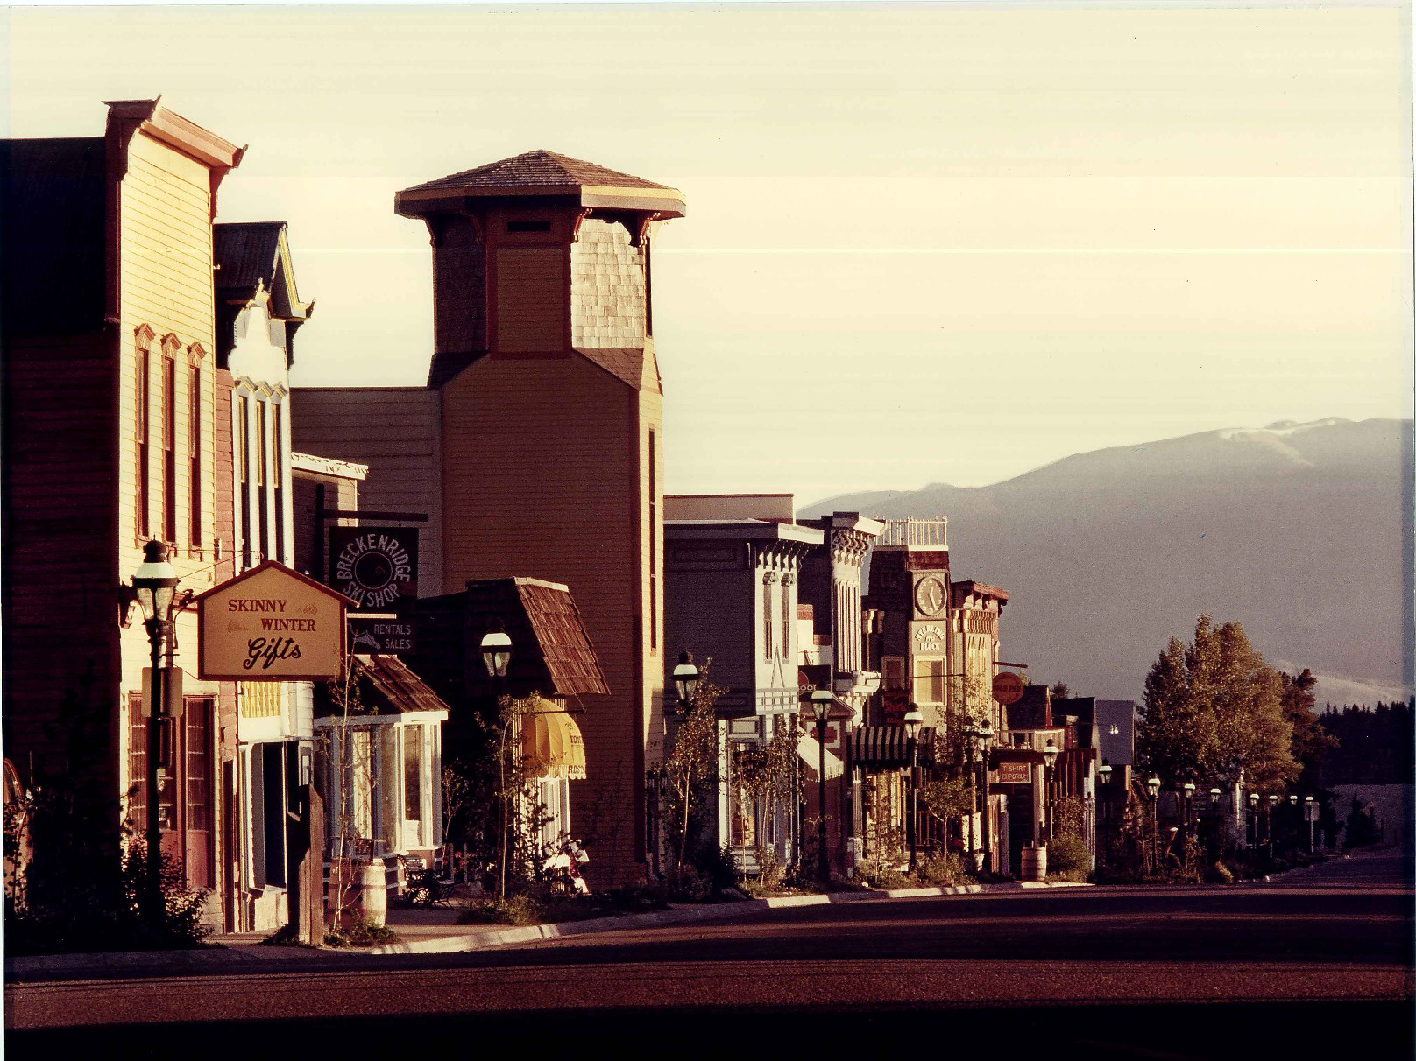
Georgian Square Mixed-Use Project on Main Street in Breckenridge, Colorado Design & CM by RBA, 1978

INTRODUCTION: REAL ESTATE - A SOUND INVESTMENT
Real estate or property development has always had a number of sound investment characteristics. First and foremost, in growing economies such as the UK and USA there is a continuous demand for its products. Secondly, real estate will in a stable economy assume its replacement value and this will continue to appreciate to keep up with inflation, a natural byproduct of our free enterprise, capitalist system where the cost of money sets the pace for growth. In addition, governments have created tax incentives to promote economic development utilizing property depreciation schedules to provide investors with tax shelters. Together these incentives will continue to attract institutional and smaller investors alike for the foreseeable future.
To the architect, the importance of understanding all the interacting financial and other issues presented in this summary cannot be overstated. Indeed, it gets to the very nature of development projects and the key factors affecting their success or failure. So, if architects want to gain their clients attention they must first be able to identify with their clients concerns and business goals. Knowing what the key variables are for any given project, will allow the architect to creatively discuss a broad variety of solutions which may well differ dramatically from preconceived notions the client may be evaluating.
With reference to the previous discussion we have seen how the benefits of a “one stop shop” accrue to both client and architect alike by including CM as an extension of the architects professional service. These include faster delivery, reduced costs and better, more flexible control of design throughout the whole design/construct process. In delivering the finished building as opposed to the construction documents, the architect has also considerably enhanced his potential partnership contribution toward the total development cost, should he elect to participate in the ownership of a project as part of
a group (Section IV, ahead) or as sole owner (Section XII, ahead).
If we review the pie chart (page 80) of typical project cost centers, we can see that the Architect’s fees for combined design and construction management services would represent considerable savings in development cost in regard to delivering the finished project. The G C’S profit margin associated with the construction also represents a major saving in the costs normally associated with competitive projects. These all combined, even if discounted 50%, can represent the Architect’s sweat equity and gives his project a huge edge against the competition, while also making the projects’ feasibility far less of a risk to the lender. Usually this will also translate into better interest rates and/ or the capability to offer lower, more competitive rents if called for by a downward changing market.
From the standpoint of their substantial contribution, Architects who are also construction managers are therefore the perfect partners to involve in any project. For the reasons outlined above, I would also go so far as to say they are by definition and in practical terms, in the best position to succeed in the business of development. Of course ultimately, nothing can take away from the entrepreneurial instinct, critical judgment and due diligence required to be successful . In this context let us review the basic issues which form the backdrop to the business of development. For illustration purposes, included are photos and data relating to three projects where:
1. Architect provides full professional design and CM services. (Georgian Square) 2. Architect participates as a joint venture partner, contributing professional fees as equity investment. (Beaver Creek Vista)
3. Architect is sole owner of an investment project. (West Beaver Creek Lodge)

(A) UNDERSTANDING THE RULES - HIGH RISK, HIGH PROFIT.
As vital participants in the development industry, architects are by any measure in an enviable position to benefit from their knowledge and experience, not just as consultants, but as equity owners in a project, either in lieu of, or in addition to their fee. In the US it has been estimated that about one third of architects participate in real estate development ventures on some level. Making this transition from passive consultant to active decision maker and real estate entrepreneur does however, come with the need for a strong commitment to understanding the operating rules of the game.
There is of course, a world of difference between mere speculation versus calculated risk, and what normally determines the success or failure of any venture. Here again the operative words are” due diligence”. The following insight into the business of development is therefore critically important to architects, but especially because it is also the driving force behind the efforts of any client to secure project financing. It is clearly a game of high risk, high profit, where the risk/benefit ratio must be determined as positive and worthwhile to both the lender and investor alike.

(B) THE IMPORTANCE OF TIMING AND THE ECONOMY.
To begin with, in this high stakes arena where positive and negative economic cycles ebb and flow, timing is everything. The trick is to time the projects’ completion to coincide with an upswing in market demand for its product, so that the expectations and rates forecast in the feasibility analysis can be achieved. Beyond the matter of timing, the challenge to the developer in financing his project lies in demonstrating the positive cash flow of the proposed development, presents the lender with a minimum of risk.
Outside of the projects feasibility, the primary speculation therefore, lies mostly in forecasting the state of the economy at the end of the projects’ completion, given that this is typically one to three years into the future. At the end of the day, however, committing to any speculative development project does take a leap of faith, because the consequences of missing this mark can be serious if not disastrous for both developer and lender alike. This is why the game is typically, but not exclusively played by well healed, seasoned players.

(C) PROJECT FEASIBILITY AND THE ROLE OF LENDING INSTITUTIONS.
First and foremost, understand that lending institutions are not in the “risk- taking” business. On the contrary, they only accept projects which are relatively full-proof and compatible with their own portfolio and experience. Economic and political stability is therefore critical to the development community and, should conditions change unexpectedly the developer must have the financial resources to cover a worst case scenario. Here the importance of an exit strategy cannot be overstated. The reason some projects fail is that they focus too much on the upside versus the down side.
The lender is in the loan business where the basic commodity for sale is money, and does not want to end up in the real-estate or property management business. This possibility too however, is a valid consideration on his part in making his decision to go or not go with the projects financing and under what terms. Weighing all aspects of the project, the greater the perceived risk, the more demanding are the lenders terms, to the point where they can render the projects feasibility un-supportable.

(D) CRITICAL DETERMINATIONS IN EVALUATING THE VIABILITY OF DEVELOPMENT PROJECTS.
The business of development is as much an art as a science. The importance of vision on the one hand and determination on the other cannot be overstated in a business underpinned by insight and speculation. At one rational end of the evaluation, the three most important considerations with regard to real estate are said to be “location, location, location”. At the other end, the notion that “build it, and they will come,” has as many examples of successes as failures. So, beyond the more subjective pronouncements, what are the key tangible considerations when an architect or developer contemplates the viability of a project? These will include the following, but first let’s take a look at all the costs which are normally involved in a typical project. With reference to the pie chart, (page 115) note in this generic example the chart breaks down the retail sales price of a typical project into its constituent parts as follows:
o Total cost of construction is approx 50% of the retail price.
o A &E fees represent 5.5% of retail price or 11% of total construction cost.
o The GC makes a potential profit of 11%.
o The developer, a potential profit of 22%.
o Land cost can vary dramatically but normally will fall in the range of 15% to 20% of total retail price of the project. If it is more, then the project proposed is probably under developed or the land is overpriced.
Note: 1. The above are based on the retail price of the project, not its construction cost. So that
the 5.5% for professional fees actually represents 11% of total construction costs.
2. Serious delay in the sale or lease can cost the developer as much as 1% per month.

Typical Project Cost Centers Based on Design/Bid/Build Delivery Model
(based on experience accumulated from numerous projects)
Cost center | Original value
A. Construction Costs (Actual) | 39.0%
B. Construction Costs (Overhead & Profit) | 11.0%
C. Developer’s Potential Profit | 22%
D. Real Estate Sales Commission | 7.0%
E. Land Costs | 15.5%
F. Professional Fees: Architects & Engineers | 5.5%
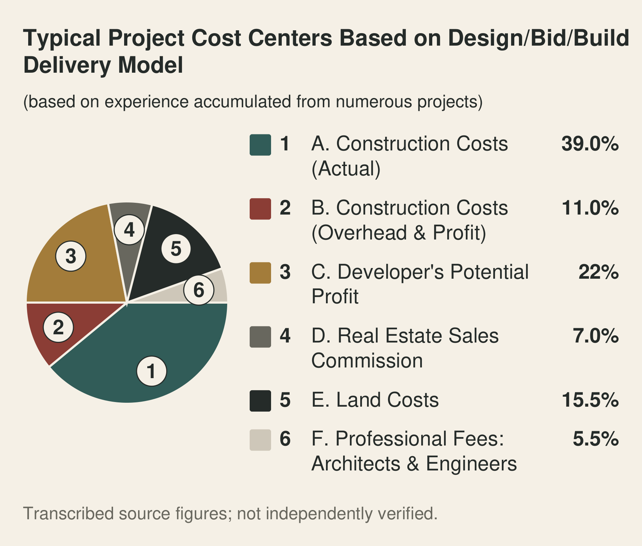
Typical Project Cost Centers Based on Design/Bid/Build Delivery Model
Note:
1. The lower half of the pie represents the lowest tender price of a typical Construction Project.
2. When we eliminate the General Contractor and substitute combined Professional Construction
Management with Design Services for a Project’s delivery, two significant changes occur:
o Actual Construction Costs represented by A. (39%) are reduced - see pages 33 thru 42.
o Related Overhead and Profit Costs represented by B. (11%) is replaced by the
Architect’s fee for Professional Construction Management Services.
3. In addition, there will be significant improvements in a Project’s delivery time and quality.
Together, these represent considerable savings on a Project’s total cost to the Client.

(I) THE ARCHITECTS NORMAL INVOLVEMENT
In the course of his career an architect can be presented with the prospect of participating in a development project in a number of ways. Normally of course, he is approached by developers of building projects who have a basic project outline or concept based on calculation or market analysis, experience or even intuition. Sometimes all three. Typically, these entrepreneurs want only to consult with the architect for design services and are not looking for a joint venture partner unless seed money is tight, or there is a perceived need for a higher level of design or construction management commitment required to ensure the projects’ success. At this point, and assuming that the proposed project is again determined to be essentially sound, (more on this calculation shortly) the architect is presented with certain options with regard to the various types of agreement for his remuneration. Usually, he will agree to a stipulated fee for a defined scope of services to be paid on a progress basis.

(II) THE VALUE OF THE ARCHITECTS COMBINED DESIGN AND CM SERVICE
Alternatively, if his risks are greater than normal, (e.g. because planning or zoning is not assured and the client wants the architect to exchange this portion of his fees for a percentage share holding in the project, the architect is in a position to request more than his basic fee. Or else, he may present the client with a partnership agreement before preparing any related studies, because if approval is not forthcoming he stands to forfeit his remuneration. Here, it is important that the architect not under estimate the value of his partnership contribution which should now be expressed in terms of a percentage of the seed money or initial capital required to float the project, as opposed to percentage of construction cost. Additional consideration needs to be factored into this assessment when the architect is also responsible for determining the development concept.
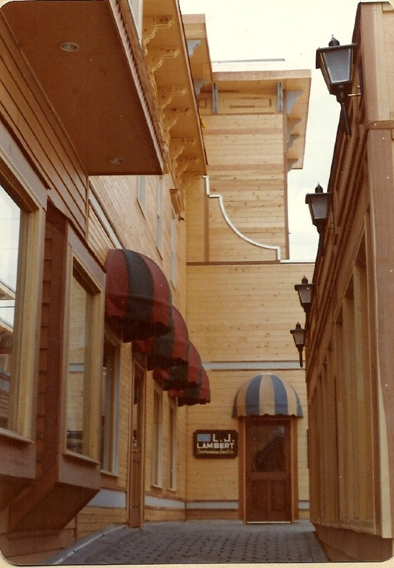
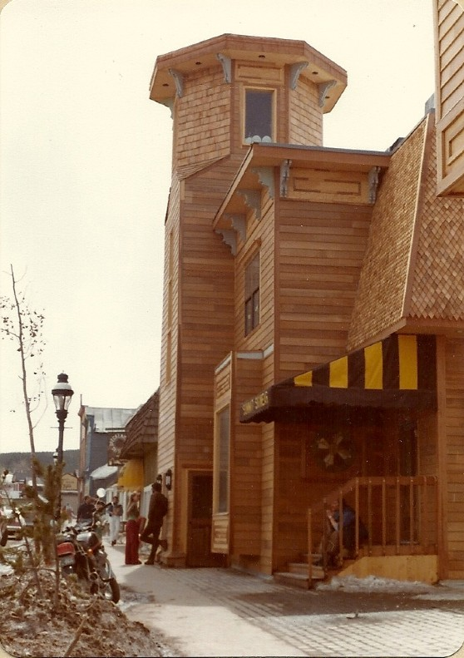
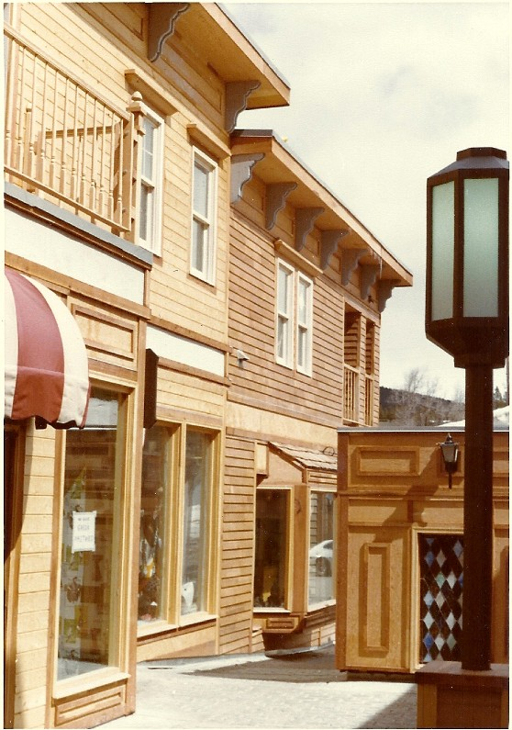
When marginal projects with questionable feasibility, or for that matter, financially weak clients present themselves, it is of course critical to reject these outright. An architect can make these preliminary determinations quickly by making his own “ball-park” economic evaluations. In this regard it is important to distinguish between project cost and mortgage value. Value is not always a function of cost. A lender does not give a developer $2 million because the project costs $3 million and the lender will lend 67% of that amount. If he does get $2 million it will be because the value of the project is $3 million, not the cost. Value can be determined on the basis of replacement cost, comparables, or for rental or commercial applications, more appropriately income potential. The following is one simplified variation of feasibility study commonly used by mortgage bankers in arriving at project value. It is helpful to make these calculations in two parts. Part A, Determination of projected cash flow. Part B., Cash return on equity invested. The subject project is Georgian Square, Breckenridge,Colorado, completed 1978.

(III) FEASIBILITY ANALYSIS - Example: Georgian Square Mixed Use Project
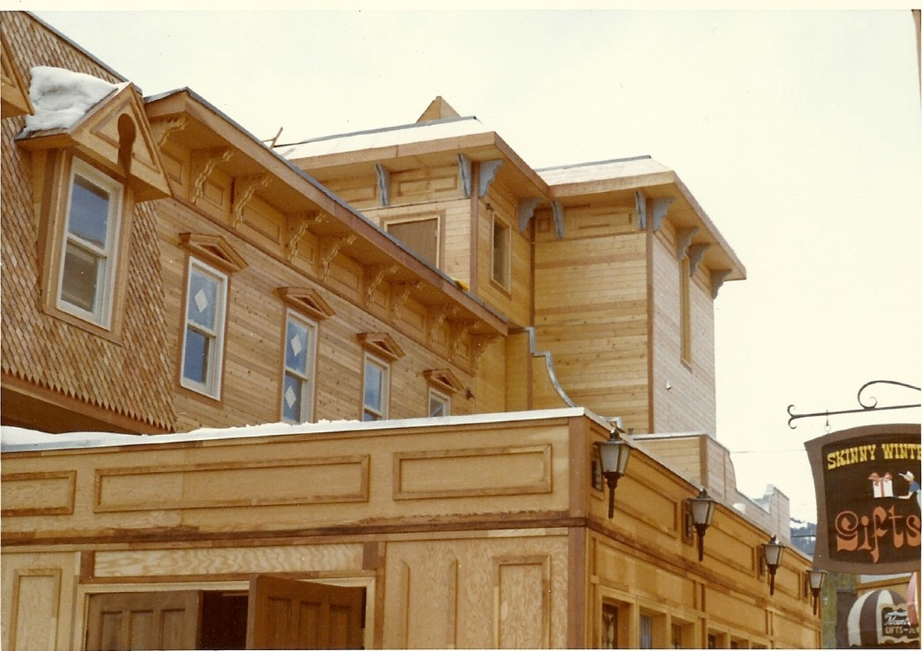
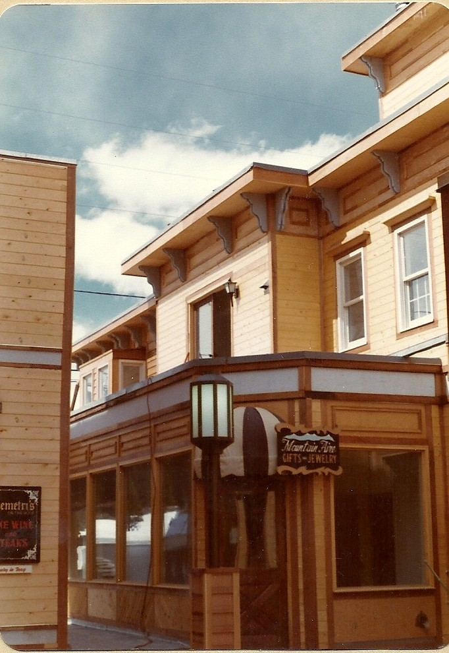
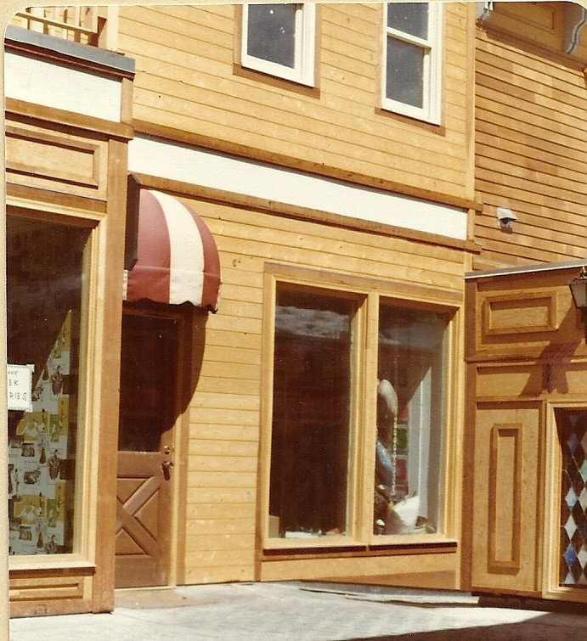
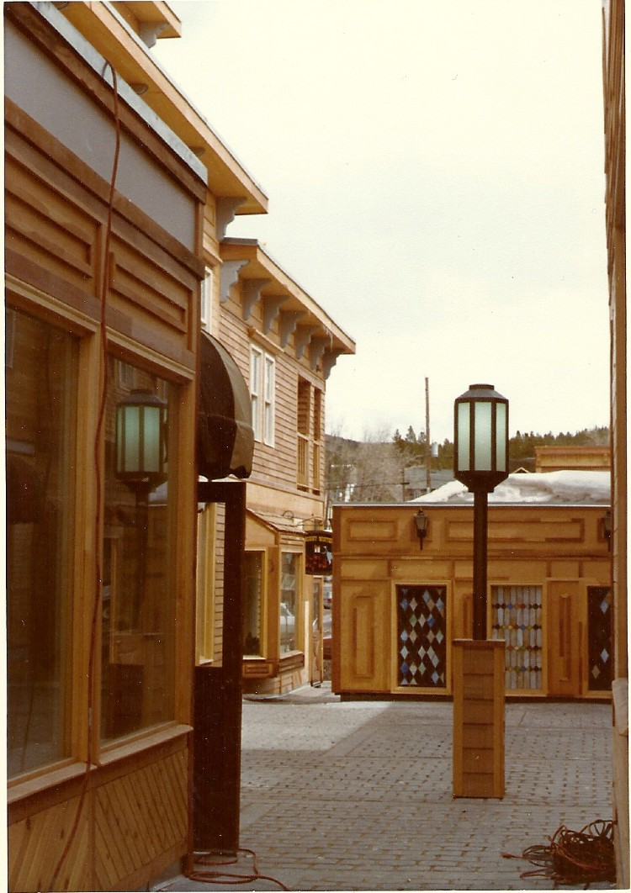
Construction progress photos of Georgian Square prior to completion in December, 1978 .
Integrated Design and Construction Management services by RBA on this complex, mixed-use project made it possible using Fast-Track Construction Methods to complete on time and on budget within a 12 month period. The building program provided for offices, retail shops, four restaurants and four living units for a total of 25,000 gross square feet.
Part A
- Multiply the rent per square foot by the number of square feet net leasable area to determine the gross rent.
Georgian Square 25,000 sq. ft. gross
22,000 sq. ft. net leasable. Going rate per sq. ft. = $9.00
Gross rental income = $198,000.00
- Multiply gross rent by the ratio of vacancies plus expenses to determine the vacancy
and expense allowance.
Conservatively let’s say 20% x 198,000 = 39,600
- Subtract the vacancy and expense allowance from the gross rent to arrive at the net income
198,000 - 39,600 = $158,400
- To determine project value, now “capitalize” the net income: i.e. divide the net income by the “cap rate” (variable) The simplest way to understand capitalization and cap rate is basically this; How much money would it take to produce the same return based on the current cap rate ( Usually expressed by the lender as the current interest rate plus a margin - let’s say 8% .
$ 158,400 divide by 8% = $1,970,000
- Multiply the project value by the mortgage ratio ( determined by lender- say .50) to determine the amount of the loan.
$1,970,000 x .50 = $985,000
- Multiply the loan amount by the debt service constant (say 10.0%) to determine the amount of debt service which must be repaid annually to the lender.
$985,000 x .10 = $98,500.
- Subtract the debt service from the net income to determine the cash flow (before taxes) remaining for the equity investors.
158,400 - 98,500 = $59,900.
Part B
- Subtract the loan amount from the actual project costs (hard costs only i.e. land and construction cost) to arrive at the actual equity which must be invested by the owner.
project construction cost = 25,000 x $42.00/s.f. = $1,050,000
add land cost ……………………………………………… = 200,000
sum total …………………………………………………… = 1,250,000
Equity to be invested by owner ($1,250,000 - $985,000)= 265,000
- Determine your cash return on equity invested. If it is not more than 20%, the project cost is too high, the rents are not high enough, or something else is wrong.
59,900 on 265,000 = 22.60% (before tax )
This kind of analysis by the Architect will make sure the project is not way out of line. Remember that if a project’s value is $3 million and it justifies a $2 million loan, the fact that it costs you $2.2M means that your equity must be $200,000. If the actual project cost is $2.5 million, your loan will be the same (assuming the value is still $3 million), so you must then invest $500.000 instead of$ 200.000. This difference in the loan amount and the cost of the project must be invested by the owner before any mortgage funds can be drawn for construction. This usually requires that at the very least the land is “free
and clear” and in the legal ownership of the owner.
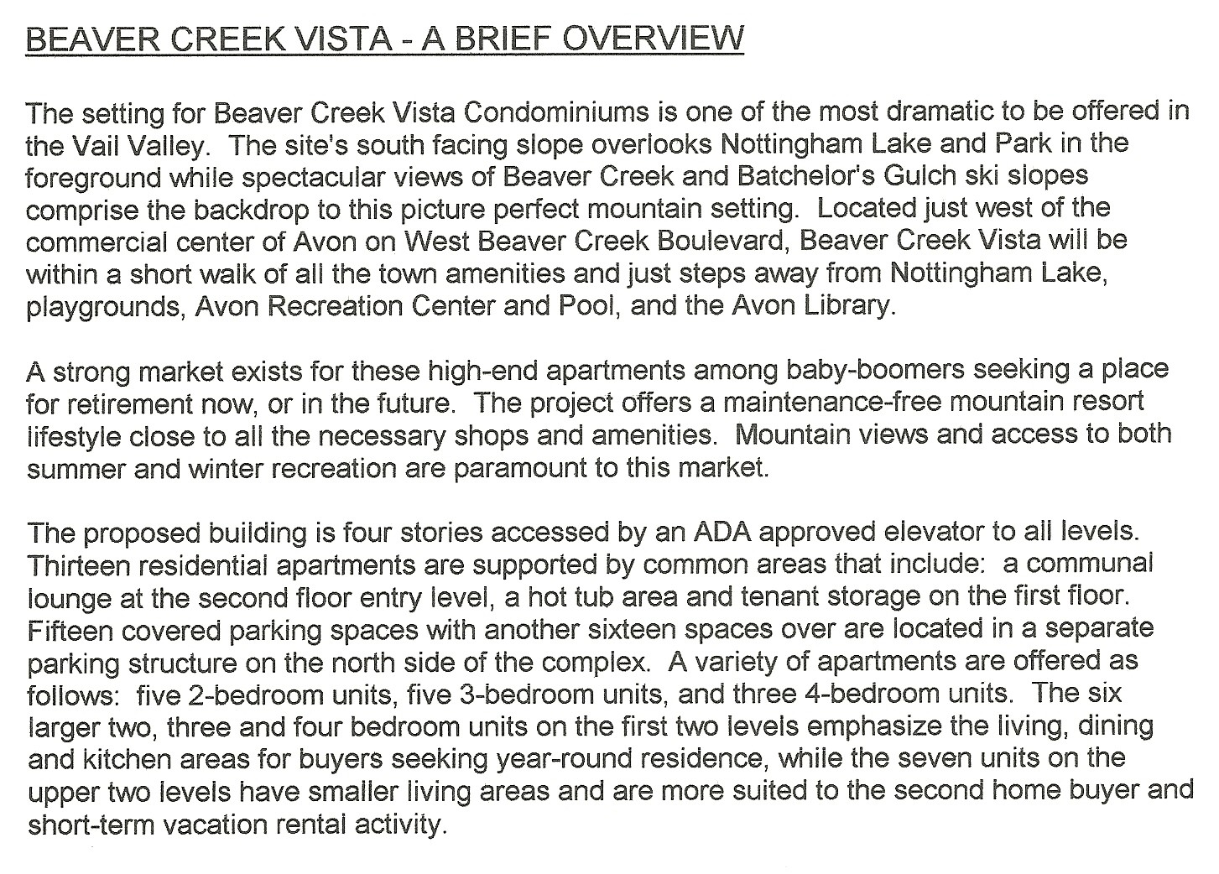

(IV) ARCHITECT AS EQUITY INVESTOR - Example: Beaver Creek Vista Condominiums
An architect becomes an equity investor when he contributes all or some of his fees to the seed money necessary to float the project. This is of course when the risks are greater. As such he is in a position to command a greater share of the action, the earlier he comes into the project. Once the project is approved together with a mortgage commitment, additional investing partners can then be drawn in if necessary, and for a reduced share of the equity to reflect their reduced risk. The principle here is not to give up project equity until necessary.
The following is sample data prepared for a lender’s review relating to a joint venture partnership project (Beaver Creek Vista) between the owners of a vacant development lot and the architect/construction manager.

Beaver Creek Vista Project Cost Centers
Based on Professional Design and CM Delivery Model
Cost center | Original value
Construction Costs (Actual) | 50.0%
Real Estate Sales Commission | 7.0%
Professional Design & CM Service Fees | 7.5%
Developer’s Potential Profit | 23.8%
Land Costs | 11.7%
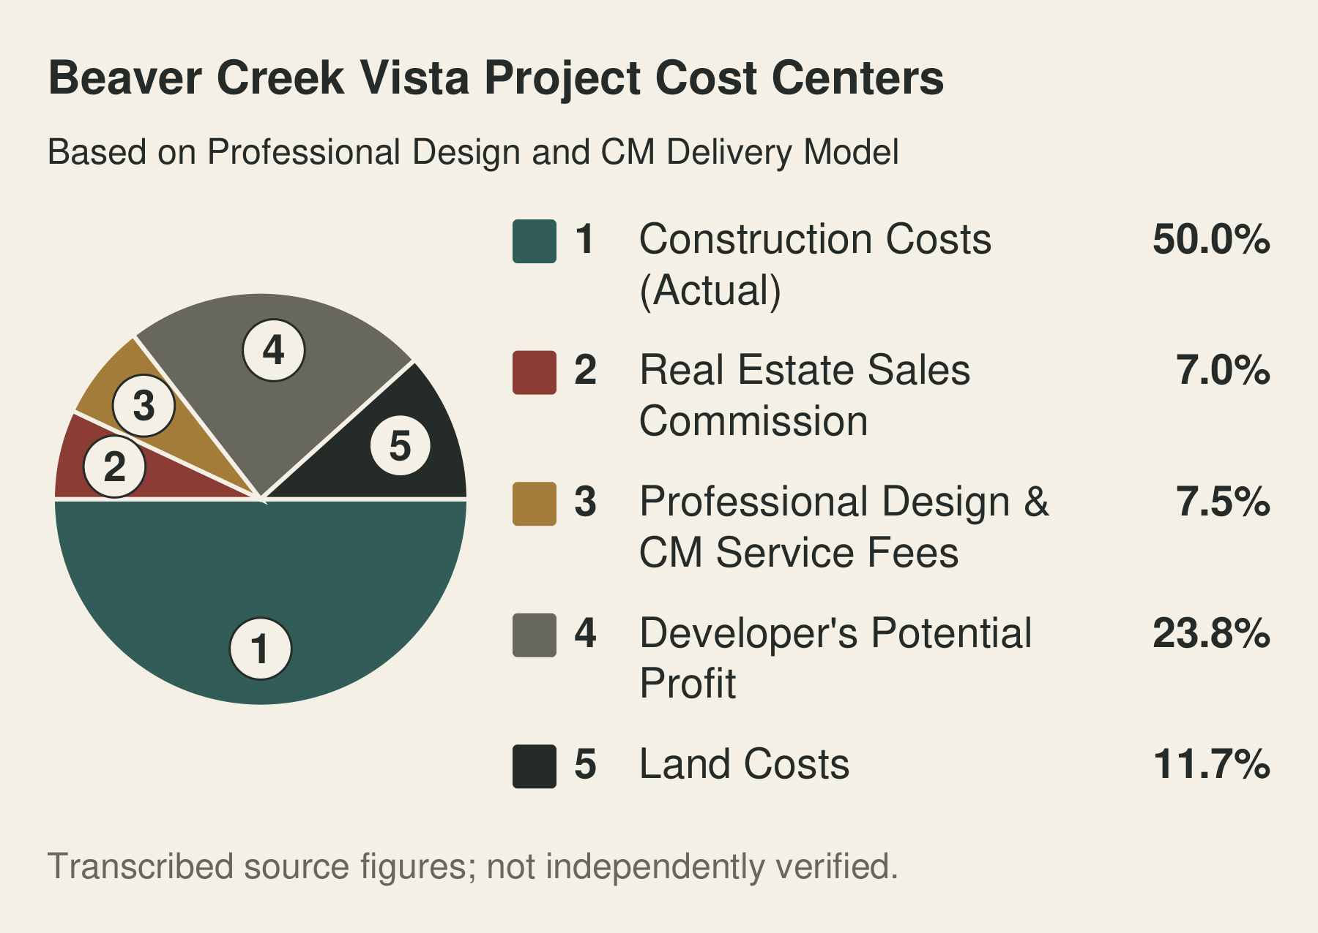
Beaver Creek Vista Project Cost Centers
The above pie chart reflects cost data summarized in the following addendums #1 through #6. The value of the project was $6M. Construction cost estimates a total of $3M. Land owners contributed $700K in land equity. Architects and Construction Managers $450K in professional services including engineering costs. The total equity investment by the partnership $1.150M. Upon completion of the project the option of selling the units versus renting them for a period to realize additional appreciation was a consideration given that the market was on the rise.
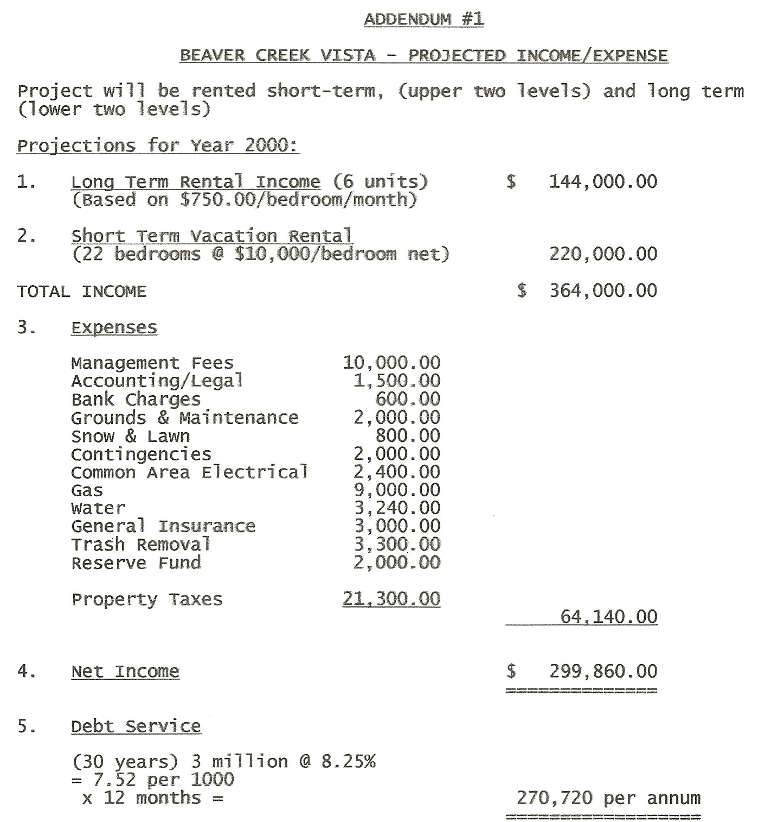
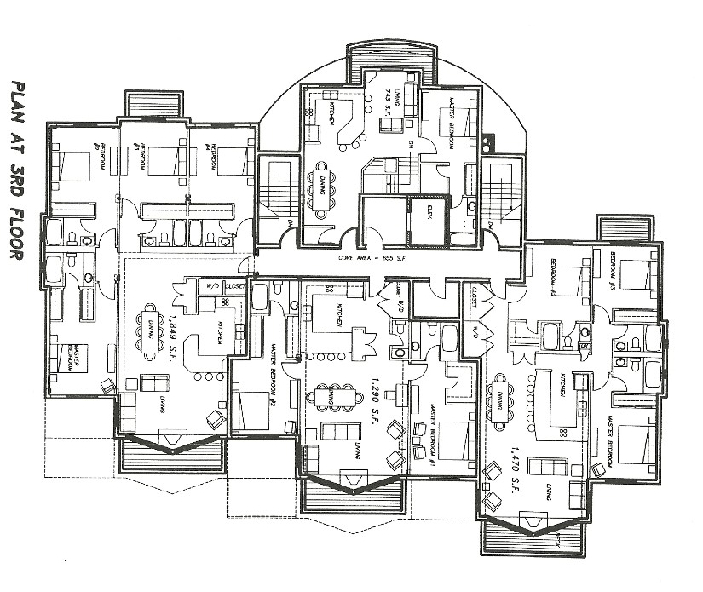
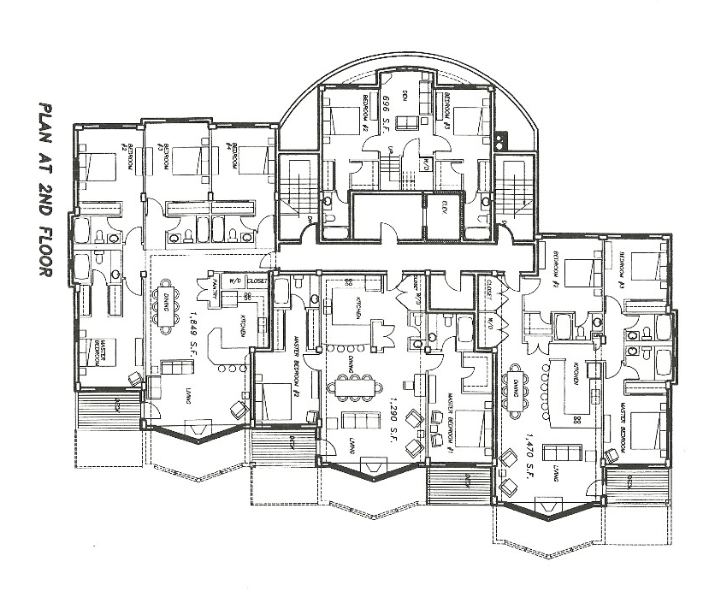
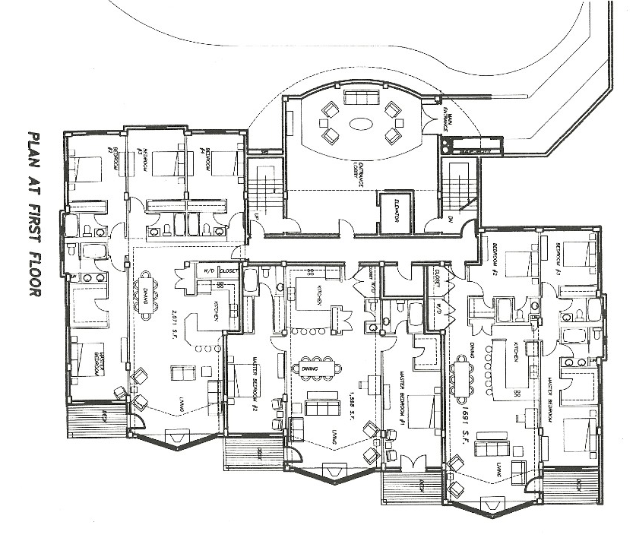
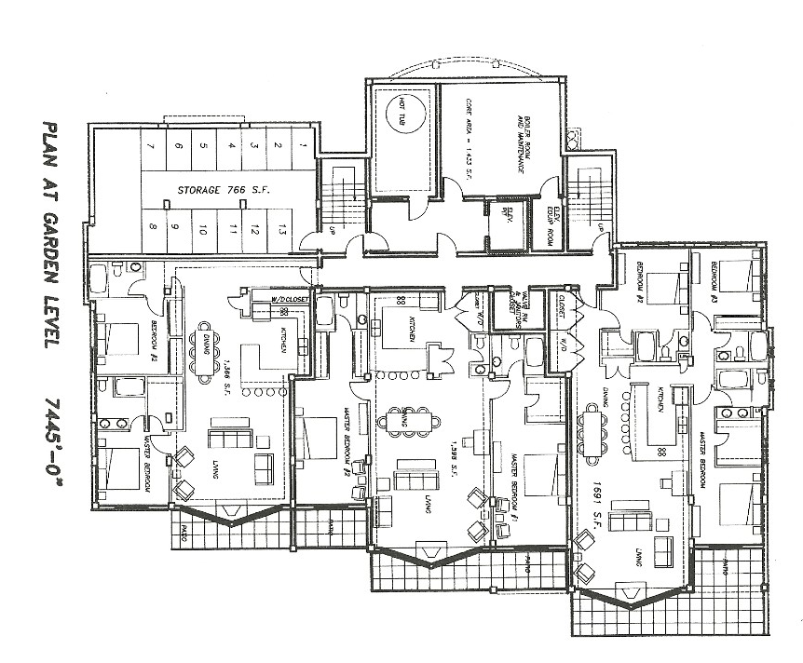
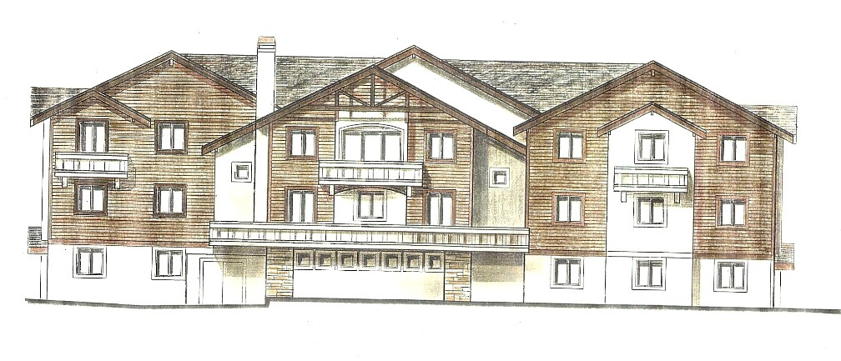
North Elevation
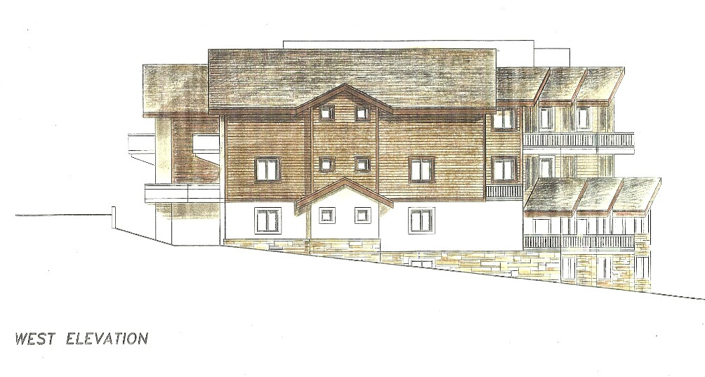
West Elevation
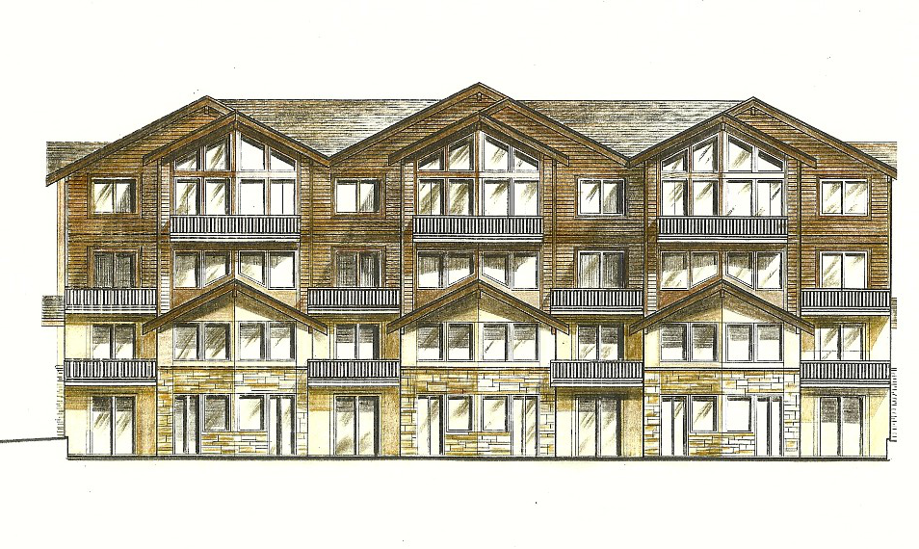
South Elevation
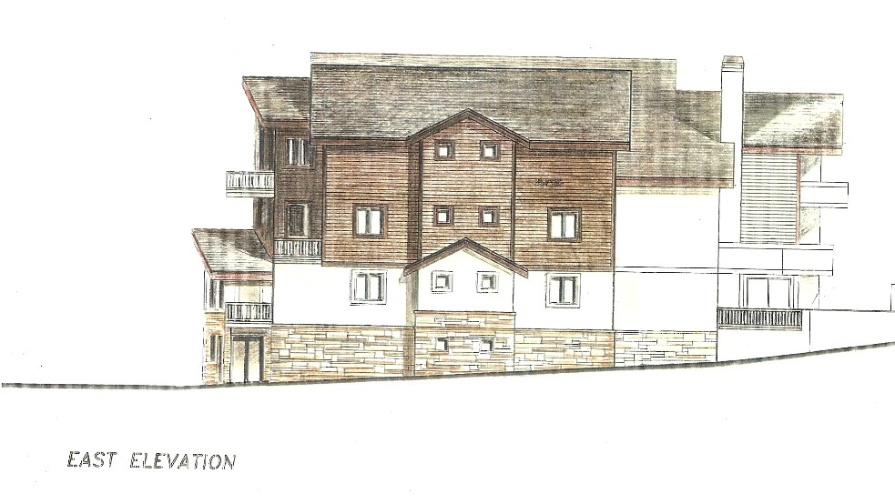
East Elevation
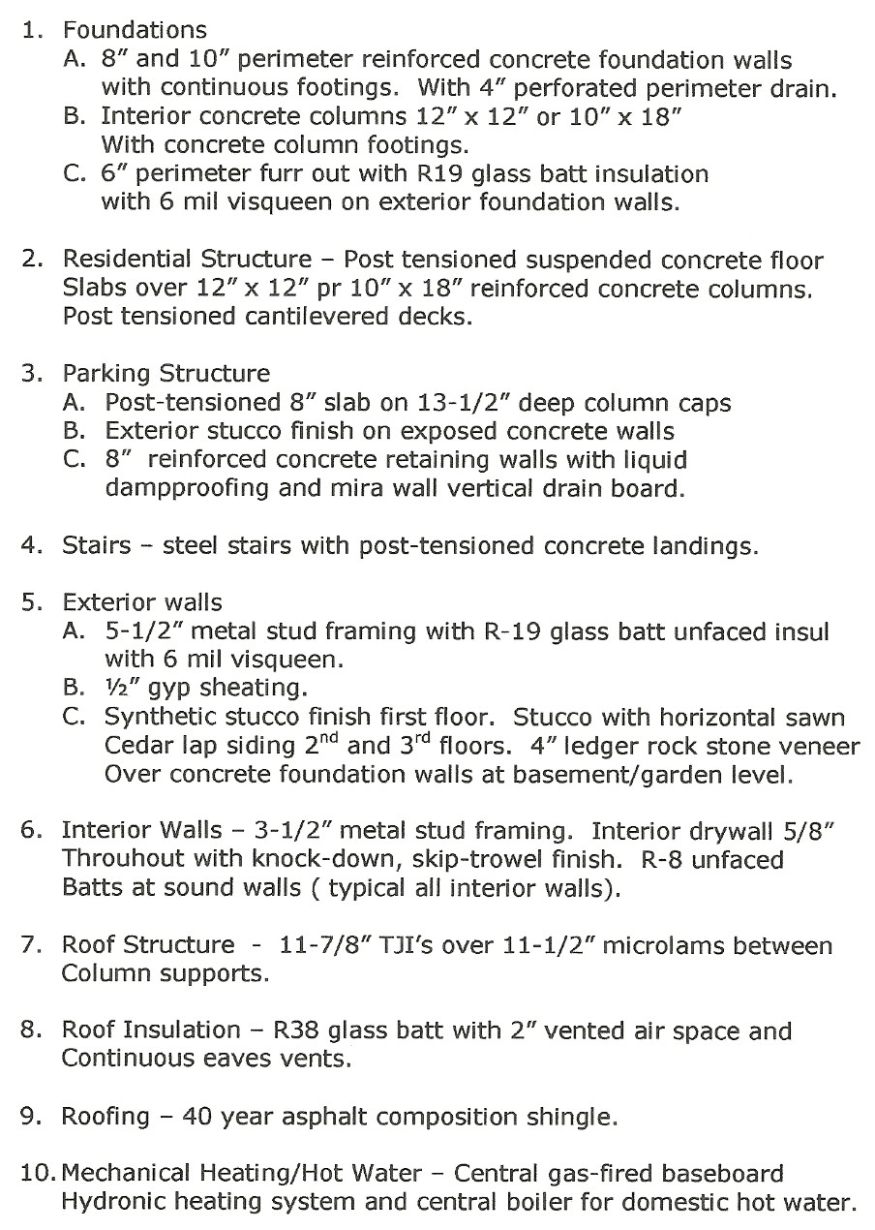
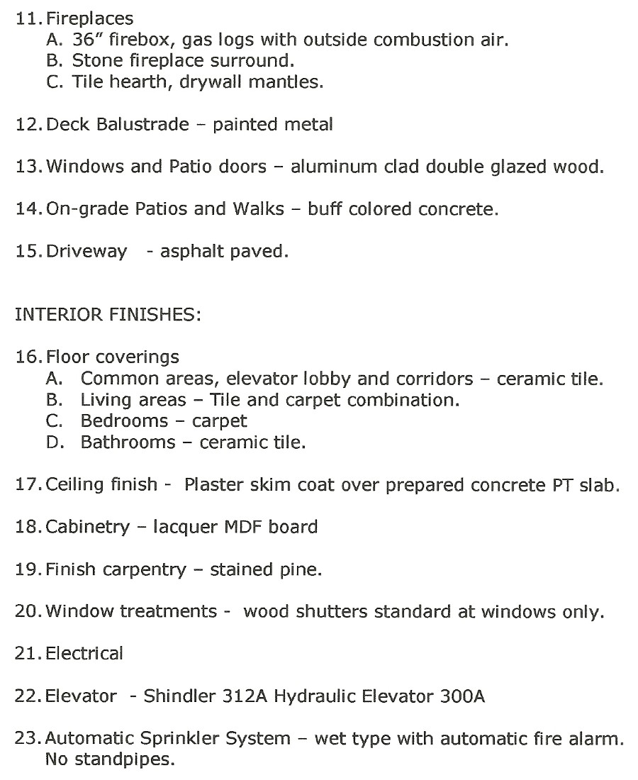
Outline Specifications Prepared for Lender
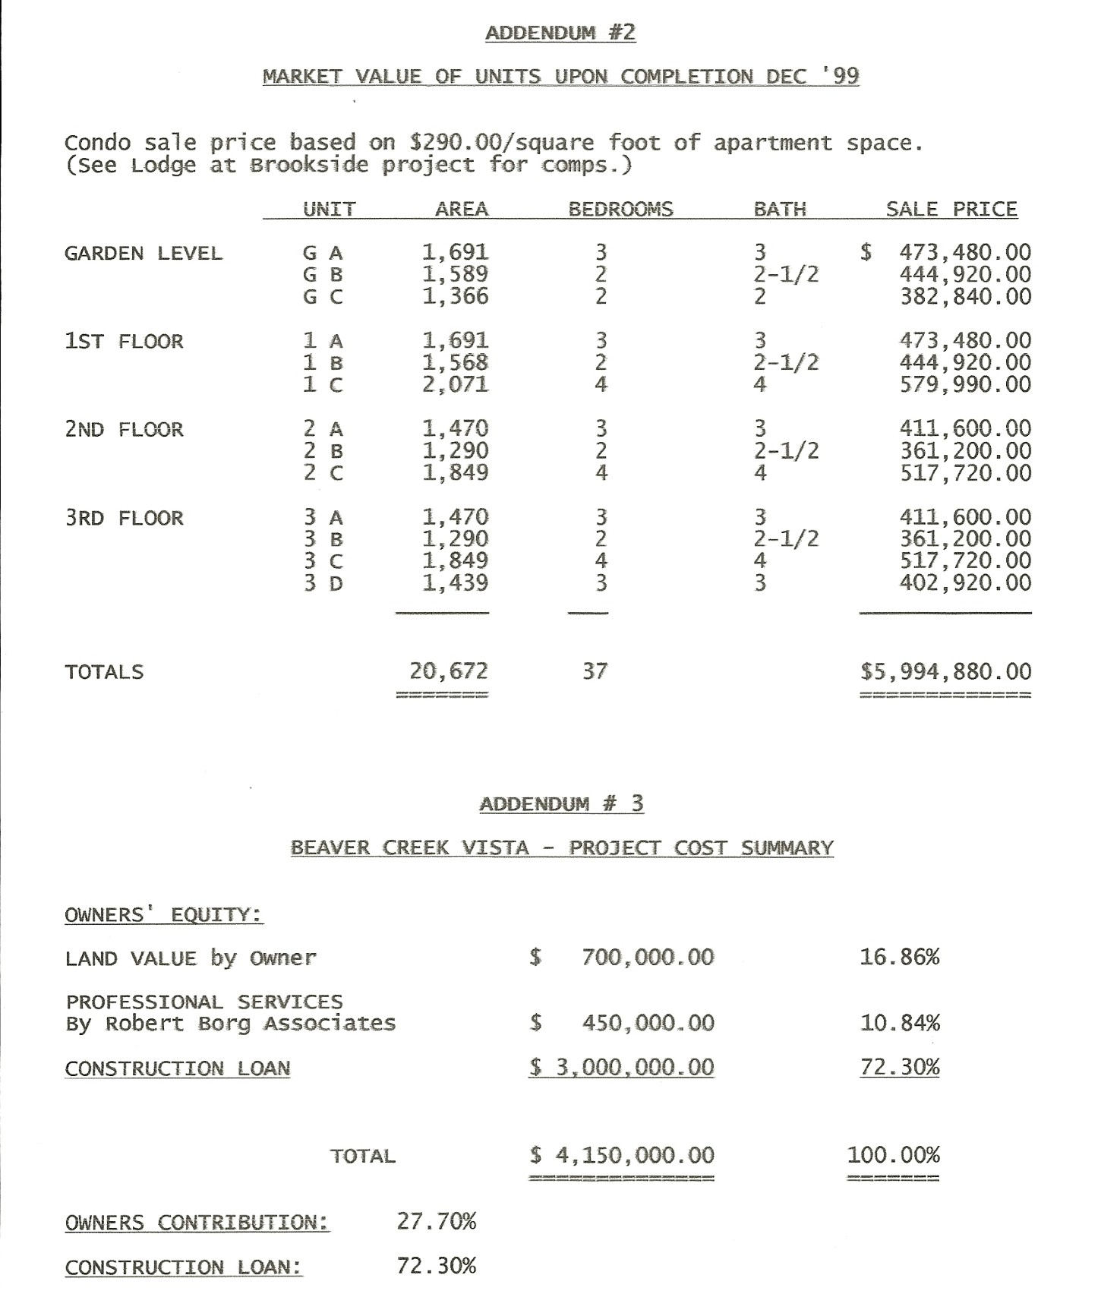
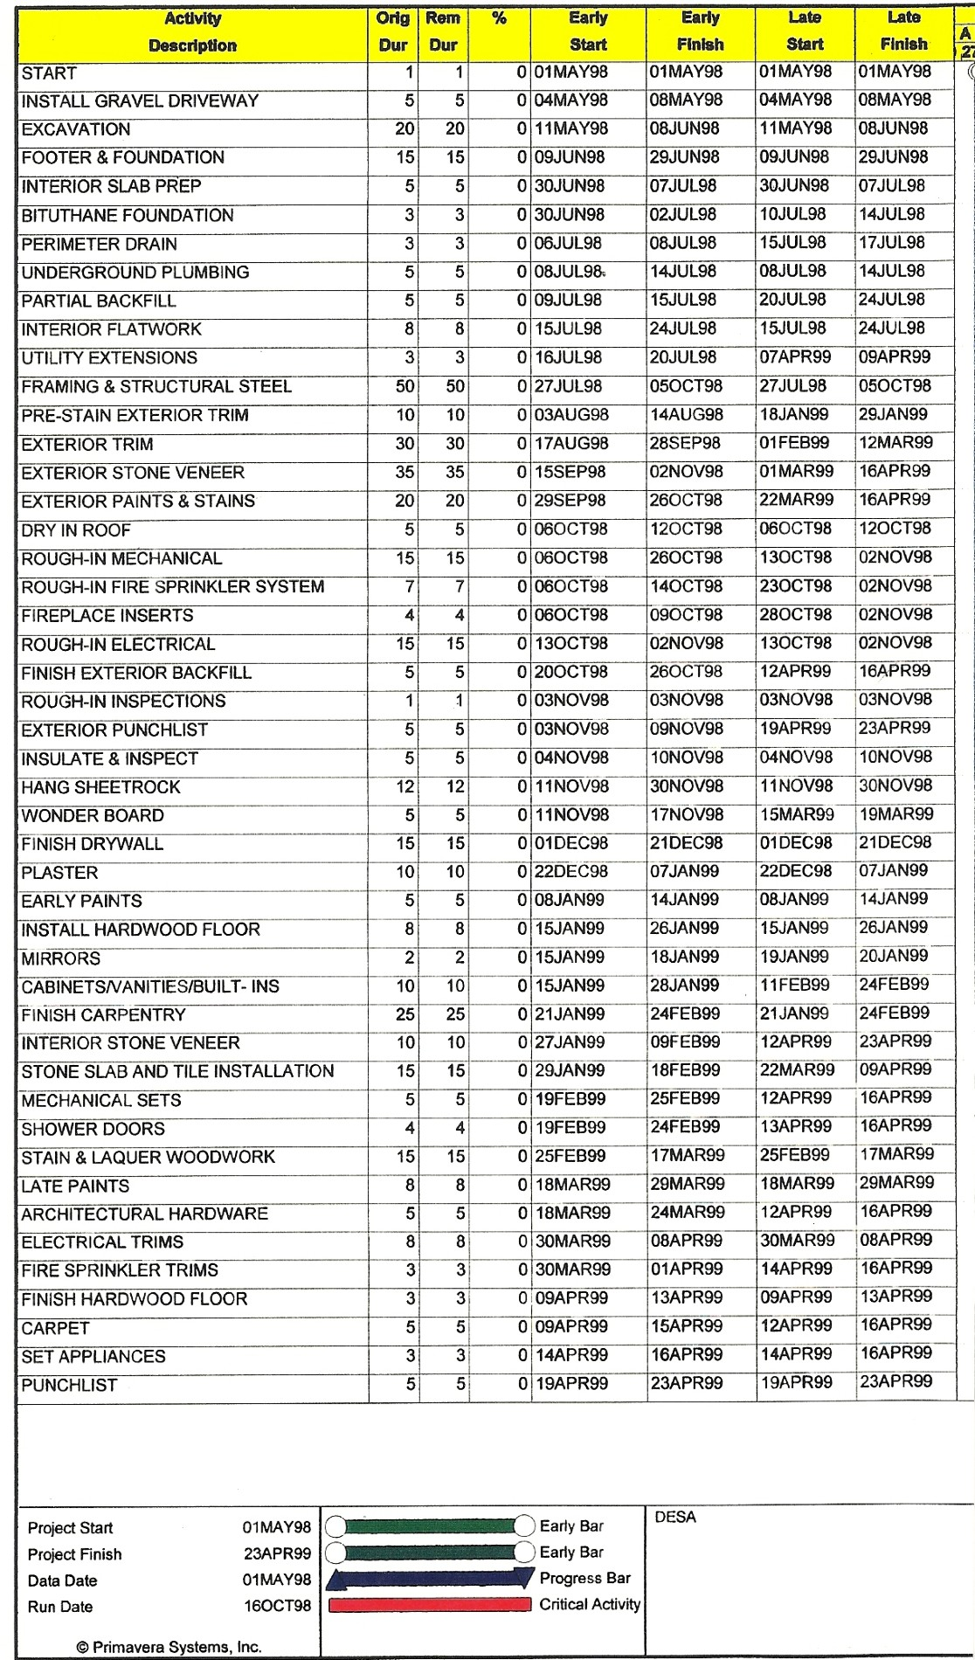
KEY NOTES:
Numerous software programs for construction management are available. This one is by Primavera Systems, Inc.
The attached schedule lists construction activities in sequential order vertically, against a 12-month timeline shown horizontally starting in May of 1998 and finishing in April of 1999.
Each activity is given an early start and finish date together with a late start and late finish date as color coded below.
The critical activities controlling the earliest completion of the project are shown in red.
This is an important tool used in construction management that requires monitoring on a weekly, if not daily basis to ensure timely project completion. The impact of any deviations must be evaluated by the Construction Manager.
It is critical that all players contribute to and approve the timeline so that all trades and material supplies are coordinated well in advance of commitments.
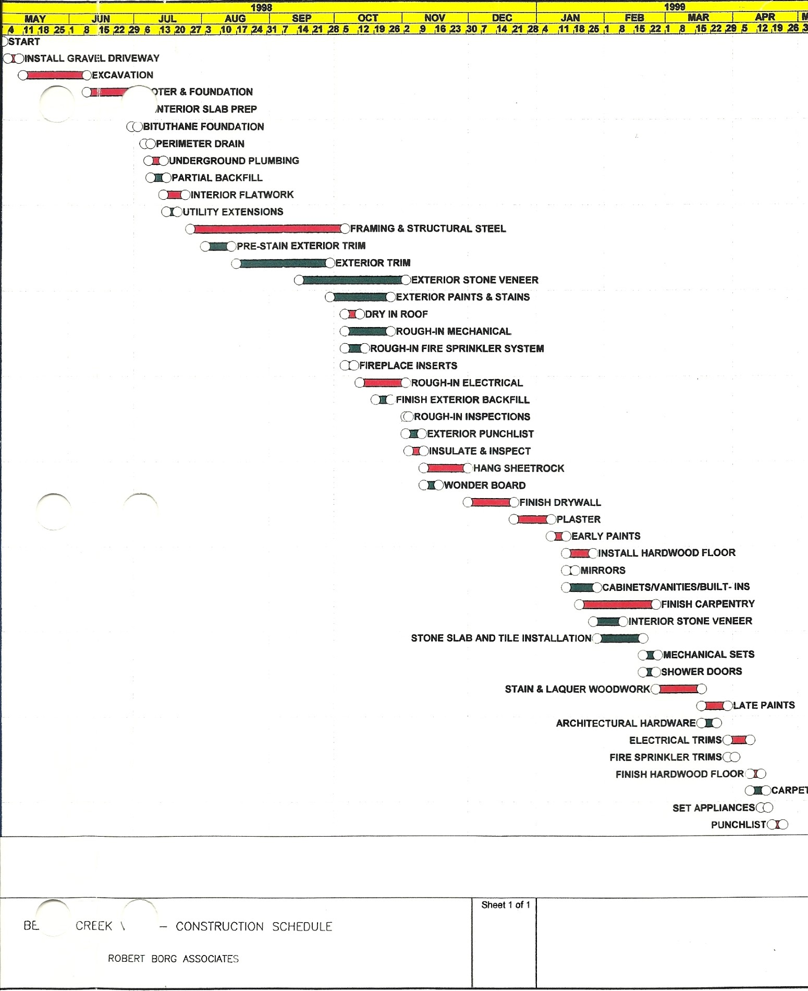
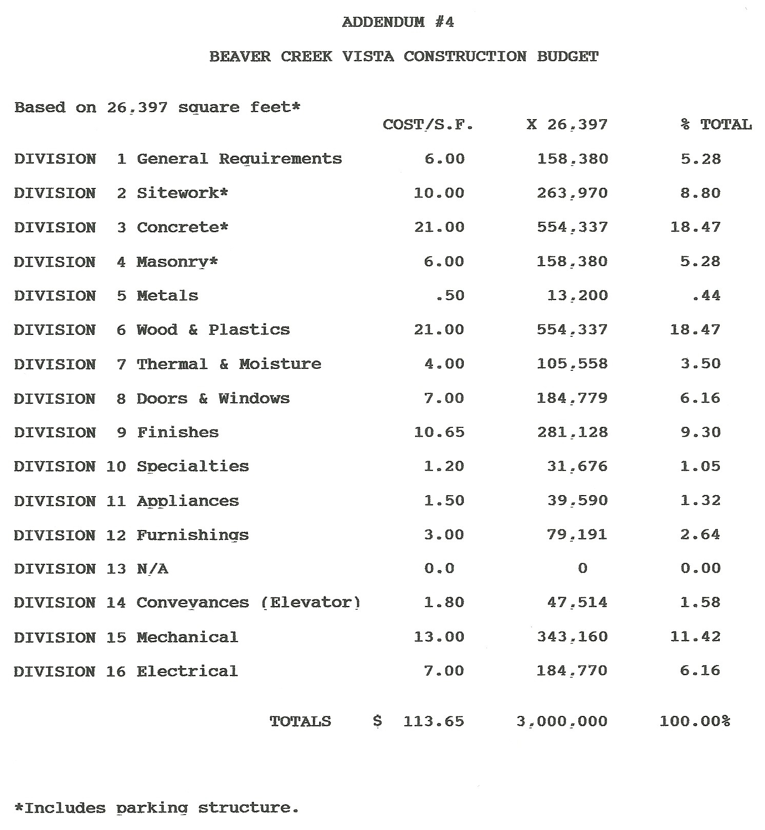
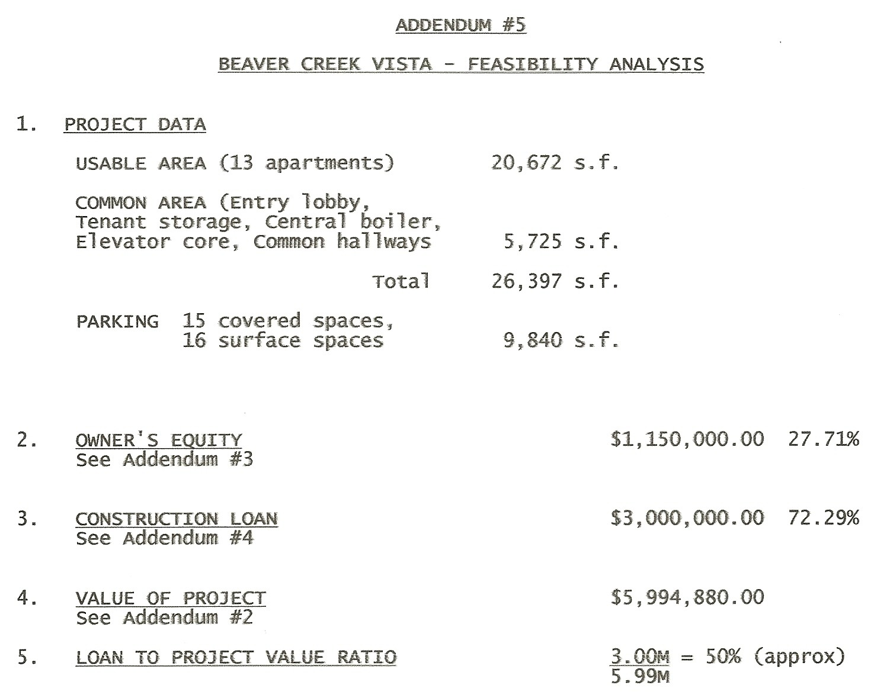
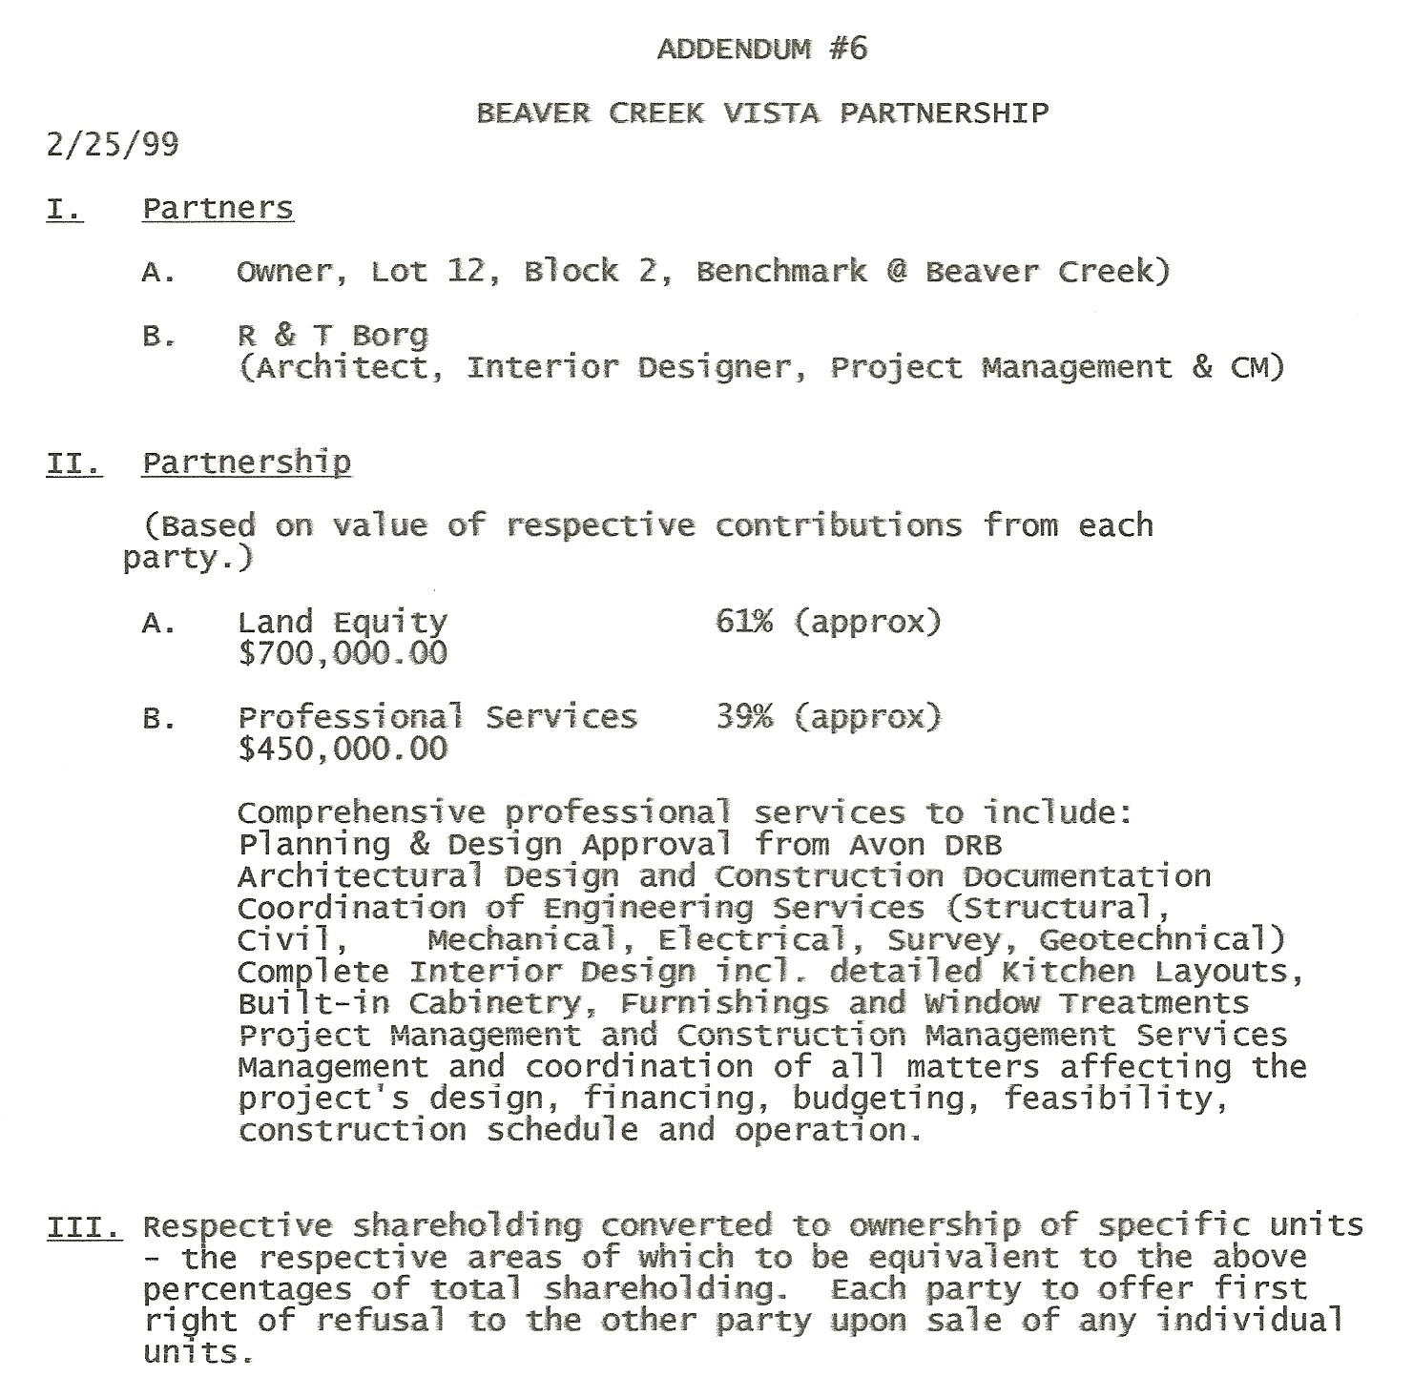

(V) PROJECT FINANCING
A knowledge of basic financing techniques is most useful in matching the type and scope of the project with appropriate financing. Typically a construction loan is available upon approval of a short term stand-by commitment, or a permanent loan. Of the two, the stand-by commitment is preferable because it does not lock-in the term of the loan for a period of ten years or more and at an interest rate higher than achievable once the project is up and leased and the rents and income no longer a matter of speculation. A prerequisite for any loan approval is usually a minimum of 40% pre-sale or pre lease prior to the project’s construction start. In less certain times this can be substantially greater.

(VI) THE IMPORTANCE OF PRE-SALES OR PRE-LEASE AGREEMENTS
Permanent lenders will often condition their loans on the achievement of 80% of projected rents and will more favorably appraise a project which is actually leased. The difference in the amount of the permanent loan commitment and full construction cost will require so called gap” financing, the source for which can be private investors or an institutional lender. Upon securing these loan commitments the construction lender will provide an amount equal to the full permanent loan.

(VII) EQUITY TAKE OUT
Upon completion of the project, a developer is in a position to take his equity investment out by selling off all or part of the project to an institutional investor looking for sound projects to acquire, and then leasing it back. Of course rental payments will diminish future income to the developer, but the sale and lease back will usually result in a substantial current profit for him as well as the return of his capital. There are other techniques used to facilitate the extraction of investment capital which vary according to the specific goals of the investor.

(VIII) THE TRUE COST OF BORROWING
In estimating the total construction cost of a project, the cost of borrowing i.e. the loan interest should be calculated factoring in a higher rate than the stated rate. This will vary according to the lenders assessment of the borrower, the strength of his project and the source of the funds. So called discount points are added to cover a higher rate of return for the lender than the so called prime rate and it will for this reason always be higher than the stated rate. Another technique is to require the borrower always leave a compensating balance of 20% of the loan in the bank, which has the same effect.

(IX) DON’T DELAY
When a project passes the feasibility test, there is no advantage to delaying its start. When interest rates are high however, this results in higher “cap” rates, which in turn means lower project values and therefore smaller loans. As a result it becomes more difficult to get a loan which will cover all project costs without bringing in private investors. As a rule of thumb, construction costs will go up 1/2 of one percent per month. Every months delay therefore is a permanent loss of almost 10% of a year’s income from the project. In addition property taxes and other carrying costs must be paid regularly on unproductive property. Faced with these hard facts a developer cannot afford to wait.

(X) CONSULT ON FINANCING EARLY
The success of a project depends on three main factors: location, market and financing. Financing is frequently the deciding factor on whether a project goes forward. It is therefore most important to consult with a mortgage banker early, based on preliminary proposals and before committing to a full blown construction loan package. A competent mortgage banker should also be able to develop an appraisal quickly and then advise on potential methods of financing. Suffice it to say that dealing with the wrong lender will cause unnecessary delays no valid project can afford.

(XI) LOAN APPLICATION PACKAGE
This following brief overview is intended to give aspiring architects a basic understanding of the back ground information required by lenders for a loan application.
- The lenders’ loan package requirements are exhaustive and are described below: 1. Personal and business background information relating to the owner.
2. Financial statement of the partnership and entity. i.e., net worth (assets minus liabilities) Liquidity and holding power.
Real estate owned - income producing and non income producing. Liabilities, outstanding loans and their nature. Most lenders require individual or personal liability statements. Asset liability ratio very critical. Same for partnership.
3. Specific partnership information which qualifies the entity as a good risk or
uniquely qualified.
4. How long in business. Here the lender is looking primarily for related experience.
5. Other similar projects under the partnerships’ belt.
6. A professional company brochure.
(B). Information relating to the land parcel and its location together with applicable codes and building ordinances. Also, available utilities; their depth and location, height and bulk restrictions area map and all significant info relating to transportation, traffic count, nearest airport, history of general growth, etc.. Much of this will be assembled by the marketing consultant.
(C). A statement relating to the need for the project. Why is it viable. Supporting newspaper articles, personal studies relating to growth in the area, vacancy etc. Also existing competition in the area and what you propose to do that is different and better. This is separate from the professional marketing study.

(XII) The Architect as Sole Owner - Example: West Beaver Creek Lodge, PUD

West Beaver Creek Lodge Project Cost Centers
Architect/Construction Manager as developer of his own project
Cost center | Original value
Construction Costs (Actual) | 50.0%
Engineering Fees | 2.0%
Potential Developer’s Profit and Sweat Equity | 38.0%
Land Costs | 10.0%
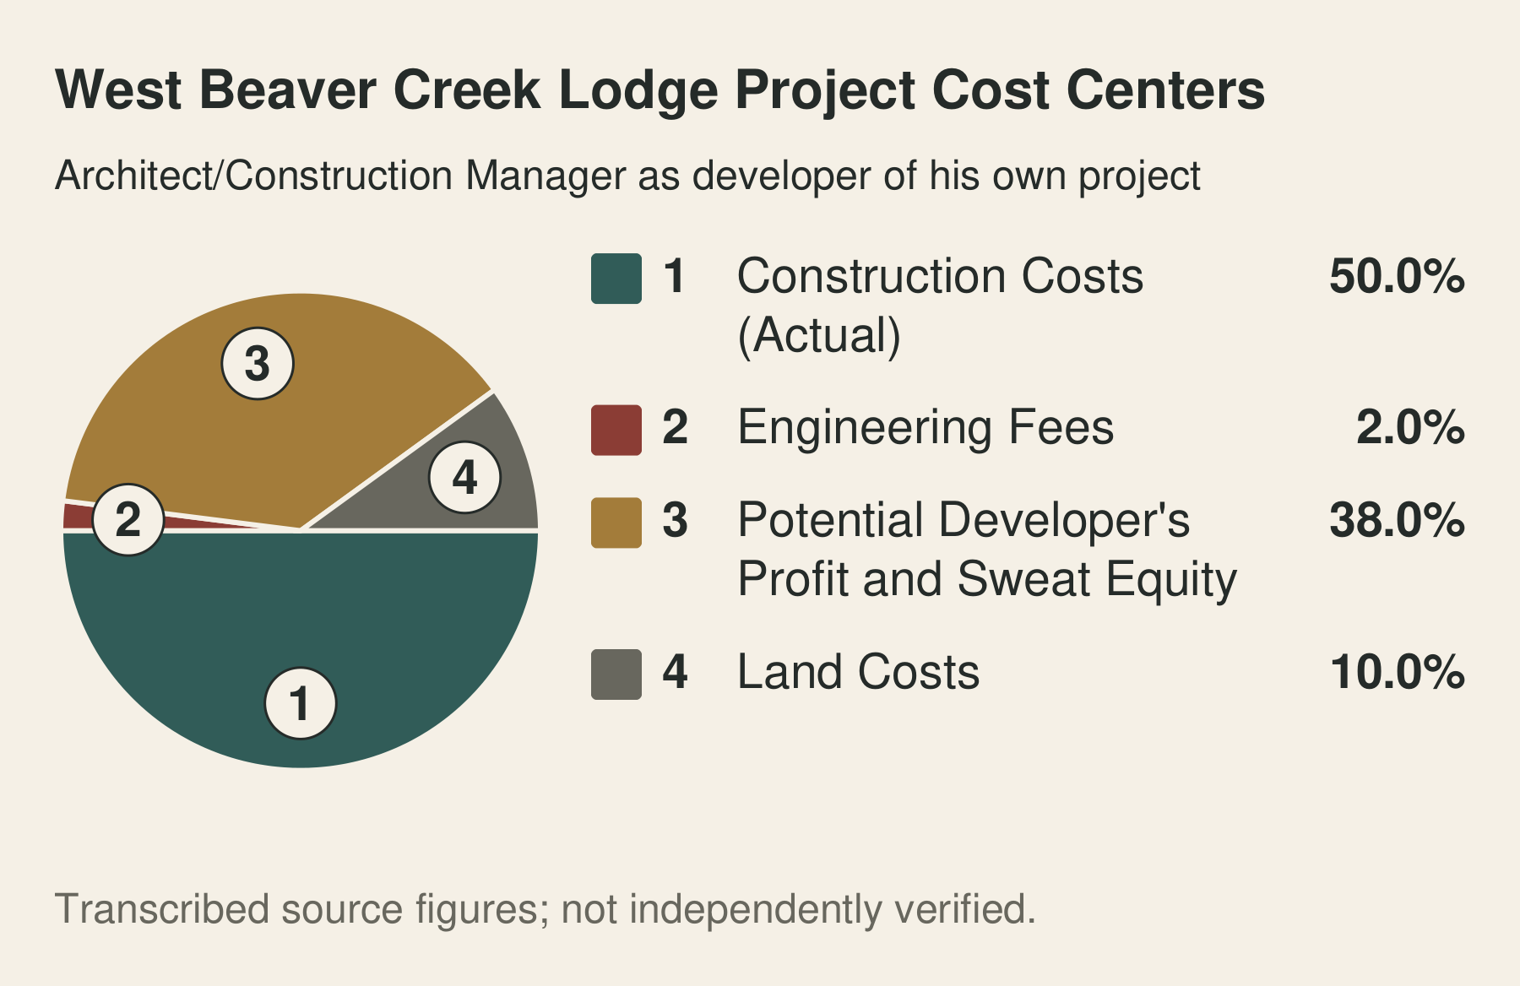
West Beaver Creek Lodge Project Cost Centers
In the course of serving as a consultant to owners and developers of investment projects, the Architect will come across opportunities in which he may wish to participate, using his own personal resources. The following is an example where the Architect developed for himself an 8,000 s.f. Bed & Breakfast/Private Residence Club using fast track construction to complete the project in eight months and within the budget target. Comparing the above pie chart with that of the Design-Bid-Build model, note the elimination of 11% GC Overhead & Profit. This 11% saving was re-invested to the benefit of the project in terms of higher quality design, materials and finishes together with complete furnishings all of which would translate into a higher sales price. If sold, the 7% Real Estate Commission would reduce the Developer’s Profit to 31%.
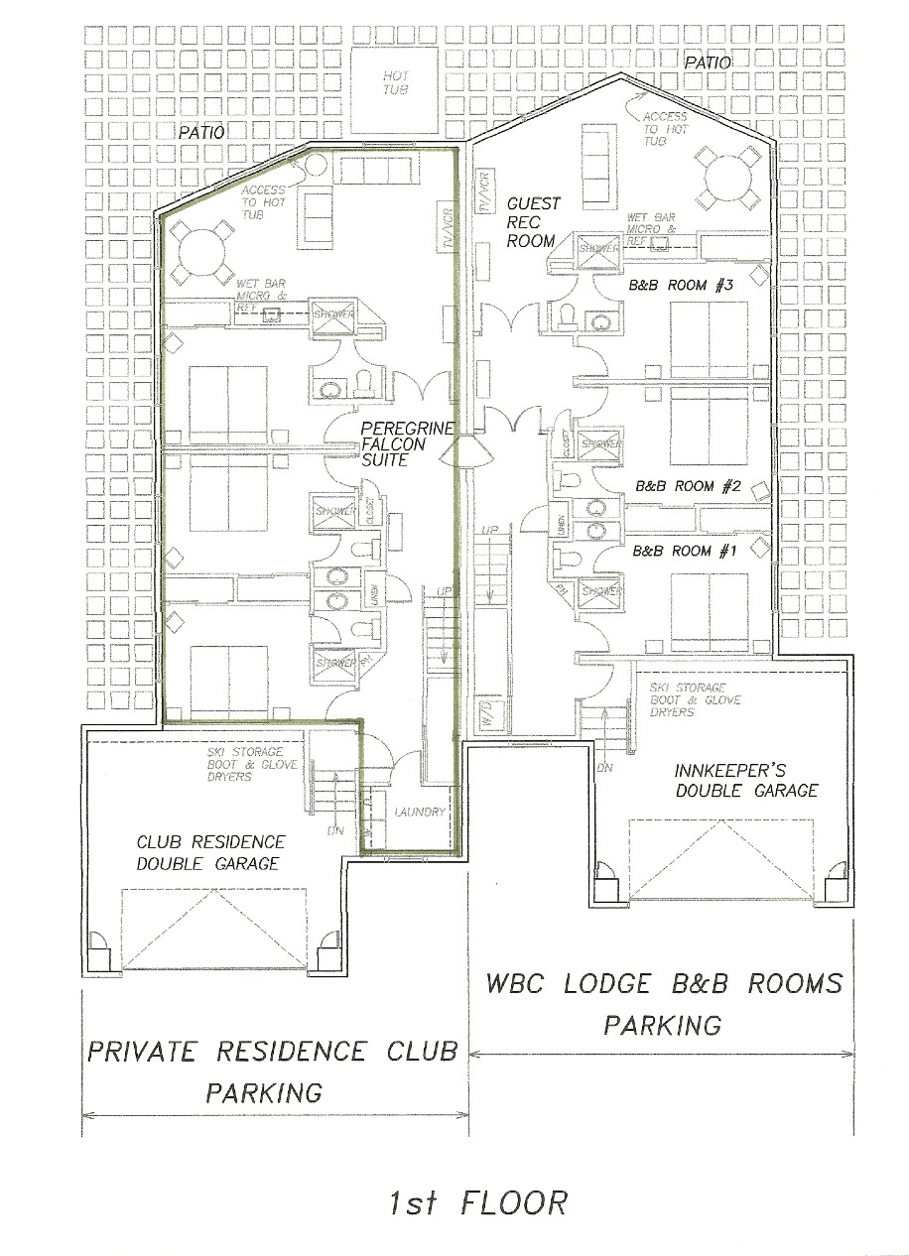

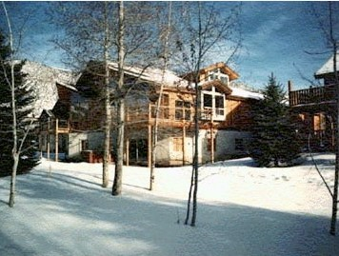
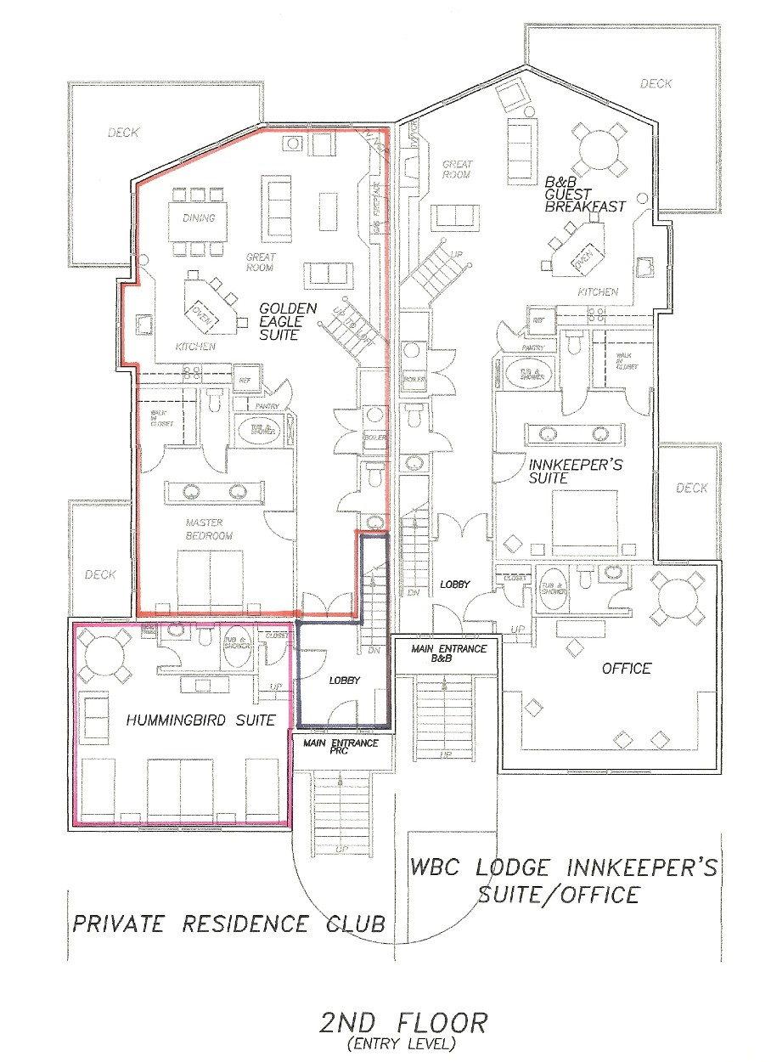
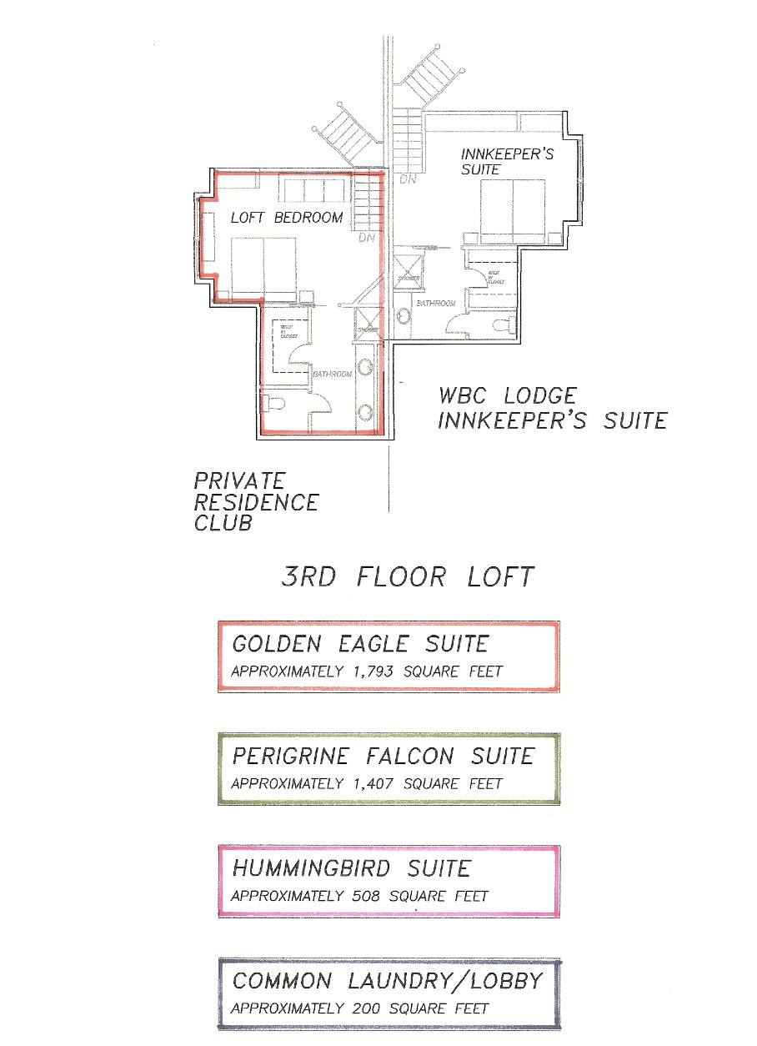
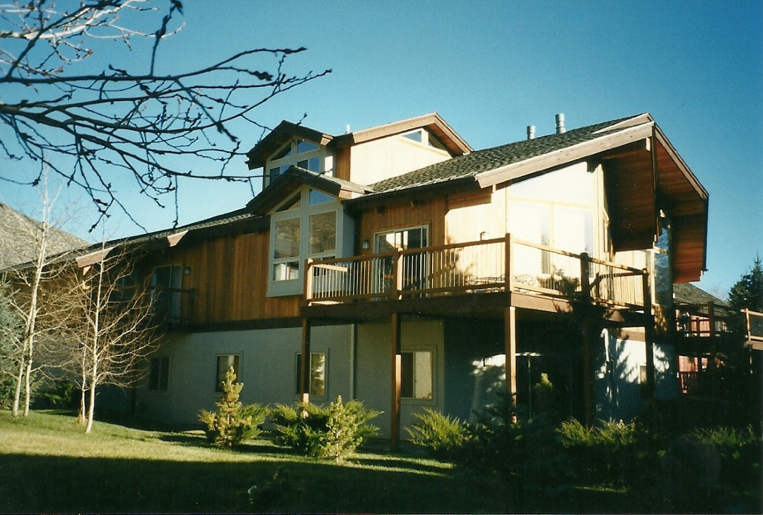
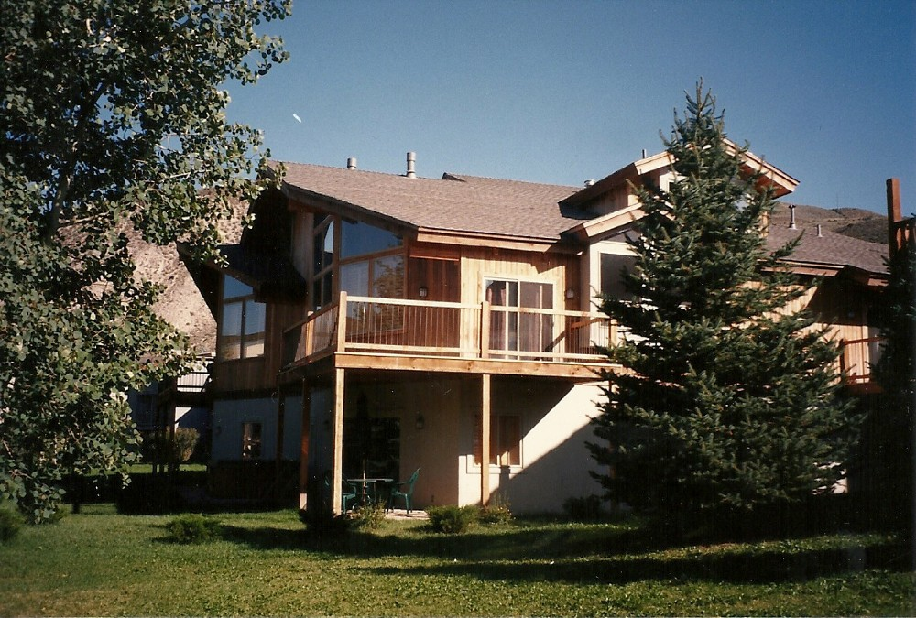
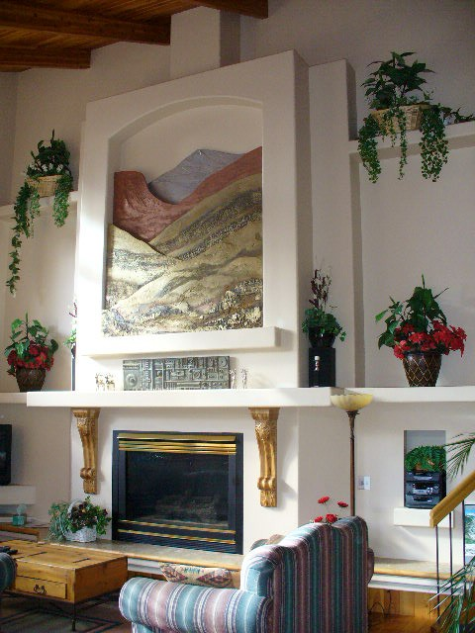


(E) Large Scale Development - Los Algadones, Sonora, Mexico
Illustrating the need for comprehensive evaluations and the integration of creative planning, architectural design, and construction management solutions.
Los Algadones near San Carlos, Sonora, Mexico was a 2,000 acre, multi-million dollar resort project by the Woodmoor Corporation and represents development on a grand scale. This project by virtue of its location, climatic setting, unusual scale and local building resources, required a complete appraisal of both architectural and planning criteria. Following a study of the local construction, it was proposed that modern technology be applied to adapt and improve traditional local skills, techniques and materials towards higher standards of finish and faster production rather than replace available local skills. The use of two basic materials, the native adobe brick and concrete in an indigenous style of architecture thus became the design theme for the project.
Preserving the existing site amenities of mountains, beach, exotic vegetation, and majestic views presented the greatest challenge. The large scale of the project and the need to phase its development over a realistic time-frame and within a flexible, comprehensive economic plan presented certain practical problems, too. These were resolved by going to a village unit concept, fifteen villages in all. (See page 108.) Existing site values could thus be preserved and only a small area of the site need be affected at any one time. Plentiful open space, ease of access to all site facilities and aspects of security are some of the values incorporated within the development of the total design/planning concept.
The following five drawings are partial samples of the culmination of these efforts to integrate all the above into a workable, phased program. The first drawing is the master plan for the development showing all fifteen villages separated by open space and golf course. The second drawing highlights village number one with single family units on the periphery and clustered town house development around a community core. This is illustrated to a larger scale in the third drawing which shows how parking is confined to the periphery and pedestrian walkways are preserved.
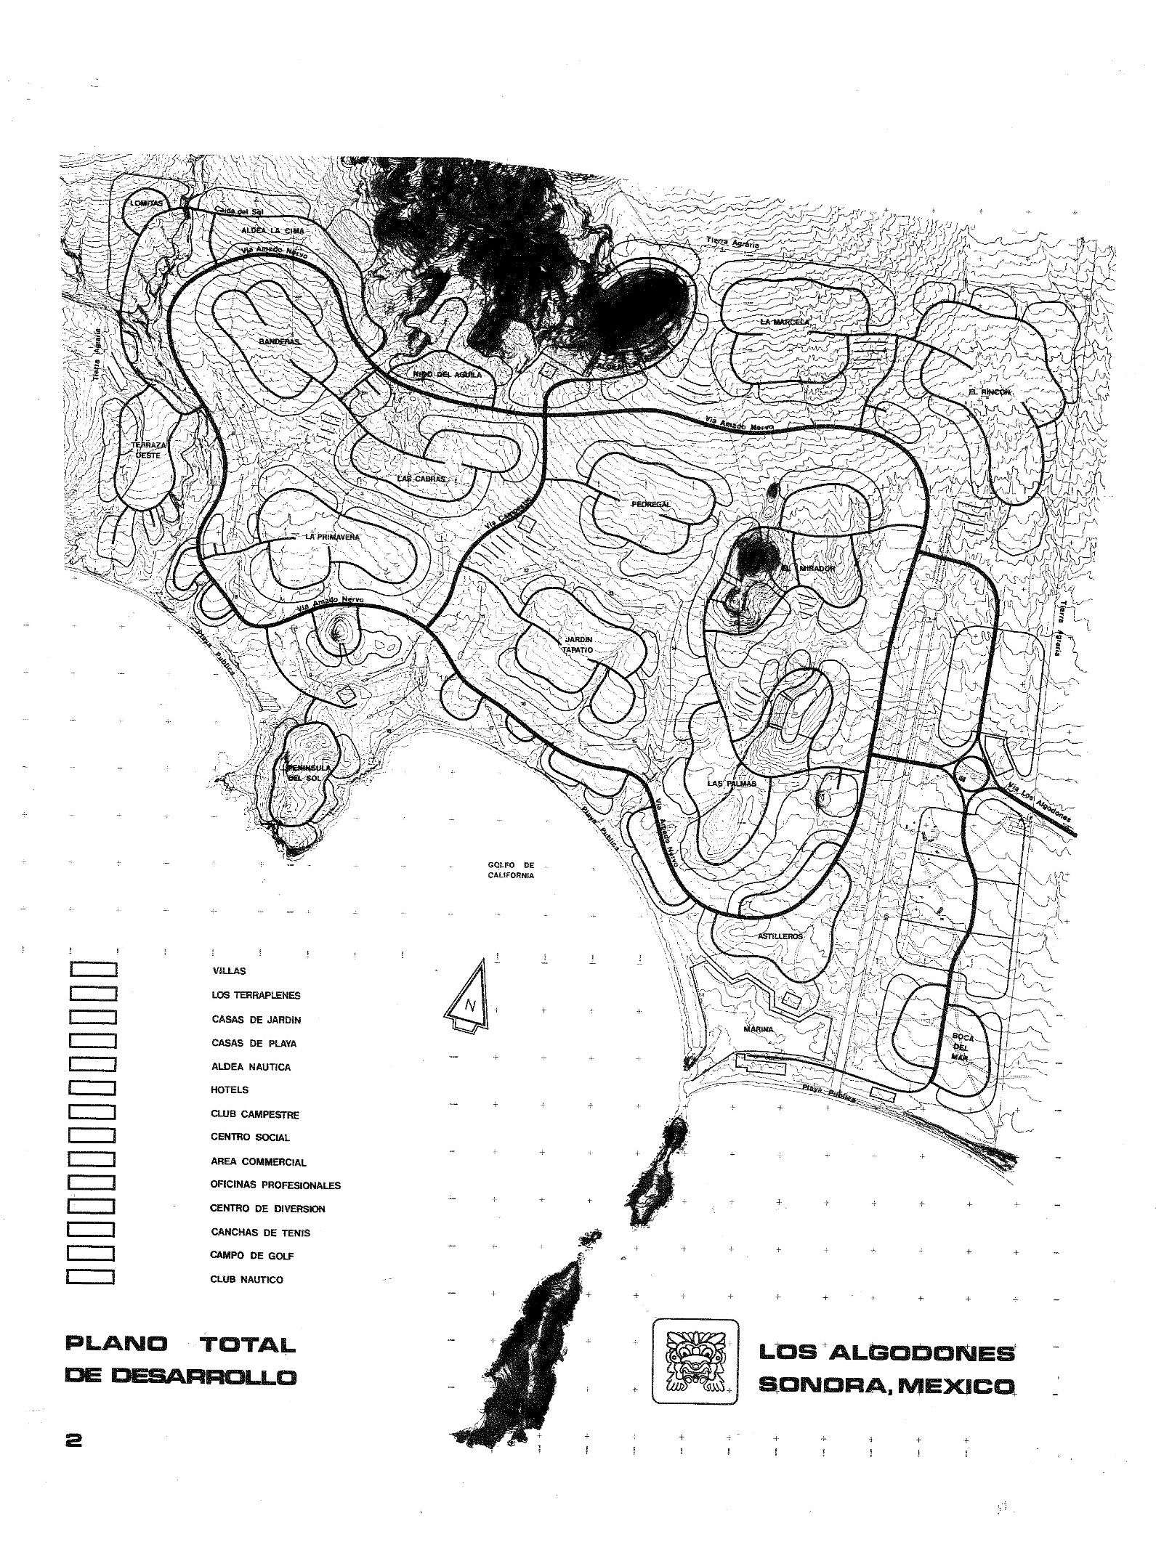
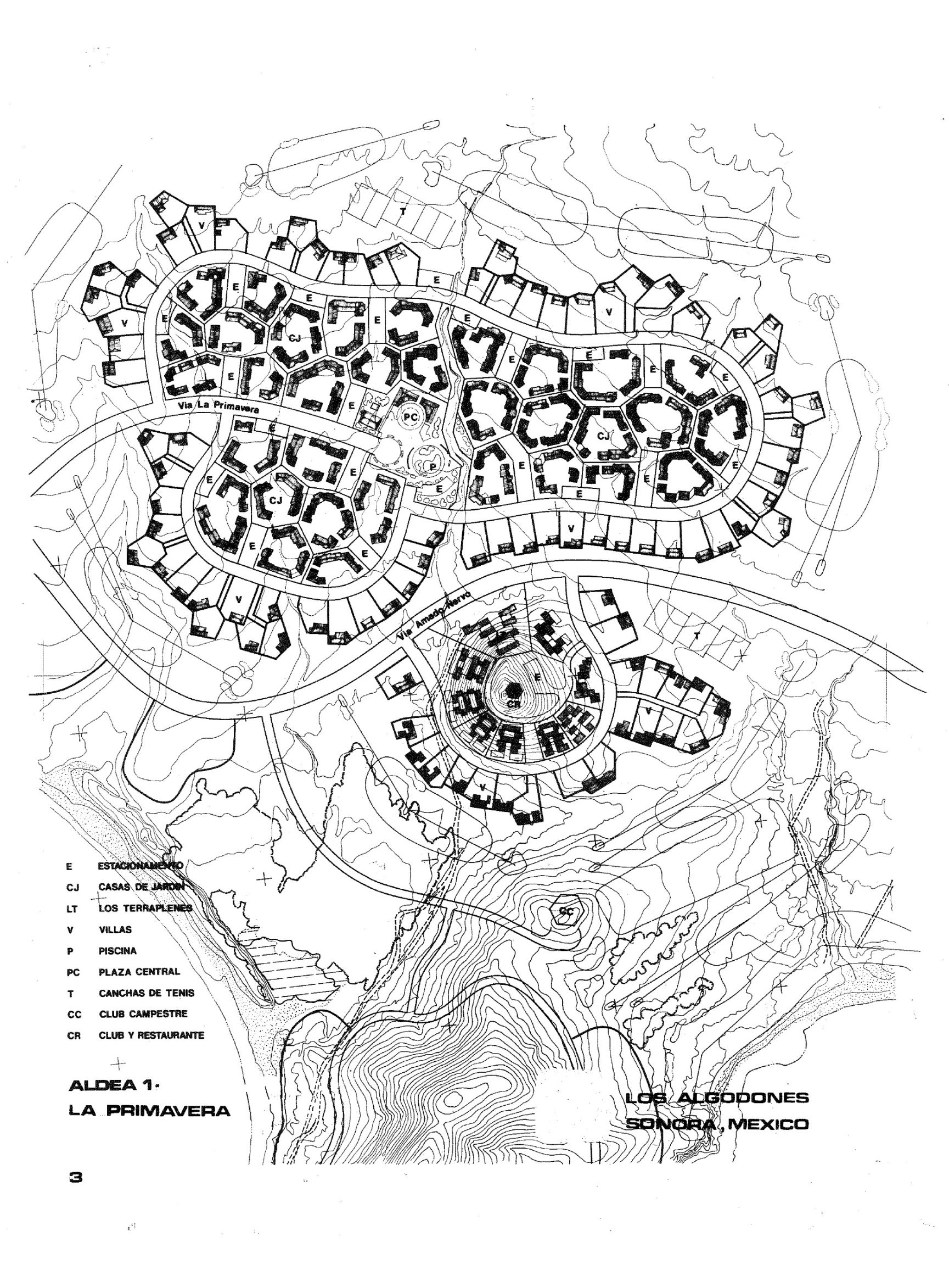
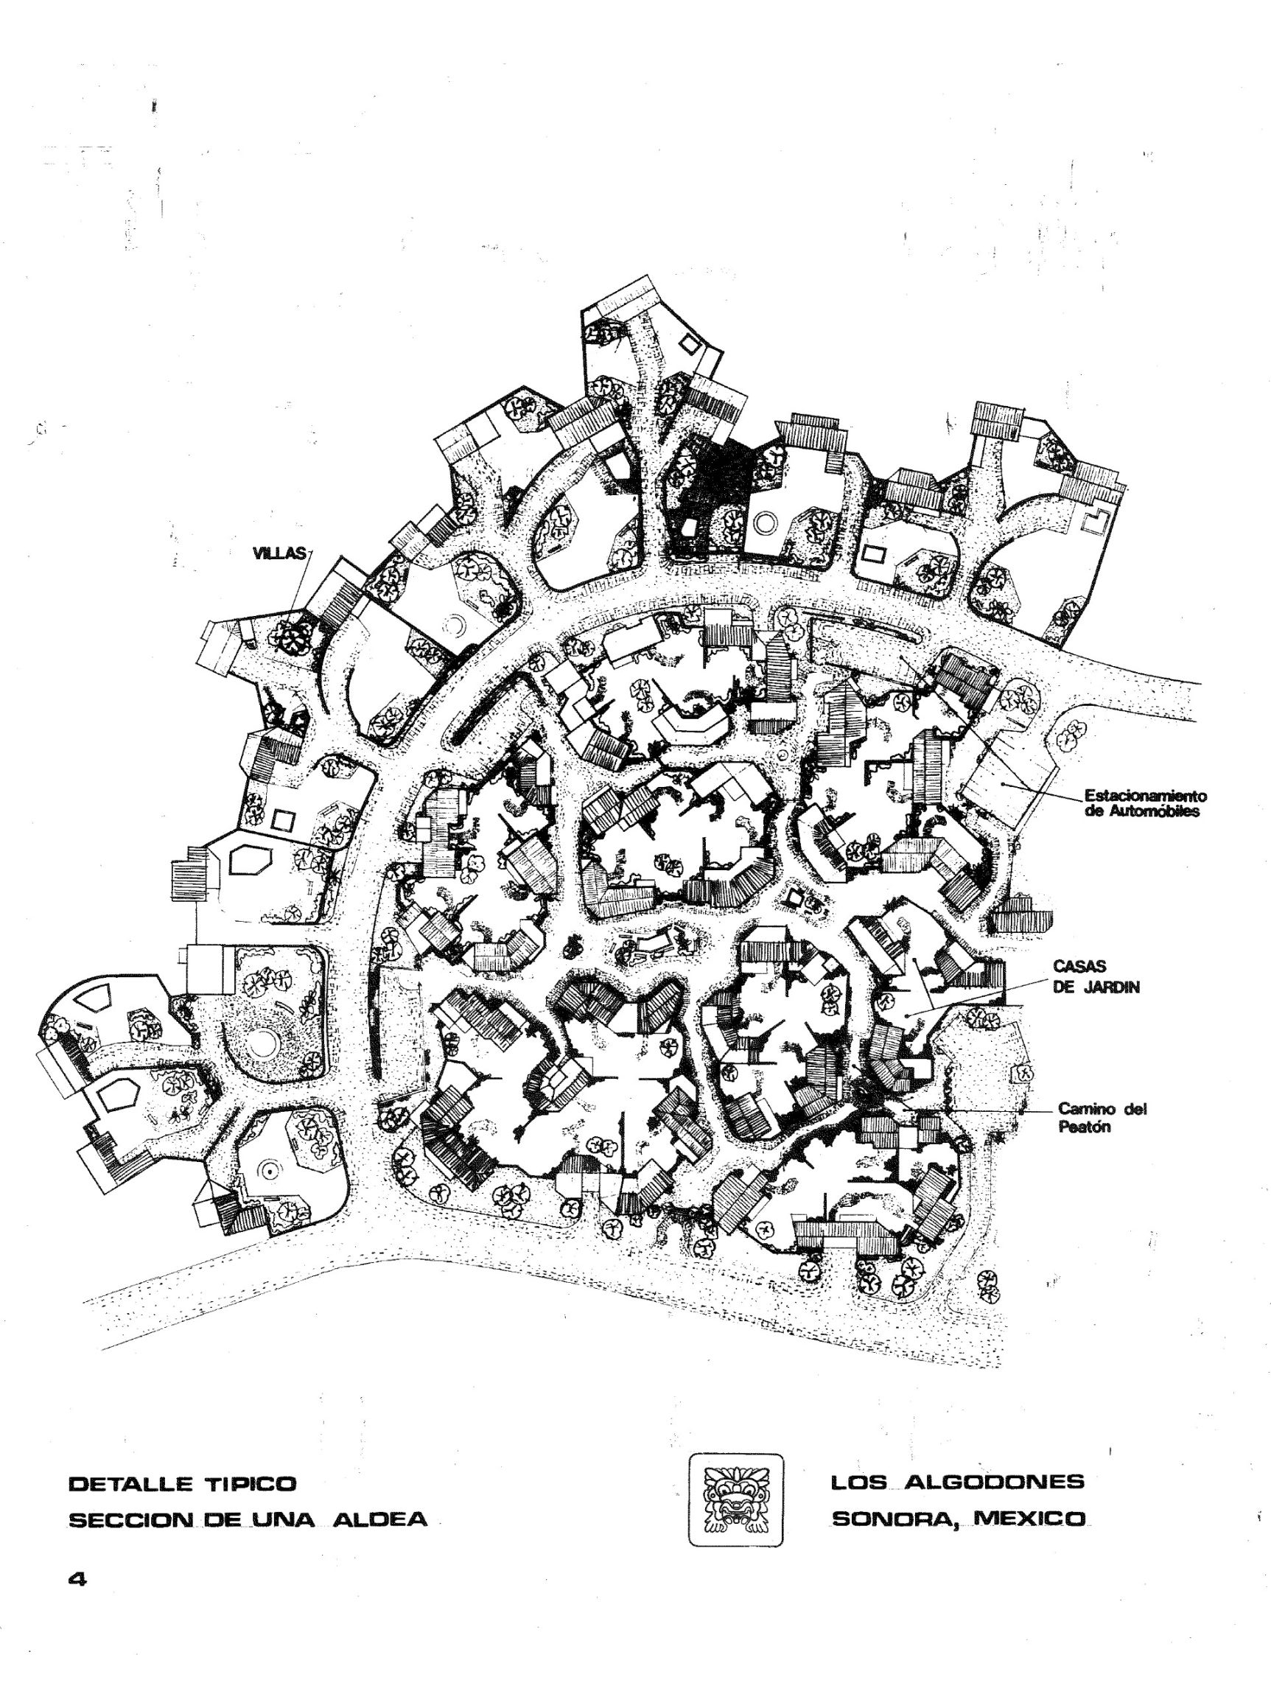
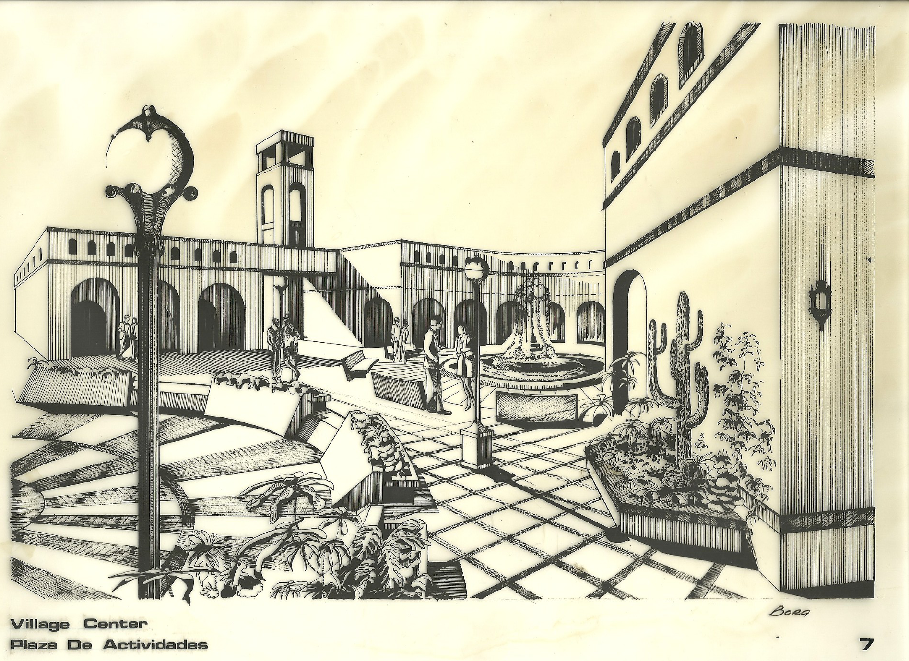
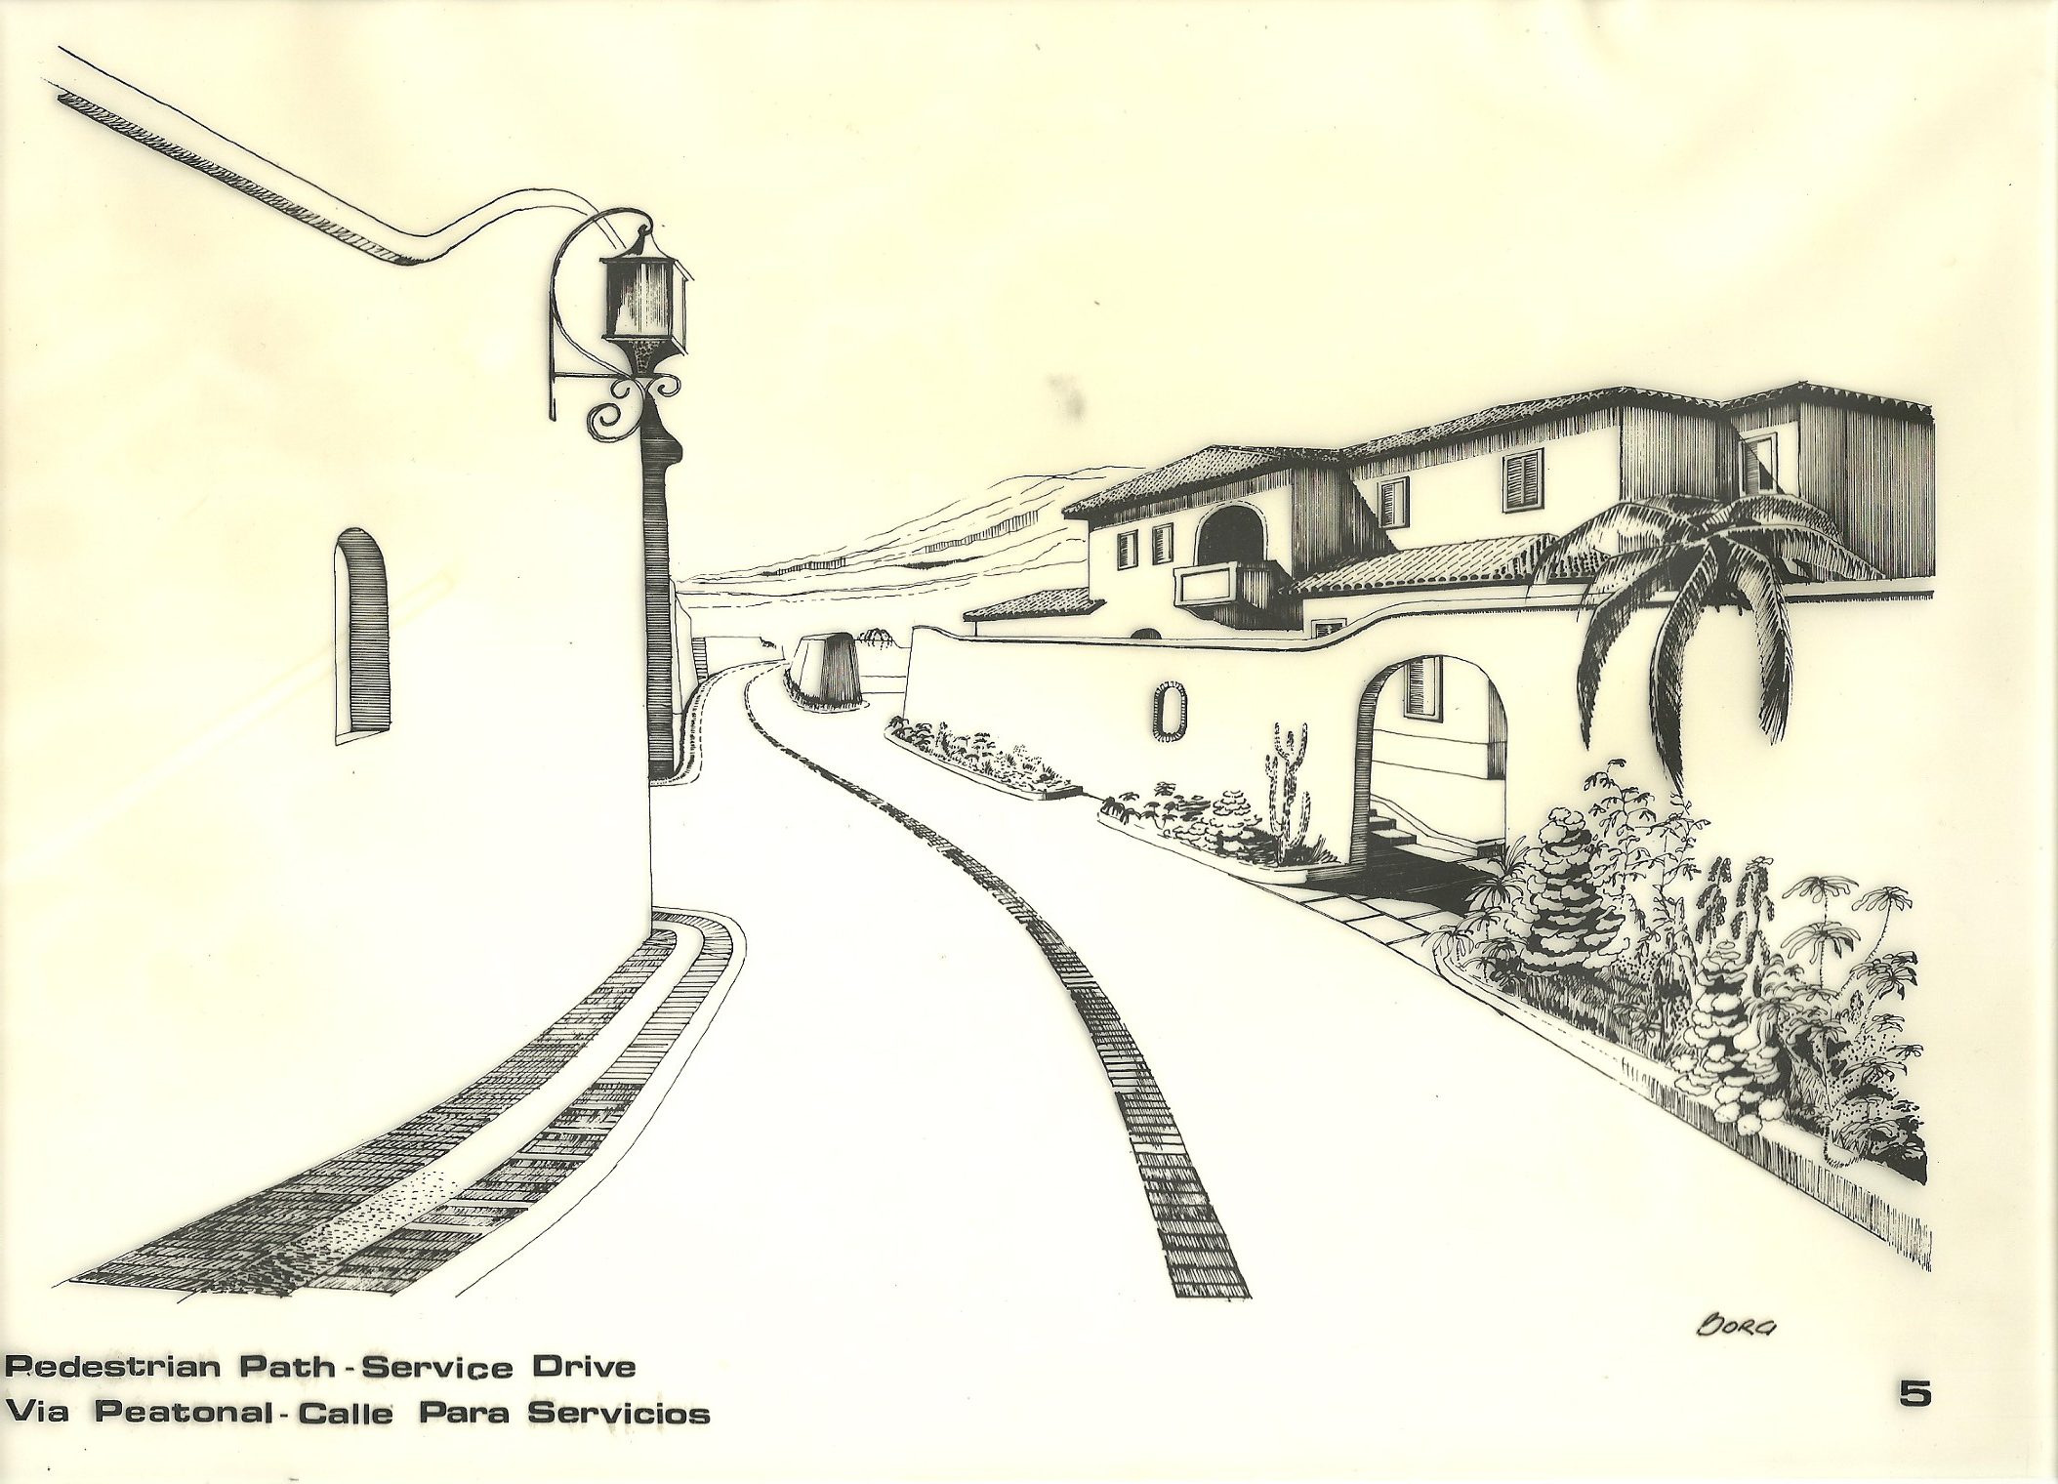

REFERENCES:
A Short History of the Building Crafts by Martin S. Brigs, FRIBA
Oxford University Press. First Published in 1925, reprinted in 1945
Lessons in Professional Liability, Edited by Sheila A. Dixon
XL Specialty Insurance Company, 2004
Untangling the Web of Professional Liability, Third Edition
Edward B. Howell and Richard P. Howell
Design Professionals Insurance Company, 1980, 1982, and 1983
CPM Construction Scheduler’s Manual by Jonathan F. Hutchings
McGraw Hill, 1996
Architecture and Energy by Richard G. Stein
Anchor Press/Doubleday, 1977
Planning and Managing Interiors Projects by Carol E. Farren
RS Means Company, Inc. Construction Consultants & Publishers, 198

